**Metric and Imperial Conversions**

***Length***  ***Volume***

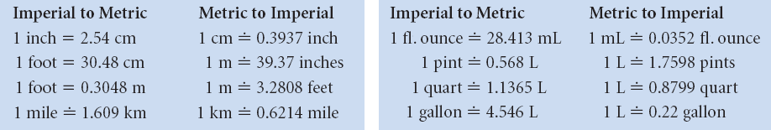

**Formula Sheet**

**2-Dimensional Shapes**

|  |  |  |
| --- | --- | --- |
| **Geometric Figure** | **Perimeter** | **Area** |
| **Rectangle** |  |  |
| **Parallelogram** |  |  |
| **Triangle** |  |  |
| **Trapezoid** |  |  |
| **Circle** |  |  |

**Formula Sheet**

**3-Dimesional Shapes**

|  |  |  |
| --- | --- | --- |
| **Geometric Figure** | **Surface Area** | **Volume** |
| **Cylinder** |  |  |
| **Sphere** |  |  |
| **Cone** |  |  |
| **Square-based Pyramid** |  |  |
| **Rectangular Prism** |  |  |
| **Triangular Prism** |  |  |