A graph is a visual representation of the relationship between two quantities. It shows how one quantity changes with respect to the other quantity.

Trends in the graph are used to justify decisions and make predictions.

EXAMPLE 1 Describe the relationship shown in each graph. Be specific.
KEY WORDS
Increases
grows
Same
Linear
Straight

increases
slowly
rapidly

passes
rapidly
slows down

increases
maximum
decreases

GRAPH | ANALYSIS
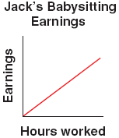 | 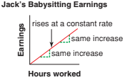  As the number of hours Jack babysits __________, his earnings ____________ by the ______ (constant) amount.  This graph represents a ________ relationship because the line is _________.
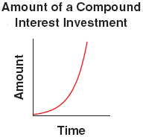 | 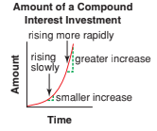  As time _____________, the amount of the compound interest investment:  PART A: increases _________  PART B: increases _________
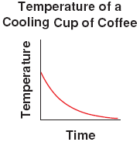 | 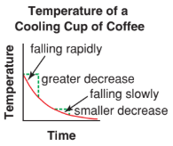  As time _________, the temperature of cup of coffee:  PART A: decreases _______ at first,  PART B: cooling ________________, finally levelling off at room temperature.
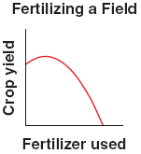 | 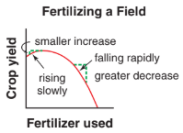  As fertilizer use ____________, the crop yield also increases to a ____________ where it reaches its peak and then _______________.

Trends (patterns of change) in a graph are often used to justify decisions and make predictions.
Trends occur in 3 broad groups:
- Increasing
- Decreasing
- Constant (no change)
Divide the graph into intervals of time when the number of births is increasing, constant, or decreasing.

EXAMPLE 2: The graph below shows the number of births in Ontario from 1945 to 2005.
Describe the trends in the graph.
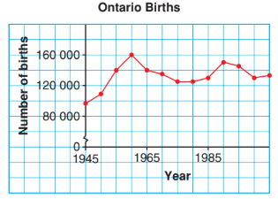
- From 1945 to 1960

- From 1960 to 1975

- From 1975 to 1980

- From 1980 to 1990

- From 1990 to 2000

- From 2000 to 2005

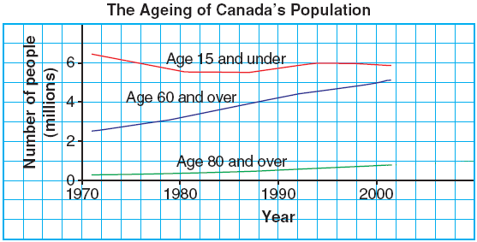
EXAMPLE 3 Use the graph to predict the number of Canadians in each age group in 2010.
Age 15 & under:
Age 60 to 80:
Age 80 plus:

This trend suggests that a declining number of younger Canadians will have to _________ an increasingly larger number of elderly Canadians.

