1. Solve each of the following using the **quadratic formula**. Round to two decimal places if

necessary.

a.  b. 

c.  d. 

1. Solve each of the following by **factoring**.

a.  b. 

c.  d. 

1. Determine the vertex of each parabola by completing the square:

a. *y* = -3*x*2 – 30*x* – 80 b.  *y* = 4*x*2 – 16*x* + 9

c.  d. 

1. Determine the vertex of each parabola by **averaging the zeros**:

a. *y* = *x*2 + 7*x* – 30 b. 

c.  d. 

1. Find the **x intercepts, vertex**, and **y-intercept** of the quadratic relation below. Graph the relation on the grid provided without using a table of values. Label the axes and curve

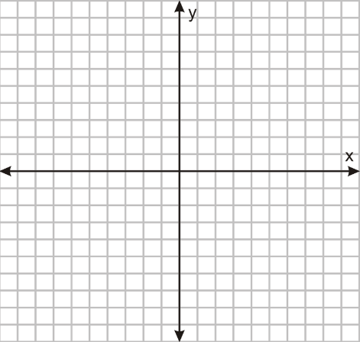

1. Mrs. Mulock hits a golf ball off a tee. Its height above the ground can be approximated by using the equation, where *h* is the height above the ground in metres and *t* is the time in seconds. What is the maximum height of the golf ball? After how many seconds does this occur?
2. Mr. Mulock works on weekends selling thingamajigs. The profit he earns is determined by the equation , where *n* is the number of thingamajigs sold and *P* is the profit in dollars.
   1. What is the maximum profit that Mr. Mulock can earn?
   2. Is it possible for Mr. Mulock to obtain a profit of $200? Show all work to justify your answer.
3. When Mr. Math realized that he had superpowers, he decided to try them out. He took a basketball and threw it into the air. Mrs. Math watched Mr. Math throw the ball and saw that it took the shape of a parabola with its height, ‘h’ in metres, being related to its time in the air, ‘t’ seconds, by the equation  .
   1. If the ball’s starting position was at the top of Mr. Math’s head, how tall is Mr. Math?
   2. What is the maximum height of the ball?
   3. When does the ball reach its maximum height?
4. A farmer’s field borders a stream. The farmer has 300 m of fencing to build a rectangular enclosure alongside the stream (so he only needs to build three sides). The area of the field is given by  where w is the length of the two matching sides. Draw a labelled diagram to represent the enclosure, and find the maximum area the farmer could enclose.
5. The backboard behind a basketball net is a rectangle whose area can be represented by the trinomial  (remember, the area of a rectangle is ). Determine the two expressions that represent the length and width.
6. Astronauts have performed various experiments while on the moon. In one of their experiments, a projectile was launched and observed. The projectile reached a maximum height of 21 m and landed on the surface of the moon after 3.8 sec. Select the equation for the height, h, in metres, of the projectile after t seconds.

a. h = -5(t – 3.8)2 + 21 b. h = -5 (t – 1.9)2 + 21

c. h = -5 (t + 3.8)2 + 21 d. h = -5 (t + 1.9)2 + 21

1. A water balloon was tossed in the air, and of course Mr. Culhane came up with a quadratic equation that models the total horizontal distance (in metres) covered throughout the flight of the balloon. The equation he came up with was . Determine the horizontal distance covered by this toss by solving the equation above. Round your answer to two decimal places.