FIRST DIFFERENCES – LINEAR OR NON-LINEAR

Whether a relationship is linear or non-linear can be determined by:
- Looking at the graph – Straight line
- Using the table of values - FIRST DIFFERENCES
- Looking at the equation

The first and most obvious is by looking at the graph. When the plotted points are connected, it they make a straight line, it is a linear relationship.

EXAMPLE | NON EXAMPLE
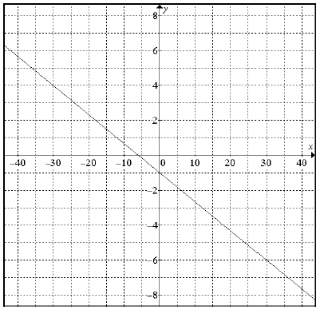  SLOPE = | 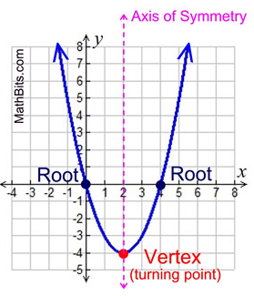

FIRST DIFFERENCES – Finding linearity in a table of values.

0 | 10 | First Differences
1 | 13
2 | 16
3 | 19
4 | 22
5 | 25
 |  | 28 - 25 = 3
6 | 28
What do you notice in the column for x values? _________________________________

This pattern must be evident in order to calculate the first differences.

To calculate the first differences, we use the second column (dependent variable) and, starting at the bottom, subtract the number above from the bottom number. The first is done for you. Continue the pattern to complete the first differences column.

What do you notice about the first differences?

_________________

This tells us that this relationship is LINEAR!
THE TILE FACTORY - PERIMETER

Jody works at a factory that produces square tiles for bathrooms and kitchens. She helps determine shipping costs by calculating the perimeter of each tile.
Side  Length (cm) | Perimeter (cm) | First  Differences
1
2
3
4
5

Calculate the perimeter and record your observations in column 2.

Construct a graph of the perimeter of a tile vs. the side length of the tile.
- Which variable is the independent variable?

- Which variable is the dependent variable?

- Use the graph to describe the relationship between the perimeter and side length of a tile.

d) Calculate the first differences in column 3 of the table. What do you notice about the first differences? What does this tell us?

e) Calculate the rate of change (slope) of your graph. What do you notice?

THE TILE FACTORY - PAYDAY

Number of Hours | Pay  ($) | First  Differences
0
5
10
15
20
Jody is paid $8.50 per hour to calculate perimeters. Calculate her pay and record your observations in column 2.

Construct a graph of the number of hours vs. her pay.
- Which variable is the independent variable?

- Which variable is the dependent variable?

- Use the graph to describe the relationship between the number of hours worked and Jody’s pay.

d) Calculate the first differences in column 3 of the table. What do you notice about the first differences? What does this tell us?

e) Calculate the rate of change (slope) of your graph. How is this different than the last example?

THE TILE FACTORY - AREA

Length of Side (cm) | Area  (cm²) | First  Differences
1
2
3
4
5
Raj, another employee at the factory, also works with the tiles. He helps to determine the shipping costs by calculating the area of each tile and recording his calculations in the table. Calculate the area and record your observations in column 2.

Construct a graph of the length of side vs. area of the tile.
- Which variable is the independent variable?

- Which variable is the dependent variable?

- Use the graph to describe the relationship between the length of the side and the area.

d) Calculate the first differences in column 3 of the table. What do you notice about the first differences? What does this tell us?

