**Describing Correlation in Scatter Plot Graphs**

When describing a relationship, you can assess the correlation (positive, negative, or no-relationship), the strength of the relationship (strong or weak) and whether or not the relationship appears to be linear (makes a straight line) or non-linear. From your course pack page 6, complete the following:

|  |  |
| --- | --- |
| **Positive correlation:** | **Negative correlation:** |
| **No correlation:** | |

|  |  |
| --- | --- |
| **Correlations are strong if:** | **Correlations are weak if:** |

|  |  |
| --- | --- |
| **A correlation is linear if:** | **A correlation is non-linear if:** |

Sketch an example of each:

|  |  |
| --- | --- |
| *Strong Linear Relationship | *Weak Linear Relationship |
| *No relationship | *Non-Linear Relationship |

Describing Correlation in Scatter Plot Graphs

**Example # 1**

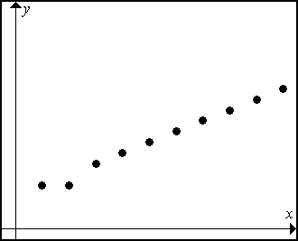This scatter plot shows the height of a tree over several years.

1. Label the axes.
2. Complete the following sentence: As the number of years ______________, the height of the tree increases.
3. Describe the correlation.

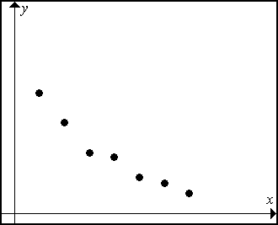

**Example #2**

This scatter plot shows the number of trees left in a forest as several loggers are cutting them down over a week.

1. Label the axes.
2. Complete the following sentence: As the number of days increase, the number of trees left ________________.
3. Describe the correlation.

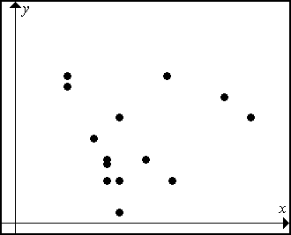

**Example 3**

This scatter plot shows the number of questions students did for math homework compared to the length of their shoelaces.

1. Describe the correlation.

Correlation

Will each of the following sets of data show a positive correlation, a negative correlation, or no correlation? Give reasons for you answer.

1. the number of pages left to be typed in your essay and the number of pages already typed?
2. the size of a student’s hand and the number of rings the student owns
3. the outside summer temperature and the number of people swimming
4. the depth of Lake Ontario and the amount of rainfall and snowfall for that year
5. the outside winder temperature and the number of centimeters of ice on Island Lake
6. the energy left in your personal radio batteries and the number of hours you have listened to this radio
7. your take-home pay and the number of hours you work
8. your math mark and the number of hours of studying you do

The Line of Best Fit

The **line of best fit** is a line that approximates the pattern for the data shown in a scatter plot. The line of best fit should be as close as possible to as many of your data points as possible. One purpose of the line of best fit is to help make predictions.

Use scatter plots A and B below to complete questions 1 to 4.

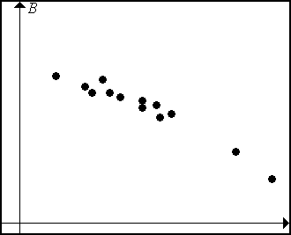

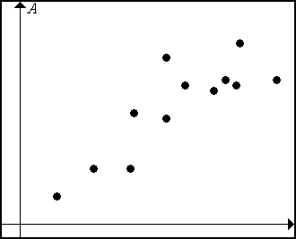

1. Use a straightedge (clear, if possible) to draw the line of best fit (this assumes the pattern is  
   linear).
2. Describe how you estimated the line of best fit for each scatter plot.
3. State the type of correlation for each graph.
4. Compare your line of best fit with a classmate. Is it important that all your classmates have lines of best fit that are identical?
5. Describe a situation where you could not draw a line of best fit.

Practicing the Line of Best Fit

* 1. Draw a line of best fit for each of the following scatter plots, if possible.



* 1. Classify each of the following graphs as Linear or Non-Linear:

|  |  |  |
| --- | --- | --- |
| a) | b) | c) |

**Application of the Line of Best Fit - Problem A**

We don’t just draw the line of best fit ‘just’ for the fun of it. This line describes the general relationship of the data and can be used to determine unknown values.

**Interpolate** – to estimate a value between (within) two known values.

**Extrapolate** – to predict a value by following a pattern beyond known values.

Several students were recording the temperature of boiling water that sat in a cup. Their results were combined and used to create this scatter plot graph. Use the graph to answer the following questions:

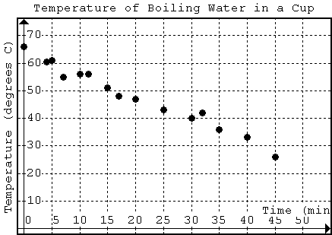

1. What type of correlation is this relationship?
2. Draw a line of best fit.
3. What was the temperature at 27 minutes? Use your line of best fit to find this missing data.
4. At what time did the temperature reach 30 degrees C? Use your line of best fit to *interpolate* this data.
5. At what time did the water reach a temperature of 10 degrees C? Extend your line of best fit to *extrapolate* this data.
6. What was the temperature at 50 minutes? Extend your line of best fit to *extrapolate* this data.

**[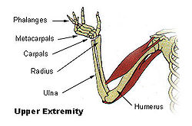](http://en.wikipedia.org/wiki/File:Illu_upper_extremity.jpg)Application of the Line of Best Fit – Problem B**

Anthropologists and forensic scientists use data to help them determine information about people. Often only a few bones are available or the evidence is inconclusive. In spite of these difficulties, by accessing the information in large databases and investigating relationships between data scientists can determine information about the height, age, and sex of the person they are examining. In this problem we are going to look at the relationship between the humerus bone “the funny bone” which is the bone of the upper arm and the radius bone.

1. 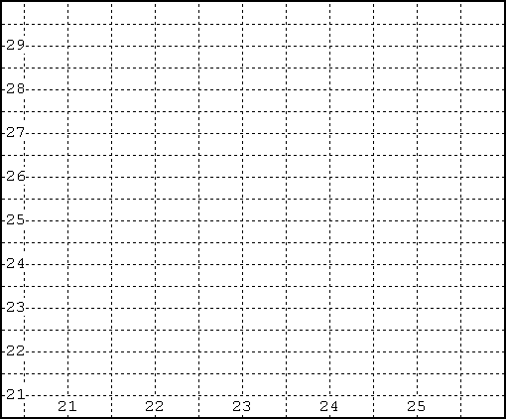Construct a graph that compares the radius of the humerus bone to the length of the bone.

|  |  |
| --- | --- |
| Radius (cm) | Humerus (cm) |
| 25 | 29.7 |
| 22 | 26.5 |
| 23.5 | 27.1 |
| 22.5 | 26 |
| 23. | 28 |
| 22.6 | 25.2 |
| 21.4 | 24 |
| 21.9 | 23.8 |
| 23.5 | 26.7 |
| 24.3 | 29 |
| 24 | 27 |

1. What type of correlation is this relationship?
2. Circle the point on the graph that represents the data for a humerus that is 27.1cm long. How long is the radius? _____
3. Underline the statement that describes the direction of the plotted points in the graph?
   * The plotted points rise upward from left to right.
   * The plotted points fall downward from left to right.
   * The plotted points are scattered across the graph.
   * The plotted points lie flat along the horizontal.
4. As the length of the radius gets longer, what happens to the length of the humerus?
5. Do you think that you can use the length of the radius to predict the length of the humerus? Explain.