Distance time graphs – Complete the sections that you can and then ask for help.
Graph | 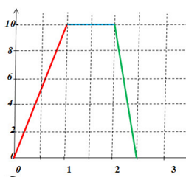  Distance Km  Time (Hours) |  | 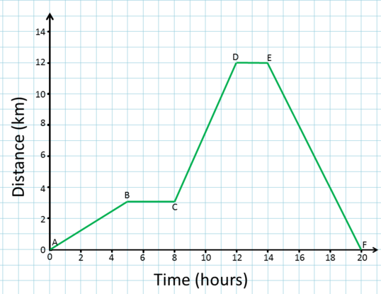
1 square on horizontal axis represents?
1 square on vertical axis represents?
How long did he stop for?
How far in total did he travel?
What was the speed for the first part of the journey?
What was the speed for the second part of the journey?
Graph | 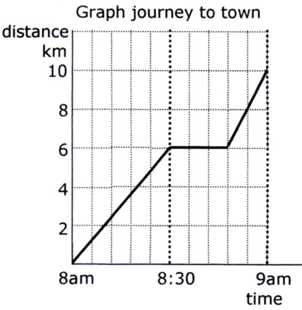 | 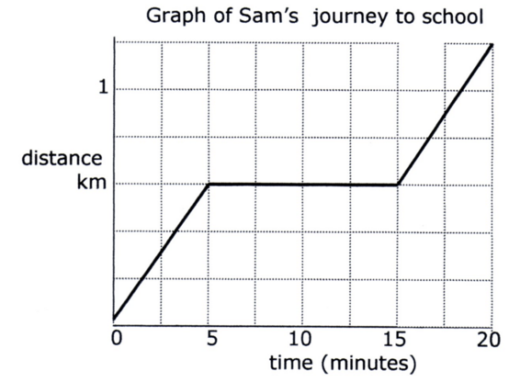 | 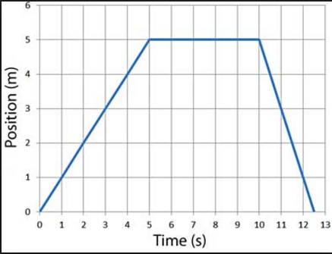
1 square on horizontal axis represents?
1 square on vertical axis represents?
How long did he stop for?
How far in total did he travel?
What was the speed for the first part of the journey?
What was the speed for the second part of the journey?

