INTRODUCTION TO DISTANCE – TIME GRAPHS
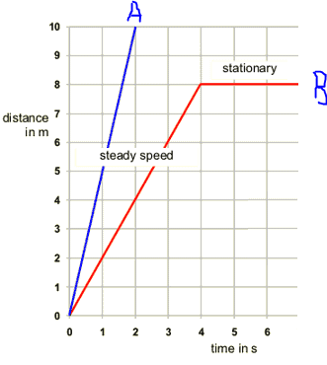

Distance is the total length travelled by an object. Distance is plotted on the y-axis (dependent) and time is plotted on the x-axis (independent).

On the left, you can see that the object represented by line A has travelled 10m in 2s whereas the object represented by the line B has only travelled 4m in this time and is therefore travelling more slowly.

'Straight lines' on a distance-time graph tell us that the object is travelling at a constant speed. Note that you can think of a stationary object (not moving) as travelling at a constant speed of 0 m/s.

CALCULATING THE SPEED
The slope (gradient) of a distance-time graph indicates the speed of the object.
Δ = Greek Letter Delta represents change
$$Speed=\frac{change in distance}{change in time}= \frac{Δd}{Δt}=\frac{rise}{run}$$

*Note that if the graph slopes downwards, you will get a negative value indicating the object is travelling back towards its origin.
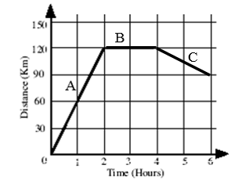

 | Part A | Part B | Part C
Distance Travelled
Time Travelled
Speed

Total Distance travelled =

DESCRIBING THE MOTION

During Part A of the journey the object travels ______ km in ____hours. It is travelling at a constant velocity (a fancy term for speed when you include the direction) of ____ km/h.

During Part B of the journey the object travels ___ km in ___ hours. It is stationary for 2 hours.

During Part C of the journey the objects travels ____ km in ___ hours. It is travelling at a _______ ________ of -15 km/h back to its starting point, our reference point 0.

The graph below shows Cole’s journey between his home and a campsite. The origin indicates home.
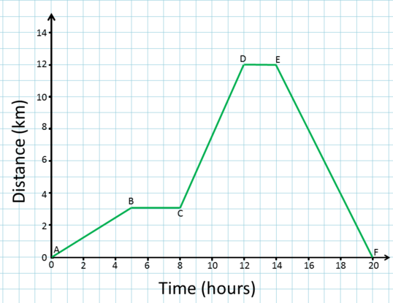
 | Part AB | Part BC | Part CD | Part DE | Part EF
Distance Travelled
Time Travelled
Speed

Note= + direction represents going towards campsite, - direction represents going back home (origin).

Describe the journey for each part using the words: constant velocity, direction, stationary
Part
AB
Part
BC
Part
CD
Part
DE
Part
EF

CURVED LINES
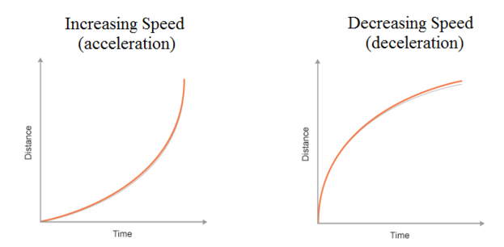

'Curved lines' on a distance time graph indicate that the speed is changing.
The object is either getting faster = 'accelerating' or slowing down = 'decelerating'. You can see that the distanced moved through each second is changing.

