Day 1 - STEADY GONZALES
Graph below shows Gonzales’ journey from his home to school over time.

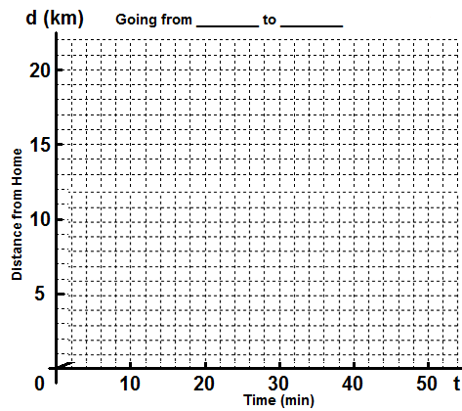  I) | 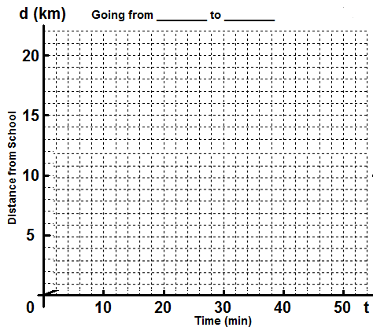  II)

a) How far does Gonzales live from school? __________
b) How long does it take Gonzales to reach school? ____________
c) What is Gonzales’s rate of change (speed / slope)? (Leave time as min)
$$speed=\frac{distance}{time}$$

d) Does Gonzales’s speed change throughout his journey according to this graph? _________
e) What does that horizontal line signify in the graph? _____________________________________
f) Graph this scenario from friend of Gonzales’s perspective who is waiting at school to meet him.

Day 2 - SPEEDY GONZALES
Now we know that, Gonzales lives 20km away from school. Another day, he leaves home at 7:20 am; he has to be at school at 8:00 am.

a) How long his journey will take on day 2? ___________
b) Calculate his rate of change (speed) for the first 20 minutes and describe this part of his journey.

c) What do you think happened between 20 and 30 minutes of his journey?

d) at 30th minute, he checks his time and it reads ______am. How many minutes does he have left to make to school on time? ________
e) Draw a straight line after 30 minutes which indicates that he arrived school on time.

f) What do you notice about the steepness of the line between 30 and 40 minutes of his journey compared to that of 0 and 20 minutes?

g) The steeper the line the __________ Gonzales travels.

DAY 3 - GONZALES THE FORGETFUL
As usual Gonzales leaves home at 7:20 am and has to be at school at 8:00 am latest.
Create a story for Gonzales’ journey to school on the third day giving as much math detail as possible.
D
C
E
G
F
B
A
Distance from __________

OTHER TYPES OF DISTANCE - TIME GRAPH
When you travel with a car, bus or a train your speed may not be constant different than the Gonzales example.
Accelerating (getting faster)
Slowing down
Steady Speed

0 - 18 minutes
When you accelerate (increase speed), this is shown as a curved line on a distance - time graph.

18 - 28 minutes
Once you reach a certain speed, you may want to maintain that speed. This is represented as a straight line because regardless of which points you pick on this straight line the slope (speed) will always be the same.

28 - 48 minutes
When you decelerate (slow down), this is also shown as a curved line on a distance - time graph. Notice the difference between acceleration and deceleration.

