AREAS OF COMPOSITE SHAPES

Perimeter: The _________ around a closed figure. Simply, the sum of all _________ sides.
KEY WORDS
Distance
exterior
cm, mm, m, in, ft
square unit
cm², m², in², ft²
composite
shapes

Possible Units: ___, ___, ___, ___, ___

Area: The number of _______ ______ needed to cover a surface
Possible Units: ___, ___, ___, ___

__________ shape is a complex figure that is made up of two or more sample figures. To solve composite figures, break them into known basic _________.

WARM UP:
1) Find the area and perimeter of each basic shape: (Use the π button on your calculator.)
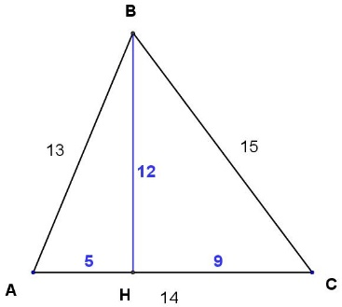 | 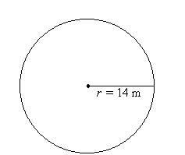

2) Find the areas of the following shapes:
A rectangle measuring 5 cm by 12 cm | A square with side lengths 6 cm | A parallelogram with base 3 cm and height 2 cm

Calculate the area of the following shapes:

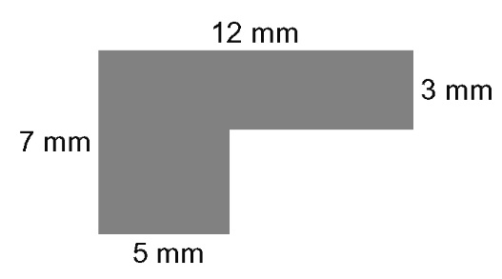  a) | 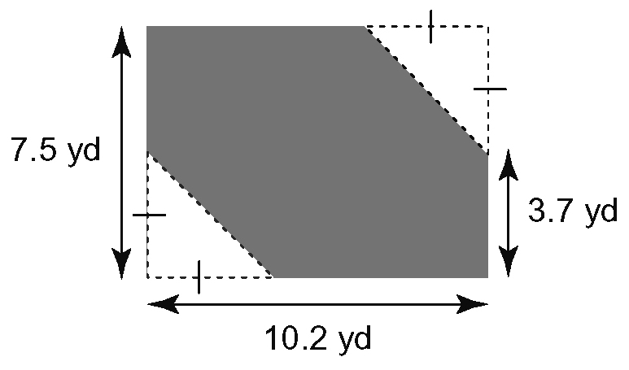b)
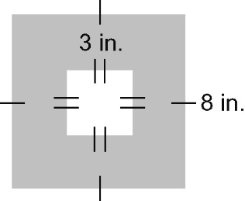  c) | 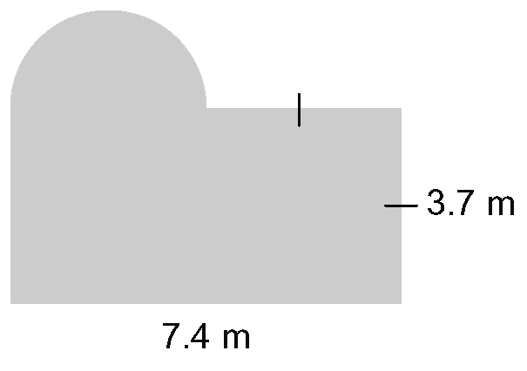d)  r  r  r

