EVOLUTION OF NUMBERS & NUMBER SETS
The Counting Numbers
We can use numbers to count: 1, 2, 3, 4, etc. We humans have been using numbers to count with for thousands of years. It is a very natural thing to do.
- You can have “3 friends”
- a field can have “6 cows”
Counting Numbers: {1, 2, 3…}
So we have:

Zero
The idea of zero, though natural to us now, was not natural to early humans…if there is nothing to count, how can you count it?

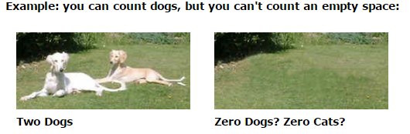

An empty patch of grass is just an empty patch of grass!

But about 3,000 years ago people needed to tell the difference between numbers like 4 and 40. Without the zero they look the same! So they used a “placeholder”, a space or special symbol, to show “there are no digits here”

5 2 So, “5 2” meant “502”

The idea of zero had begun, but it wasn’t for another thousand years or so that people started thinking of it as an actual number.
But now we can think, “I had 3 oranges, then I ate the 3 oranges, now I have zero oranges.”
The Whole Numbers
So, let us add zero to the counting numbers to make a new set of numbers.
We need a new name, and that name is “Whole Numbers”:
Whole Numbers: {0, 1, 2, 3…}

The Natural Numbers (N)
Natural numbers can mean:
- the “counting numbers”: {1, 2, 3…}
- or the “whole numbers”: {0, 1, 3…}
depending on the subject. The controversy is caused by whether zero is “natural” or not.
Negative Numbers
We can count forward: 1, 2, 3, 4…
When we can backwards we have negative numbers -1, -2, -3, -4…
When a number is less than zero it is simply negative.

Integers (Z)
If we include the negative numbers with the whole numbers, we have a new set of numbers that are called integers.
Integers: {…-3, -2, -1, 0, 1, 2, 3…}

The integers include zero, the counting numbers, and the negative of the counting numbers.
Rational Numbers (Q)
Any number that can be written as a fraction is called a Rational Number.
So, if “p” and “q” are integers, then $p/q=3/2$ is a rational number.

The only time this does not work is when q is zero.

Rational numbers include:
- all the integers and all fractions
IRRATIONAL NUMBERS
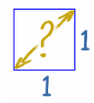
If you draw a square (of size “1”), what is the distance across the diagonal?
You know that the is the square root of 2, which is 1.4142135623730950…(etc)
But it is not a number like 3, or five-thirds. So it is not a rational number. We call them Irrational Numbers. Some examples are $\sqrt{2, }$ π (Pi)

You need irrational numbers to:
- find the diagonal distance across some squares,
- to work out lots of calculations with circles (using π)

We really should include irrational numbers. Thus, we need to introduce a new set of numbers…
REAL NUMBERS (R)
Real numbers include:
- the rational numbers, and
- the irrational numbers
A Real Number can be thought of as any number.

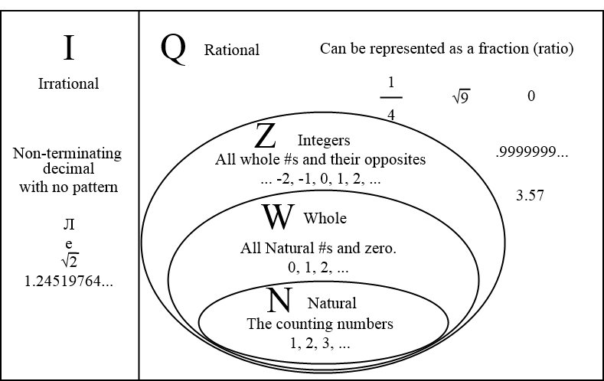
For practice go to Bit.ly/numberset
OPERATIONS WITH INTEGERS

ADDITION
CASE 1: SAME SIGN (+) + (+) or (-) + (-)

RULE
SIGN: KEEP the common sign
VALUE: ADD the numbers

Example 1: (+2) + (+1)  SIGN Both are (+) so the answer will be (+)  QUANTITY 2 + 1 = 3  ANSWER: Therefore the answer is ________ | Example 2: (–2) + (–4)  SIGN Both are (-) so the answer will be (-)  QUANTITY 2 + 4 = 6  ANSWER: Therefore the answer is _________

Let’s Try Some:
a. (+3) + (+7)= | b. (–9) + (–3)= | c. (+3) + (+2) = | d. (–8) + (–5)=

CASE 2: OPPOSITE SIGN (+) + (-) OR (-) + (+)

RULE
SIGN: Keep the sign of the larger number (ignoring the sign)
VALUE :Then find the difference between the two numbers (without the signs)

Example 3: (-8) + (+1)  SIGN Which number is larger, 8 or 1?  8 is (–) therefore the answer will be (–)  QUANTITY 8 is larger than 1 by how much? (or 8-1)  = 7  ANSWER: Therefore the answer is ________ | Example 4: (-2) + (+4)  SIGN Which number is larger, 4 or 2?  4 is (+) therefore the answer will be (+)  QUANTITY 4 is larger than 2 by how much? (or 4-2)  = 2  ANSWER: Therefore the answer is _________

Let’s Try Some:
a. (–3) + (+7)= | b. (–9) + (+3)= | c. (–3) + (+2) = | d. (+8) + (–5) + (-3) + (+4)=

SUBTRACTION - Adding the opposite!
Subtracting can get tricky! To avoid this, we are able to change the question from subtract to add, if you change whatever follows the subtract sign to ‘the opposite’. This is referred to as ‘adding the opposite or the additive inverse’. Once it is +, we follow the rules from the previous page.

Example 5: (+8) – (+1)  Add the opposite: (+8) + (–1)  SIGN Which number is larger, 8 or 1? 8 is (+) therefore the answer will be (+)  QUANTITY 8 is larger than 1 by how much? 7  ANSWER: Therefore the answer is ________ | Example 6: (–2) – (+4)  Add the opposite: (–2) + (-4)  SIGN Both numbers are (–), so the answer will be (–)  QUANTITY 2 + 4 = 6  ANSWER: Therefore the answer is _________

Let’s Try Some:
a. (–6) – (+4)= | b. (–9) – (–9)= | c. (–3) – (+3) = | d. (+8) – (–5) + (+3) – (–2) =
MULTIPLICATION and DIVISION
(+) x (+) or (+) ÷ (+) = ( )
(–) x (–) or (–) ÷ (–) = ( )

(+) x (–) or (+) ÷ (–) = ( )
(–) x (+) or (–) ÷ (+) = ( )
There is a simple rule used for multiplying and dividing integers:

Example 7: (+8) x (-4)  SIGN (+) x (-) = ( )  QUANTITY 8 x 4 = 32  ANSWER: Therefore the answer is ________ | Example 8:  SIGN (–) ÷ (–) = ( )  QUANTITY 6 x 2 = 3  ANSWER: Therefore the answer is _________

Let’s Try Some:
a. (–6) x (+4)= | b. (–9)(–9)(+4)= | c. (–1) ÷ (+4)= | d. (–9) ÷ (–9)=
e. = | * Integers and exponents:
 | f. (-1)³ = | g. (–5)² (4) | h. –5² (4)

Summary: Integer Operations

- Adding Integers:  - (+4) + (+2) = ______  - (+3) + (+5) = ______ | To add two positive integers, we…
- (-3) + (-5) = ______  - (-4) + (-2) = ______ | To add two negative integers, we…
- (+5) + (-3) = ______  - (-7) + (+3) = ______ | To add one positive and one negative integer, we…
- Subtracting Integers  - (–4) – (–3) = (–4) + (+3) = ______  - (+4) – (+6) = (+4) + (–6) = ______ | To subtract integers, we…
- Multiplying or Dividing Integers  - (+9) x (+3) = ______  - (+60) ÷ (+4) = ______ | To multiply or divide two positive numbers, we…
- (–4) x (–7) = ______  - (–36) ÷ (–12) = ______ | To multiply or divide two negative numbers, we…
- (–6) x (+5) = ______  - (–40) ÷ (+4) = ______  - (+4) x (–6) = ______  - (+20) ÷ (–4) = ______ | To multiply or divide one positive and one negative number, we…
- Exponents and Integers  - (-2)² = ______  - -2² = ______ | To evaluate the power, the exponent is only applied to the base, which is directly to the left of the exponent.  What is the difference between question a. and b.?

