TERMINOLOGY
Measured
One attribute
Frequency
Tally
Frequency charts
Bar graphs
Histograms
Circle (pie) charts
Mean, median, mode
Average
Middle
Frequently
Relationship , two
Two attributes
Independent (x - axis)
Dependent (y-axis)
Ordered pairs
Scatter plots
Two column charts

key words
VARIABLE: an unknown value/attribute that can be ________________________

ONE-VARIABLE DATA: gives the measures of ________________________.
Counts the ______________________ of occurrences for possible values of the variable
Often displayed as:
______________ __________________ _________________________
______________ _________________________________

Analyzed using: ______________________, _________________________,
and ___________________, as well as range, variance, and standard deviation.

Mean: the ____________________________ of a set of one-variable data
Median: the ________________________ value in a SORTED set of one-variable data
Mode: the most ________________________________ occurring value in a set of
one-variable data
Correlation: measures the strength of the __________________________ between
_______ variables

TWO-VARIABLE DATA: gives the measures of _______________________________
Compares the values of the _____________________ and _________________________
variables
Often displayed as:
_______________________ ____________________________ _________________________________

Analyzed using: correlations, linear regression, and non-linear regression (more to come…)

IDENTIFYING SITUATIONS OF ONE AND TWO VARIABLE DATA
Ask yourself: 1. What is this information measuring?
2. How can this information be displayed?
3. How can this information be analyzed?

Example 1 State whether each situation involves one-variable or two-variable data. Justify your answer.
- Noah researches annual hours of sunshine in Canadian cities.

- A study compares the amount of time people spend watching TV and the amount of time reading.

TYPES OF DATA
Categorical Data: ________________ data that is arranged into categories
Examples: ____________________, __________, ____________________, ________

Discrete Data: _________________ data that is specific and can be counted (integers)
Examples: ______, ________________, ________________

Continuous Data: ___________ data that can hold any value
Examples: ____________, ___________, ______________, ___________

Discrete data is ________, continuous data is ____________.
KEY WORDS
Non-numerical
Favourite colour
City
Sports team
gender
Numerical
Age
Class size
money
Numerical
Weight
Height
Temperature
time
Counted
measured
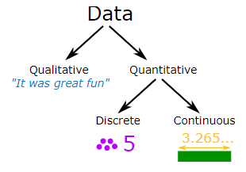

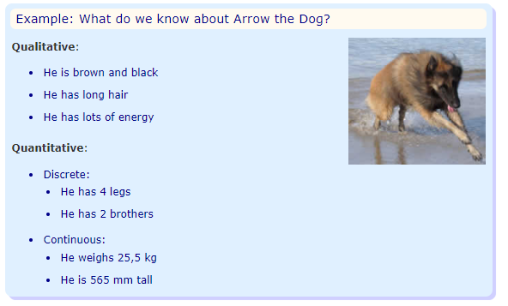

DISPLAYING DATA

BAR GRAPH | HISTOGRAM
Shows relative sizes of different results:  - One variable data  - Shows frequency of each data  - Discrete or categorical data  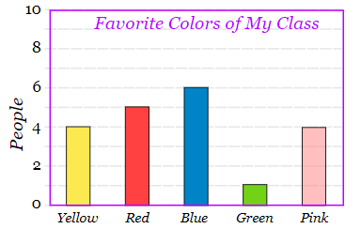 | Shows frequency of a RANGE of data values  - One variable data  - Groups numbers into ranges.  - Used for continuous data  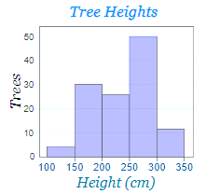
PIE CHART | SCATTER PLOT
- One variable data  - Shows proportion of each data value  - Used for categorical data  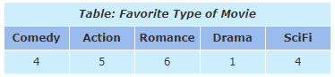  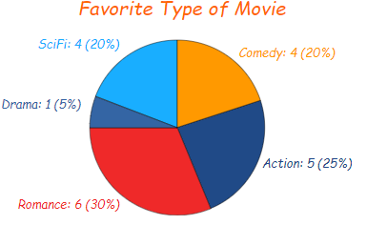 | Show the relationship between two sets of data.  - Two variable data  - Shows two pieces of info for each item  - Used for discrete or continuous data  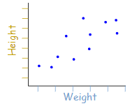

DECIDING WHICH GRAPH TO DRAW
Ask yourself:
1. Is it one or two variable data?
2. What type of data is it?

Example 1:
$ Spent  on Lunch | Frequency  (# of days)
0 to 2 | 6
2 to 4 | 4
4 to 6 | 8
6 to 8 | 3
8 to 10 | 2
a) Does the table show one or two variable data? ____________
(Note: Frequency is not a variable.)
b) Graph the table.

A | B | C | D
4 | 12 | 10 | 2
Example 2: Here is how many students got each grade in recent test:
a) Does the table show one or two variable data? _________
b) Graph the table.

Example 3: 145 people were asked “Which is the nicest fruit?”:
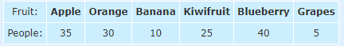
a) One or two variable data? __________
b) Graph the table.

Example 4: For a class project, Dylan surveyed students about their part-time jobs. The data is shown below.

 | Hours Spent at Part-Time Job
Student | Week Hours | Weekend Hours
Anya | 5.0 | 12.5
Ellen | 8.0 | 12.0
Fiona | 17.0 | 8.0
Aaron | 0.0 | 16.5
Leila | 10.0 | 16.0
Mason | 9.5 | 8.0
Petra | 15.0 | 6.0
- What type of graph would be best to show how many
hours each student worked on the weekend?

- What type of graph would best show a possible relationship between weekday and weekend hours?

