OPERATIONS WITH INTEGERS
Integers are positive and negative whole numbers with no fractional parts. Addition is the process of finding the sum of two or more numbers.
ADDING LIKE SIGNS | ADDING UNLIKE SIGNS
To add two signed numbers with like signs, add the numbers and apply the common sign.  Examples:  (-8) + (-7) = - (8+7)= -15  6 + (+2) = +8 or simply 8  Note that in the absence of a sign, the number is understood to be positive, i.e.:5 means +5 | 1. Find the difference between two numbers excluding signs.  2. The result from Step 1 takes the sign of the integer with the greater numerical value.  Ex:  (-9) + (5) = ?  Step 1: 9 – 5 = 4  Step 2: The number 4 will take a negative sign.  Therefore, the answer is -4.  Alternative solution: Treat the negative numbers the money you owe. Your bank account shows -$9, then you earned $5. You still owe the bank $4. Therefore, the answer is -4.

Practice:
1) (-6) + (- 9) = | 2) (7) + (11) = | 3) (5) + (-3) =

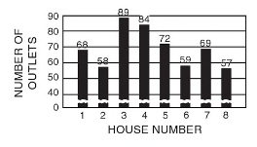
APPLICATION: In wiring eight houses, you are to install outlets. The graph shows the number of outlets to be installed in each house. Find the total number of outlets that must be roughed in.

SUBTRACTING INTEGERS
Problem: The temperature in Anchorage, Alaska was 8°F in the morning and dropped to -5°F in the evening. What is the difference between these temperatures?
RULE: To subtract an integer add its opposite
Solution:
The opposite of -5 is 5. Then we add 5 to 8.
(8) – (-5) = 8 + (+5)
= 13
The difference is 13 degrees.

PRACTICE:
a) (6) – (9) = | b) (11) – (-8) = | c) (-13) – (5) =
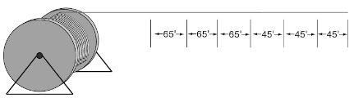
For a residential job, a reel containing 1050 feet of cable is delivered. Three 45-foot lengths and three 65-foot lengths are used. How many feet are left?

MULTIPLYING INTEGERS
It is actually a method of addition used when like numbers are added.
Example: If four 5s are added, the answer will be 20. If the number 5 is multiplied by 4, the answer (product) is equal to 20. Therefore 5 x 4 is the same as adding four 5s.

5
5
5
+ 5
20

5
x 4
20

DIVIDING INTEGERS
Division is the process of subtracting a smaller number from a larger number a certain number of times. The larger number, the number to be divided, is called the dividend. The number used to indicate the number of times the dividend is to be divided is called the divisor. The answer is known as the quotient.

It is quite easy to multiply or divide integers. Draw a line between the two signs in the triangle. The remaining sign is the sign of your answer. Just do the operation either multiply or divide.

Ex1. (+8) x (-4) Ex2.

a. (–6) x (+4)= | b. (–9)(–9)(+4)= | c. (–1) ÷ (+4)= | d. (–9) ÷ (–9)=

CHALLENGE
Where do you put the brackets with:
