OPERATIONS WITH INTEGERS
Definition: Integers are the ________ of ____________ numbers (no decimals) which include ______________ numbers, ______________ numbers and the number __________
KEY WORDS
Set
Whole
Positive
Negative
Zero

ADDITION
CASE 1: SAME SIGN (+) + (+) or (-) + (-)
SIGN: KEEP the common sign
QUANTITY: ADD the numbers

Example 1: (+2) + (+1)  SIGN Both are (+) so the answer will be (+)  QUANTITY 2 + 1 = 3  ANSWER Therefore the answer is ___ | Example 2: (–2) + (–4)  SIGN Both are (-) so the answer will be (-)  QUANTITY 2 + 4 = 6  ANSWER Therefore the answer is ___

Try Some:
a. (+3) + (+7) = | b. (–9) + (–3) = | c. (+3) + (+2) = | d. (–8) + (–5) =

CASE 2: OPPOSITE SIGN (+) + (-) OR (-) + (+)
SIGN: Keep the sign of the larger number (ignoring the sign)
QUANTITY: Then find the difference between the two numbers (without the signs)

Example 3: (-8) + (+1)  SIGN Which number is larger, 8 or 1?  8 is (–) therefore the answer will be (–)  QUANTITY 8 is larger than 1 by how much?  (or 8-1)  = 7  ANSWER Therefore the answer is ________ | Example 4: (-2) + (+4)  SIGN Which number is larger, 4 or 2?  4 is (+) therefore the answer will be (+)  QUANTITY 4 is larger than 2 by how much? (4 - 2)  = 2  ANSWER Therefore the answer is _________

Try Some:
a. (–3) + (+7) = | b. (–9) + (+3) = | c. (–3) + (+2) = | d. (+8) + (–5) + (-3) + (+4) =

SUBTRACTION - Adding the opposite!
Subtracting can get tricky! To avoid this, we are able to change the question from subtract to add, if you change whatever follows the subtract sign to ‘the opposite’. This is referred to as ‘adding the opposite or the additive inverse’. Once it is +, we follow the rules of addition

2 is the opposite of -2, or -4 is the opposite of 4. Simply switch the sign from positive to negative or negative to positive.

Example 1: (+8) – (+1)  Add the opposite: (+8) + (–1)  SIGN Which number is larger, 8 or 1? 8 is (+)  therefore the answer will be (+)  QUANTITY 8 is larger than 1 by how much? 7  ANSWER Therefore the answer is ________ | Example 2: (–2) – (+4)  Add the opposite: (–2) + (-4)  SIGN Both numbers are (–), so the answer will be (–)  QUANTITY 2 + 4 = 6  ANSWER Therefore the answer is _________

Try Some:
a. (–6) – (+4) = | b. (–9) – (–9) = | c. (–3) – (+3) = | d. (+8) – (–5) + (+3) – (–2) =

MULTIPLYING & DIVIDING
When multiplying or dividing integers:
- If the two integers have THE SAME SIGN then the answer is POSITIVE
Examples:$2×3=6 or-2 ×-3=6$

- If the two integers have THE OPPOSITE SIGN then the answer is NEGATIVE
Examples: $-2×3=-6 or 2 ×-3=-6$

Example 1: (+8) x (-4)  SIGN (+) x (-) = ( )  QUANTITY 8 x 4 = 32  ANSWER Therefore the answer is ________ | Example 2:  SIGN (–) ÷ (–) = ( )  QUANTITY 6 ÷ 2 = 3  ANSWER Therefore the answer is _________

Try Some:
a. (–6) x (+4) = | b. (–9)(–9)(+4) = | c. (–1) ÷ (+4) = | d. (–9) ÷ (–9) =

ORDERS OF OPERATIONS
BEDMAS is an acronym we can use to remember the order
BEDMAS
B – Brackets

E – Exponents / Roots

D – Division
M – Multiplication *

A – Addition
S – Subtraction **

*division & multiplication in the order they appear from left to right
**addition & subtraction in the order they appear from left to right
in which mathematical operations are to be performed.

Example 1: 4 – (5 – 6) =

Example 2: 48 ÷ 2(9 + 3)

Example 3:

Try these:
a. (3 – 6) ÷ (9 – 10) + (24 – 4) ÷ (–5) | b. 12 – 2[18 – (–1) ² + 3]
c. 32 ÷ [16 x (–2)] + 20 – (4² + 3) | d.
e. -4(2³)-6 | f.

PRACTICAL PROBLEMS
1. In wiring eight houses, you are to install outlets. The graph below shows the number of outlets to be installed in each house. Find the total number of outlets that must be roughed in.
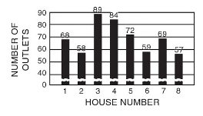

2. The materials charged to a wiring job are as follows: 100-ampere distribution panel $118; meter switch $38; conduit $64; number 2 wire $88; BX cable $73; conduit fittings $26; outlet boxes $153; switches $112; fixtures $215 and $64 for wire nuts, grounding clips, staples and pipe clams. What is the total amount charged for these materials?

3. A bearing on a large machine is tested over a period of 8 hours at a speed of 40500 revolutions per hour. How many revolutions does the shaft turn in the bearing during the test period?

4. A total load of 25,620 watts is distributed equally over the 5 branch circuits shown. What is the average load per circuit in watts?
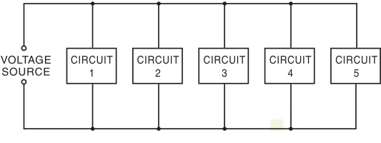

5. Box A and box B each contain type C connectors. Box A contains 200 connectors and costs $30. Find the cost of box B, which contains 250 connectors. The unit price is the same for both boxes. [$37.50]

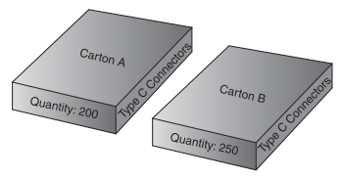

6. A child weighing 23 kg is prescribed 8 mcg/kg/day 12 hourly. How much should be given in a single dose?

7. A client who weighs 60 kg is to be given a drug at 2 mg/kg. Stock strength is 40 mg/2 ml. What volume of the drug should they be given?

8. Betsy recently graduated from St. Lawrence College Personal Support Worker Program. She is trying to decide what environment she would enjoy working in. Betsy’s annual income will vary depending on where she decides to work.
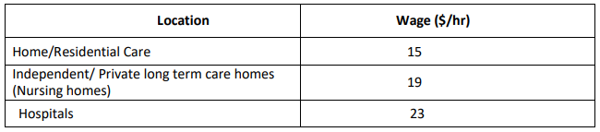

- How much would Betsy earn in one week if she works with homes/residential care? (Assume that she will work 40 hours per week.)

- How much would Betsy earn in one week if she works in an independent/private long-term care home? (Assume that she will work 40 hours per week.)

- How much would Betsy earn in one week if she works in the hospital? (Assume she will work 40 hours.)

- How much would Betsy make in one year (52 weeks), in the home/residential, nursing home/private long-term care homes and in a hospital?

6. On occasion, when working in a nursing home, PSWs will be responsible for making orders of essential supplies.

The following items are needed for the nursing home:

- 500 adult diapers
- 12 bottles of powder
- 6 antibiotic ointments
- 5 boxes of gloves
- 125 syringes

To make the order, the following chart will to be completed. Keep in your mind what is NEEDED, and then make sure that amount is covered by the order. You cannot order small parts of anything listed, just one or more.

