**TRIGONOMETRY**

|  |
| --- |
| ______________ is the branch of mathematics dealing with the relations of the sides and angles of triangles and with the relevant functions of any angles. Simply, it helps us calculate the distance and angles.  **KEY WORDS**  Trigonometry  Right  Hypotenuse  Adjacent  Opposite  Sine  Cosine  Tangent  Right  SOH  CAH  TOA  The triangle with a 90 degree is called a ___________ triangle.  **Labelling** the right triangle right is the most crucial step in trigonometry.  The **______________** is always the longest side, across from the right angle. The other two sides are named either ‘**side __________** or ‘**side __________** depending on the location of **reference angle** θ (theta). |

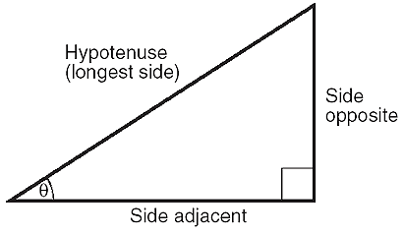 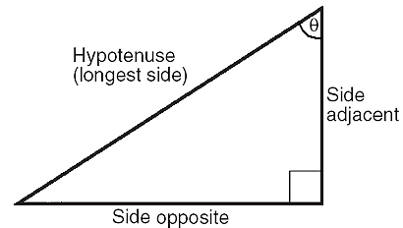

|  |  |  |  |  |  |  |  |
| --- | --- | --- | --- | --- | --- | --- | --- |
| **Ex1.** In, label the hypotenuse (H), adjacent (A) side, and opposite (O) side for θ   |  |  | | --- | --- | | θ |  | | **Ex2.** In, label the hypotenuse (H), adjacent (A) side, and opposite (O) side for θ.   |  |  | | --- | --- | | θ |  | |  | |  | |

**PRIMARY TRIGONOMETRIC RATIOS**

|  |
| --- |
| By definition, **ratio** is the comparison of two or more quantities with the same units. There are **three** primary trigonometric ratios: _______, ________ and ____________  Primary trig ratios help us calculate angles and lengths in construction, navy, landscaping, electricity, etc.  We can use the acronym _______-_______-_______ to help us remember the trigonometric ratios. |

**Example:** Determine the primary trig ratios for the following triangle

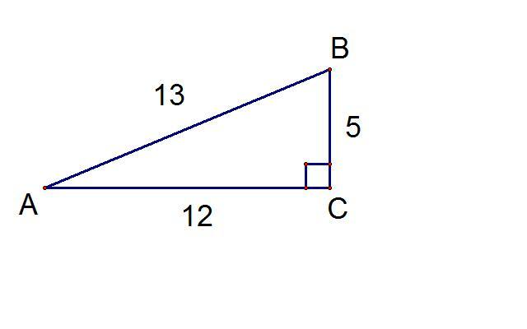

θ

**sin** θ**o=**

**cos** θ**o=**

**tan** θ**o=**

**FINDING SIDE LENGTHS**

|  |
| --- |
| **Solved example** 1: Find the length of side AC to the nearest tenth.  **Step 1**:  Label the sides of your triangle relative to the given angle    H  *Note: Do not label side BC.  O  **3 Steps to Solving**  **Step 1**:  Label the sides of your triangle relative to the given angle  **Step 2**:  Determine which trig ratio to use (sin, cos, tan)  **Step 3**:  Set up the equation with the unknown side and solve.  **Step 2**:  Determine which trig ratio to use (sin, cos, tan)  Side lengths AB and AC give us the letters OH; therefore, we can calculate the sine ratio. Or simply choose the matching ratio from SOH CAH TOA. OH is only in SOH.  **Step 3**:  Set up the equation with the unknown side and solve. $\sin{25=}\frac{O}{12}$ * multiply both side with 12 $12×\sin{25=}\frac{O}{12}×12$ * 12 on the right side will cancel $5.1=O$   ∴ Side AC is approximately 5.1 cm. |

|  |
| --- |
| **Solved example 2**: Find the length of side BC to the nearest tenth.    A  H $\cos{10=}\frac{15}{H}$ * multiply both sides by H $H×\cos{10=}\frac{15}{H}×H$ * H on the right side will cancel. $H×\cos{10=}15$ * Divide both sides by cos10 to leave H by itself on left side $$H×\cos{10÷\cos{10}=}15÷\cos{10}$$ $$H=15÷\cos{10}$$ ∴ Side AB is approximately 15.2 m. |

**Practice**

1. Identify the opposite, adjacent, and hypotenuse sides associated with the indicated angle.

|  |  |  |
| --- | --- | --- |
| a) | b) | c) |

1. Using your calculator, evaluate the following ratios. Round your answers to three decimal places.

|  |  |  |
| --- | --- | --- |
| a) | b) | c) |

1. Find the length of the unknown side, rounded to one decimal.

|  |  |
| --- | --- |
| a) | b) |
| c) | d) |

1. Find the measures of sides x and y to the nearest tenth of a metre.

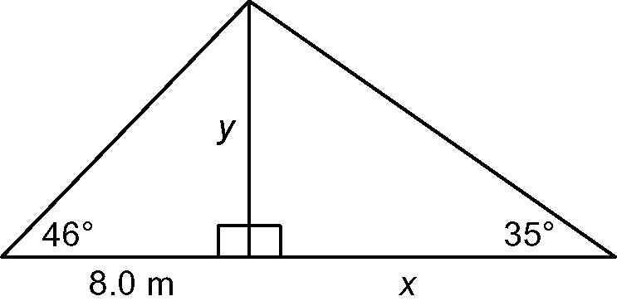

1. Based on the following diagram use the values given to find the missing side indicated.

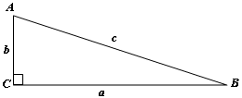a) find *a*

*Diagram is NOT drawn to scale*

b) find *b*

c) find *b*

d) find *a*

**COMPLETE p. 8 #3, 4, 5, 6**