TRIGONOMETRY

calculate the:

calculate the:

SINE
LAW
COSINE
LAW
TRIG RATIOS
$$sinθ, cosθ, tanθ$$
TRIANGLE MEASUREMENT

LABELLING TRIANGLES
To label any triangle, use:  1. CAPITAL letters for the ___________________.  2. Corresponding small letter for the ___________  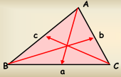  opposite the corresponding _______________ . | Reference Angle is an acute angle used to label a right triangle. It can be represented by a CAPITAL letter or by a SYMBOL (A, θ, or β ).  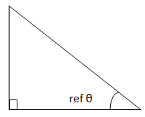

THE THREE PRIMARY TRIG RATIOS
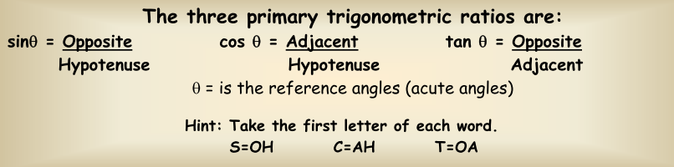

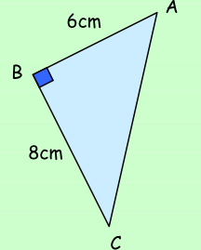
1. Determine the following ratios for the given right triangle.
a. cos A b. tan C

2. Using your calculator, determine each trigonometric ratio to FOUR decimal places.
a. cos32º = b. tan 75º = c. sin 25º =

3. Determine the length of x in each triangle.
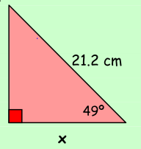 | 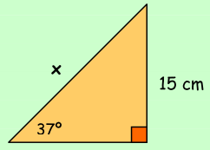

4. Solve the triangle. (Solve in this context means to find out every unknown: sides and angles.)
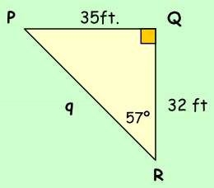

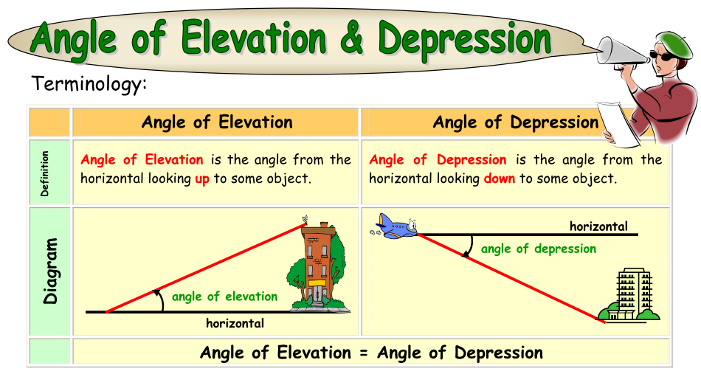
Ex1. A plane is coming down for a landing at YYZ. The angle of depression is 22º. The plane is 350 m from the ground. Determine the distance from the plane to the airport.

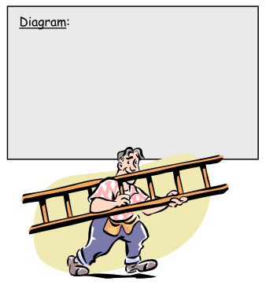
Ex2. A carpenter leans a ladder against a wall at an angle of 68º. The distance from the foot of the ladder to the wall is 36 inches. Draw a diagram with the given information.
a. How long is the ladder?
b. How high up is the ladder?

DETERMINING ANGLES USING TRIG RATIOS
1. Determine the measure of each angle to the nearest degree.
a) sin A = 0.350 | b) cos M = 0.8721 | c) tan B = 3/4 | d) sin X = 1/2

2. Calculate the measure of $∠A$ to the nearest degree.
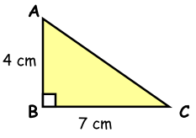

3. Solve the triangle. (ROUNDING: Angles nearest degree, Sides one decimal place)
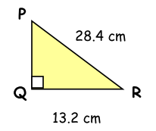

4. Suppose a tree 50 feet in height casts a shadow of length 60 feet. What is the angle of elevation from the end of the shadow to the top of the tree with respect to the ground?

