|  |
| --- |
| **QUADRATIC** **FUNCTION:**  **QUADRATIC** **EQUATION**: |

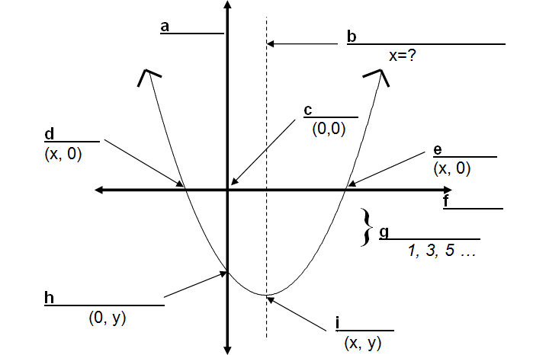

|  |  |  |
| --- | --- | --- |
| 1. **Standard Form**:      * Shows direction of opening * Best form if you need the y-intercept (let x = 0) | 1. **Vertex form**:      * Shows direction of opening   Best form if you need the max/min value (*k*) and when it occurs (when *x* = *h*) | 1. **Factored Form**:      * Shows direction of opening * Best form if you need *x*-intercepts (let *y* = 0) * If you want to determine the max/min you must first   expand it and write it in standard form and then complete the square |

**PROPERTIES OF QUADRATIC FUNCTIONS**

**Forms of Quadratic Functions**

Standard form: y = ax2 + bx + c y-intercept: (0, c)

Factored form: y = a(x – p)(x – q) roots, zeros, x-intercepts: (p, 0), (q, 0)

Vertex form: y = a(x – h)2 + k vertex: (h, k)

**Direction of opening** – either up or down

If a > 0, the parabola opens up; if a < 0, the parabola opens down.

**Roots** – x values where the equation is equal to zero; the solutions to ax2 + bx + c = 0

**Zeros** – x-intercepts; where the parabola crosses the x-axis; where the function is equal to zero

To determine roots/zeros, set the function equal to zero and solve by factoring or by using the quadratic formula. You can also solve by completing the square.

* There will be either 0, 1, or 2 roots/zeros!

**Vertex** – “turning point” of the parabola

* To determine the vertex from standard form, complete the square to write the equation in vertex form.
* To determine the vertex from factored form, find the x value that is halfway between the 2 zeros using the mean formula: . To find the y-coordinate, substitute the mean x value into the original equation [ y = a(x – p)(x – q) *or* y = ax2 + bx + c]. The vertex is (x, y).

**Optimal Value** – the maximum or minimum value; the optimal value is the y value of the vertex

**Axis of symmetry**

– The parabola is *symmetric* with respect to this line

- If the coordinates of the vertex are (h,k), then the axis of symmetry is x = h.

To determine the axis of symmetry, find the mean x value for two points with equal y-values.

**Methods for Writing Quadratic Functions in Different Forms**

1. Each function is given in **standard** form. Factor fully to write the functions in **factored** form :
2. 
3. 
4. 
5. 
6. Each function is given in **standard** form. Complete the square to write the functions in **vertex** form :
7. 
8. 
9. 
10. 
11. Expand to re-write each function in **standard** form :
12. 
13. 
14. 
15. 
16. 

|  |
| --- |
| **Selected Solutions/Answers:**  1d)  2c) |