INVESTIGATE:
KEY WORDS
Ordered Pairs: Use braces {(x, y)} to list the values, or elements, in a set. {(1,3), (2,5)}
Domain: the set of all values of the independent variable (x) of a relation.
Range: the set of all values of the dependent variable (y) of a relation.
Relation: a set of ordered pairs; values of the independent (x) variable are paired with values of the dependent (y) variable.
Function: It is a special relation in which “x” value cannot match with more than one “y” value.
The ages and soccer practice of four students are listed.
Student | Age | Soccer Practice Day
Jay | 15 | Tuesday
Joe | 16 | Tuesday
Jen | 15 | Thursday
Jill | 17 | Saturday

Determine whether or not the relations below are functions.

a) students and the day for soccer practice
b) ages and the day for soccer practice

Method 1: ORDERED PAIRS (Set Notation)
a) students and the day for soccer practice  Write the relation as a set of ordered pairs.  {(Jay, Tue),  Read the definition of domain and range. List below.  Domain = { }  Range = { }  Read the definition of relation and function.  Conclusion: Is this relation a function? Justify. | b) ages and the day for soccer practice  Write the relation as a set of ordered pairs.  {(15, Tue),  Read the definition of domain and range. List below.  Domain = { }  Range = { }  Read the definition of relation and function.  Conclusion: Is this relation a function? Justify.

Method 2: MAPPING DIAGRAM
a) students and the day for soccer practice  google “mapping diagram” and draw the mapping diagram of the relation below.  Domain =  Range =  Conclusion: Is this relation a function? Justify. | b) ages and the day for soccer practice  google “mapping diagram” and draw the mapping diagram of the relation below.  Domain =  Range =  Conclusion: Is this relation a function? Justify.

Method 3: GRAPHING (Vertical Line Test)
VLT: If any vertical line intersects the graph of a relation more than once, then the relation is not a function.
a) students and the day for soccer practice  Plot the dependent and independent values below.  Conclusion: Is this relation a function? Justify. | b) ages and the day for soccer practice  Plot the dependent and independent values below.  Conclusion: Is this relation a function? Justify.

“All functions are _____________, but not all relations are functions.”
Method 4: EQUATION
If a relation is a function, substituting any value for $x$ will result in only one value of $y$. Do you think all of the following relations are functions?
a) $y=2x+1$ b) $x^{2}+y^{2}=25$

c) $y=2x^{2}-3x+1$

PRACTICE
1) Looking at these graphs, which ones are functions?
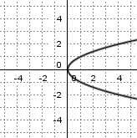
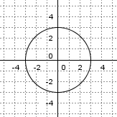
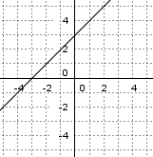

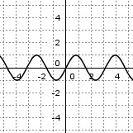
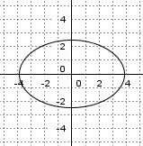
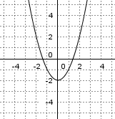

2) State if the following set of ordered pairs is a relation or function? Justify.
b) $\{(1, 3), (2, 4), (3, 5), (4, 6)\}$ b) $\{(1, 3), (1, 4), (2, 5), (3, 6)\}$

3. Use the mapping diagram:
- write the set of ordered pairs of the relation
- state if the relation is a function
2
5
8
11
14
- 5

-1
0

5
8

8
1
2
3
4
5
6
7
1
2
3
4
5
6
7
i) ii)

Domain = { Domain = {
Range = { Range = {

4. Draw a mapping diagram of $y=5$ with a domain of $D=\{1,2,3,4,5,6\}$. Is this a function?

5. Draw a mapping diagram of $x=3$ with a range of $R=\{1,2,3,4,5,6\}$. Is this a function?

6. Make an example of a mapping diagram of a function, and one that is not a function.

7. Draw an example of a graph that is a function and one that is not a function.

