|  |
| --- |
| **Warm-Up:** The equation *h* = -0.025x2 + x represents the height, *h*, in metres of one kick of a soccer ball  and the horizontal distance, *d*, in metres from the place on the ground where the ball was kicked.   * Enter the equation into the online DESMOS and **GRAPH**.  1. Copy the graph on the grid provided.        1. How far away is the ball when it is at a height of 0m?   These points are called the:  _____________  _____________  _____________  _____________  *The ball is at a height of 0 m at x = __________ and x = __________*   1. How far away does the ball land?   *Therefore, the ball lands at x = ____________*   1. How far away is the ball when it is at a height of 8 m?   *The ball is at a height of 8 m at x = __________ and x = __________*   1. Over what horizontal distance is the ball at or over a height of 8 m?   *The ball is at or over a height of 8 m over a distance of ___________* |

***These are called quadratic equations***

Let’s Look at this Algebraically:

1. a. For Question 1, what is the height of the ball when it lands? *h* = ________

b. Substitute that value into the equation: __________________________

1. For Question 2, substitute the height of 8 m into the equation: _______________________

|  |
| --- |
| **Quadratic Equations** are equations with a degree of 2 (recall: that means that the highest exponent is 2).  They can look like this in **standard** form: , although the middle or last term could be missing  They can look like this in **vertex** form: $a{(x-h)}^{2}+k=0$.  They can look like this in **factored** form: $a\left(x-r\right)\left(x-s\right)=0$ The **solutions** to a quadratic equation are the same as the **zeros/x-intercepts**. |

If we didn’t have the graph available, we would need to solve these equations for ***d*** algebraically.

Solving any equation is just determining the value of the variable that makes the equation true (LS=RS).

0 = -0.025*d*2 + *d*

8 = -0.025*d*2 + *d*

In cases like these: they can’t be solved using traditional methods (i.e. isolation), since the *d*2 and *d* are not like terms.

There are many ways to solve Quadratic Equations: - Graphing - Factoring

- Isolation (in some cases) - Formula

- Completing the Square

**Quadratic Applications**

1. A football is kicked straight up in the air. Its height above the ground is approximated by the equation , where *h* is the height in metres and *t* is the time in seconds.
   1. Complete this table of values & graph the relationship.

|  |  |
| --- | --- |
| ***t*** | ***h*** |
| 0 |  |
| 1 |  |
| 2 |  |
| 3 |  |
| 4 |  |
| 5 |  |

* 1. For how long is the ball in the air? _______________
  2. What number would you substitute into *h* in this equation to solve the problem above? ______
  3. When does the ball reach a height of 20m? _______________
  4. What number would you substitute into *h* in this equation to solve the problem above? ______

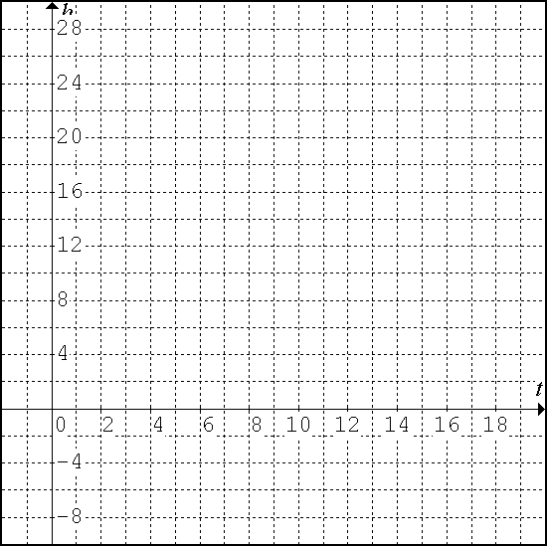

1. The equation represents the flight of a plastic glider launched from a tower on a hilltop. A height of 0m represents when the glider is at the same height as the hilltop.

Use the graphing calculator to determine the times when the glider is at the same height as the hilltop. Match your settings to those shown in the graph, and use the table function to help graph it on the right.

1. 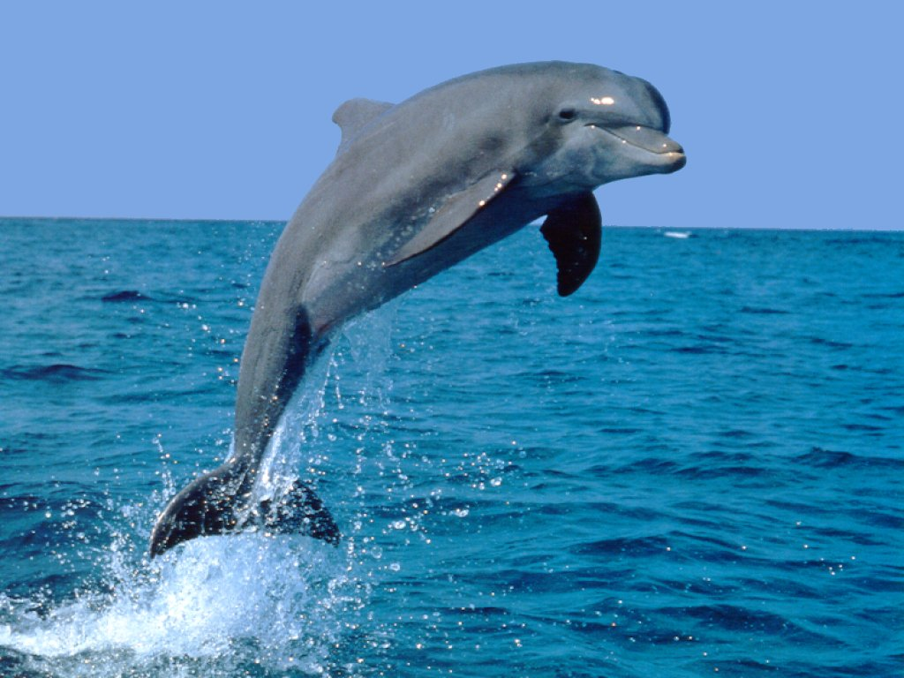The path a dolphin travels when it rises above the ocean’s surface can be modelled by the equation: , where *h* is the height of the dolphin above the water’s surface and *d* is the horizontal distance from the point where the dolphin broke the water’s surface, both in feet. When will the dolphin reach a height of 1.8 feet? (at 1 and 9 sec)

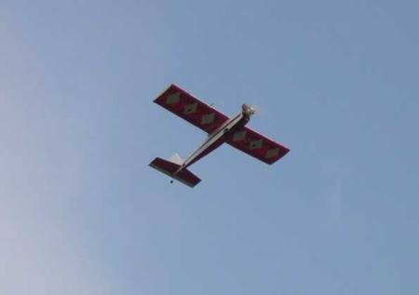

* + - * 1. A model airplane is shot into the air. Its path is approximated by the equation , where *h* is the height in metres and *t* is the time in seconds. When will the airplane hit the ground? (5 sec)



1. Snowy’s Snowboard Co. manufactures snowboards. The company uses the equation  to model its profit, where *P* is the profit in thousands of dollars and *x* is the number of snowboards sold, in thousands. How many snowboards must be sold for the company to break even (i.e. that is when the profit, *P*, is 0). (6000)
2. A rock is thrown down from a cliff that is 180 m high. The equation  gives the approximate height of the rock above the water, where *h* is the height in metres and *t* is the time in seconds. When will the rock reach a ledge that is 105 m above the water? (3 sec)

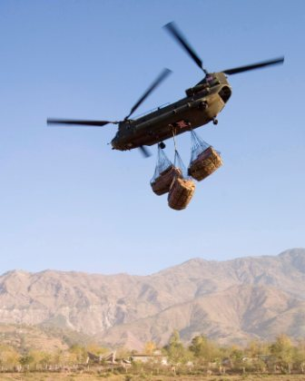

1. A helicopter drops an aid package. The height of the package above the ground at any time is modelled by the equation , where *h* is the height in metres and *t* is the time in seconds. How long will it take the package to hit the ground? (9 sec)
2. Nintendo models the profit of its Super Mario Galaxy 2 game using the equation , where *x* is the number of games, in thousands, that the company produces and *P* is the profit, in millions of dollars. What are the break even points? (i.e. that is when the profit, *P*, is 0). (5000 and 11000)
3. A stone is tossed from a bridge. Its height as a function of time is given by , where *t* is the time, in seconds, and *h* is the height of the stone above the ground, in metres, at time *t*. For how long is the stone in the air? (4 sec)
4. 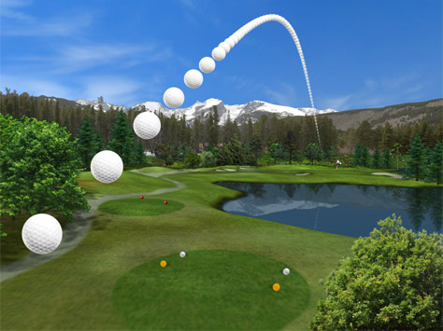Biff, the koala, has climbed to the top of a eucalyptus tree and is tossing down loose branches to koala Rocco. The height of the falling branches is modelled by the equation , where *h* is the height of a branch above the ground, in metres, and *t* is the time, in seconds. How long does it take for a branch of the eucalyptus to reach Rocco? (3 sec)
5. The relationship between the height of a golf ball after it has been hit, *h* metres, and the time the ball is in the air, *t* seconds, is given by . For how long is the ball in the air? For how long is the ball above 367.5 (20 sec, 10 sec)