|  |
| --- |
| Go to 300math.weebly.com, Unit 2&3, Day 2  [http://t1.gstatic.com/images?q=tbn:ANd9GcScy7LsBXdnU0ZXuyZawDGiuEWyk6-YmHd5yWV15gkzkDqVa77DyQ](http://www.google.ca/imgres?q=laptop+clip+art&hl=en&biw=1107&bih=617&gbv=2&tbm=isch&tbnid=NCV1SFw5DngSLM:&imgrefurl=http://www.computerclipart.com/computer_clipart_images/laptop_computer_coloring_page_0521-1004-3015-4009.html&docid=8PRvVSxIIGKSiM&w=300&h=270&ei=yjpDTorsDpDegQfRx-HGCQ&zoom=1)Click **Start** “Discovering Midpoints” |

**Task 1: The Midpoint Formula**

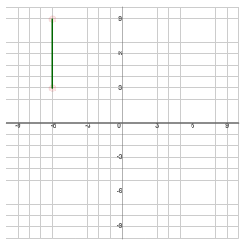

**VERTICAL LINE SEGMENTS**

**What is the midpoint of the line segment AB?**

A (-6, 9)

B (-6, 3)

M ( , )

**How can the midpoint be determined using a mathematical calculation instead of counting the number of squares?**

**Answer:**

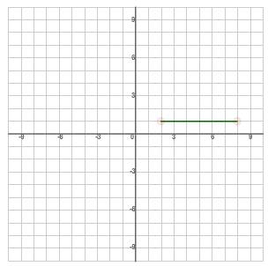**HORIZONTAL LINE SEGMENTS**

**What is the midpoint of the line segment AB?**

A (2, 1)

B (8, 1)

M ( , )

**How can the midpoint be determined using a mathematical calculation instead of counting the number of squares?**

**Answer:**

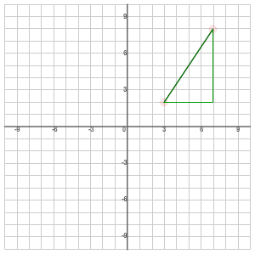**DIAGONAL LINE SEGMENTS**

**What is the midpoint of the line segment AB?**

A (3, 2)

B (7, 8)

**First, find the values**

**Next, find the values**

**Midpoint = ( , )**

**Summary:**

|  |
| --- |
| **Formula for the Midpoint of a Line Segment:**  midpoint =  midpoint = |

**Task 2: Practice**

* Complete the 5 practice examples in Discovering Midpoints.

**Task 3: Application**

M is the midpoint of line segment UP. The coordinates of U are (-2, 3) and the coordinates of M

are (1, 0). Find the coordinates of P.

