POINT OF INTERSECTION (POI)
A group of lines studied together is called a __________________________________.
To solve a _________________, we find the ________________________________.
This point is called ____________________________, ________________________ and _______________________

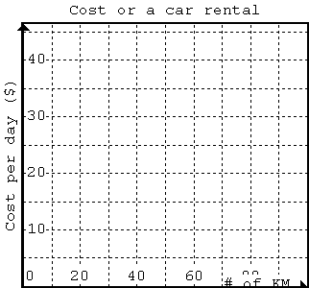
FINDING POI GRAPHICALLY

A car rental agency offers two daily rental plans. Write the equation for each plan. (Let c be cost and k be km driven)
Plan A: $20 per day plus $0.25/km _______________
Plan B: $10 per day plus $0.50/km _______________
Graph each plan using the table of values
PLAN A |  | PLAN B
k (km) | c ($) | k (km) | c ($)
0 |  | 0
20 |  | 20
40 |  | 40
60 |  | 60

Determine the coordinates of POI (__ , __)

CHECKING POI ALGEBRAICALLY
We sometimes need to check if our solution is correct algebraically. This way we will prove that we graphed both lines correctly. If we know the “x” coordinate of a point, we substitute the numerical value of x for x into an equation to produce the “y” coordinate. Since POI is a shared point on both lines; therefore, when the x value plugged into both equations we must have the same y value.
Write the equations for both plans in the chart below and plug the x coordinate of POI in each equation. If LS = RS in both equations, we just proved that we graphed both lines correctly and our POI is verified.
PLAN A = |  | PLAN B =
LS | RS | LS | RS

FINDING POI ALGEBRAICALLY
In the previous example we found out the following equations for each plan:
PLAN A | PLAN B
c = 0.25k + 20 | c = 0.50k + 10

Step 1: Determining the “x” coordinate of POI
Graphically we found out that c values are the same at POI. Therefore, we can substitute the expression of c for c in plan A in plan B. It sounds complicated but algebraically this is how it looks:

Step 2: Determining the “y” coordinate of POI

TRY: Determine the POI of the following system algebraically and verify your answer using LS = RS in both equations.
Equation 1 y = 3x – 10 Equation 2 y = 5x - 18

