**DETERMINING ANGLES IN RIGHT TRIANGLES**

|  |  |  |  |  |  |  |
| --- | --- | --- | --- | --- | --- | --- |
| RECALL the three primary trigonometry ratios.  **KEY WORDS**  Opposite/Hypotenuse  Adjacent/Hypotenuse  Opposite/Adjacent  Inverse  Sin-1  Cos-1  Tan-1  acute  measure  two   |  |  |  | | --- | --- | --- | |  |  |  |   For every trigonometry ratio there is an __________ ratio. It is used to calculate **ANGLES**. Inverse ratios are usually found on a scientific calculator by using the 2ndF, INV, or SHIFT key   |  |  |  | | --- | --- | --- | | The inverse for **sin** is: _______ | The inverse for **cos** is: ________ | The inverse for **tan** is: ________ | |

**CASE A) DETERMINING THE ANGLE WITH INVERSE RATIO**

**Solved Example**: Calculate the angles given. Round your answer to whole degree.

|  |
| --- |
| sin *θ* = 0.667 *swap *θ with 0.667*  sin-1 0.667 = *θ* *sin becomes sin-1  *θ = 4* |

**Example**: Calculate each of the angles given. Round your answer to whole degree.

|  |  |
| --- | --- |
| a) cos *θ* = 0.667 | b) tan *θ* = 0.667 |
|  |  |

**CASE B) DETERMINING THE ANGLE FROM THE TRIANGLE**

To find the measure of a(n) ________ angle in a right-angle triangle, it is necessary to have the _____________ of any _________ sides of the triangle.

**3 Steps to Solving ANGLES**

**Step 1**: Label the sides of your triangle relative to the angle you want to find

**Step 2**: Determine which trig ratio to use (sin, cos, tan)

**Step 3**: Set up the equation with the unknown and solve using the ***inverse*** trig ratio (sin-1, cos-1, or tan-1).

|  |
| --- |
| **Solved Example:** Determine the angle shown to the nearest degree.  **Step 1:**    **Step 2: with sides O and A we calculate tan ratio**  **Step 3: $tan θ=\frac{6}{8}$**  *swap 6/8 with $θ$ $$\tan^{-1}{\frac{6}{8}}=θ$$ ∴ Angle $θ$ is approximately 37o. |

**PRACTICE**

**Example**: Find each of the angles shown, rounded to one decimal place.

|  |  |  |
| --- | --- | --- |
| a) Find | b) Find | c) Find |

1. Evaluate each of the following to the nearest degree.

|  |  |  |
| --- | --- | --- |
|  |  |  |
|  |  |  |

1. Find each of the angles shown. Round to one decimal.

|  |  |
| --- | --- |
|  |  |
|  |  |

1. Find the length of side x to the nearest tenth of a metre and of angle θ to the nearest degree.

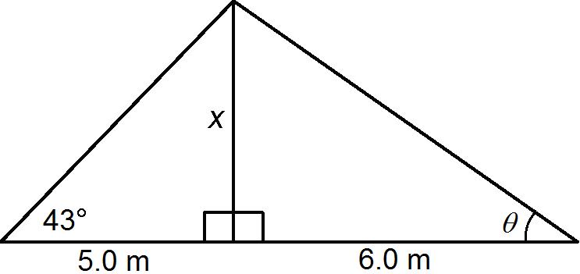

1. Based on the following diagram use the values given to find the missing angles indicated.

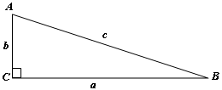a) *a* = 55 m, *b* = 137 m 🡪 find ∠*A*, ∠*B*

*Diagram is NOT drawn to scale*

b) *a* = 235 cm, *c* = 268 cm 🡪 find ∠*A*, ∠*B*

c) *b* = 21 mm, *c* = 40 mm 🡪 find ∠*A*, ∠*B*

d) *a* = 30 cm, *b* = 285 cm 🡪 find ∠*A*, ∠*B*