**Primary Trigonometry Ratios – Finding Angles**

RECALL the three primary trigonometry ratios.

|  |  |  |
| --- | --- | --- |
|  |  |  |

For every trigonometry ratio there is an ________________ ratio. It is used to calculate **ANGLES**. Inverse ratios are usually found on a Scientific calculator by using the 2ndF, INV, or SHIFT key

The inverse for **sin** is: ________ The inverse for **cos** is: ________ The inverse for **tan** is: ________

**Example**: Calculate each of the angles given. Round to one decimal place.

|  |  |  |
| --- | --- | --- |
| a) sin *θ* = 0.667 | b) cos *θ* = 0.667 | c) tan *θ* = 0.667 |

To find the measure of a(n) _______________ angle in a right angle triangle, it is necessary to have the _______________ of any _________ sides of the triangle.

3 Steps to Solving ANGLES

**Step 1**: Label the sides of your triangle relative to the angle you want to find

**Step 2**: Determine which trig ratio to use (sin?, cos?, tan?)

**Step 3**: Set up the equation with the unknown and solve using the ***inverse*** trig ratio (sin-1, cos-1, or tan-1).

**Example**: Find each of the angles shown, rounded to one decimal place.

|  |  |  |
| --- | --- | --- |
| a) Find | b) Find | c) Find |

**Primary Trigonometry Ratios – Angles Practice**

1. Evaluate each of the following to the nearest degree.

|  |  |  |
| --- | --- | --- |
|  |  |  |
|  |  |  |

1. Find each of the angles shown. Round to one decimal.

|  |  |
| --- | --- |
|  |  |
|  |  |

1. Find the length of side x to the nearest tenth of a metre and of angle θ to the nearest degree.

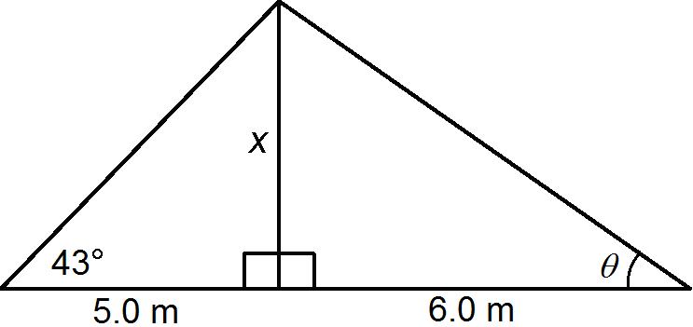

1. Based on the following diagram use the values given to find the missing angles indicated.

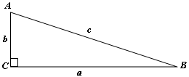a) *a* = 55 m, *b* = 137 m 🡪 find ∠*A*, ∠*B*

*Diagram is NOT drawn to scale*

b) *a* = 235 cm, *c* = 268 cm 🡪 find ∠*A*, ∠*B*

c) *b* = 21 mm, *c* = 40 mm 🡪 find ∠*A*, ∠*B*

d) *a* = 30 cm, *b* = 285 cm 🡪 find ∠*A*, ∠*B*