RATE OF CHANGE (ROC)
The rate at which something is changing. The ROC is often indicated by the slope of a graph.
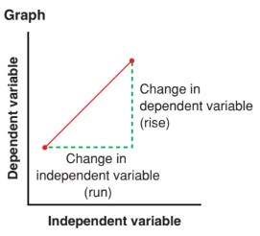
A
B
We can determine an average rate of change using a table or graph

Independent Variable (x) | Dependent Variable (y)
x₁ | y₁
x₂ | y₂
Table: Graph:

POINT A

POINT B

Average ROC (slope) = $\frac{rise}{run}=\frac{y_{2}-y_{1}}{x_{2}-x_{1}}$

CALCULATING AND INTERPRETING RATES OF CHANGE

EXAMPLE 1: Calculate the average rate of change between each pair of points. Explain what the rate of change means.
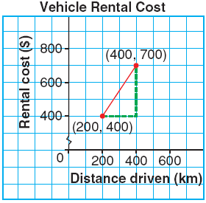
- Altitude of an Airplane b)

Time (min) | Airplane Height (m)
0 | 2000
4 | 1400

EXAMPLE 2: The graph below represents the relationship between the number of hours worked and the weekly salary an employee earns.
Calculate both rates of pay from the graph. | 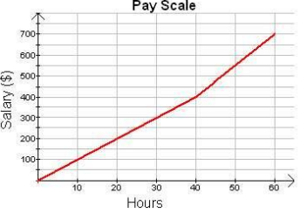

COMPARING RATES OF CHANGE

EXAMPLE 3: The distance required to stop a car depends on the speed at which the car is travelling. Use the tables below (showing the reaction distance and breaking distance needed to stop a car on dry pavement for given speed) to answer the following.
Speed  (km/h) | Reaction  Distance (m) | $$\frac{change in distance}{change in speed}$$ |  | Speed  (km/h) | Stopping  Distance (m) | $$\frac{change in distance}{change in speed}$$
0 | 0 | $$\frac{2-0}{10-0}=\frac{2}{10}=0.2$$ |  | 0 | 0.0 | $$\frac{0.5-0}{10-0}=\frac{0.5}{10}=0.05$$
10 | 2 |  |  | 10 | 0.5
20 | 4 |  |  | 20 | 2.0
30 | 6 |  |  | 30 | 4.5
40 | 8 |  |  | 40 | 8.0
50 | 10 |  |  | 50 | 12.5
- Calculate the average rate of change between consecutive points in each table. Describe the rates of change revealed in each table.
The rates of change are _________ at 0.2. The rates of change are _____________.
The reaction distance increases by ______ m for 1 km/h
- Graph the data in the tables. Describe how the graph reflects the rates of change across the data.
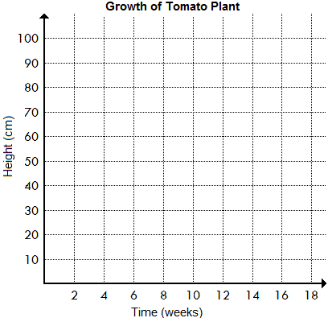  10  8  6  4  2  Reaction Distance  10 20 30 40 50  Speed | 10  8  6  4  2  Stopping Distance  10 20 30 40 50  Speed

EXAMPLE 4 The table below shows the change in height of a tomato plant from germination until the tomato ripens.
Time (weeks) | Height  (cm)
0 | 0
2 | 5
4 | 10
6 | 20
8 | 40
10 | 58
12 | 75
14 | 86
16 | 90
18 | 90

- Graph the data then determine when the rate of change (slope) in the height is:
i) Zero: ii) Constant: iii) Changing:

- When is the rate of change in height the greatest?

- Describe the growth of the plant.

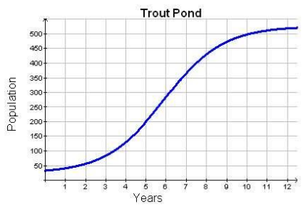
EXAMPLE 5: Conservationists introduce a small number of trout into a pond. The graph below illustrates the population growth over many years.
a) Is the rate of change of the population constant? Explain how you reasoning.

b) When is the population growing the slowest and fastest? Why might the population growth follow this pattern?

