**IDENTIFYING VARIABLES**

When looking at the relationship between the **variables**, one must decide which variable most likely depends on the other.

|  |  |
| --- | --- |
| **INDEPENDENT VARIABLE** | **DEPENDENT VARIABLE** |
| In a relation, the variable whose values you choose. The variable thatdoes **NOT** depend on the other variable. | In a relation, the variable whose values you calculate. The variable that ***depends*** on the other variable. |

Identify the independent variable and dependent variable for the questions below:

|  |  |  |
| --- | --- | --- |
| **Question** | **Independent**  **Variable** | **Dependent**  **Variable** |
| 1. What effect does the **outdoor temperature** have on the **amount of fuel** needed to heat a house? |  |  |
| 2. Is there a relationship between people’s **ages** and their **heights**? |  |  |
| 3. Is there a relationship between the **outside** **temperature** and the **number of hot chocolates** sold? |  |  |
| 4. Is there a relationship between **cost** to fix a car and **hours** worked by the mechanic? |  |  |

**Dependent variable**

is placed on the vertical axis

**Independent variable** is placed on the horizontal axis

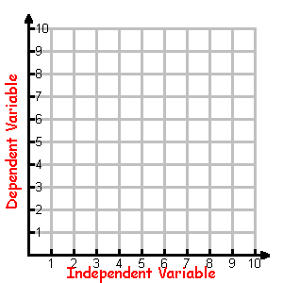

|  |  |
| --- | --- |
| **Independent** **Variable** | **Dependent**  **Variable** |
|  |  |
|  |  |
|  |  |
|  |  |
|  |  |

**Independent variable** is placed in the left-hand column or the top row

**Dependent variable** is placed in the right-hand column or the bottom row

|  |  |  |  |  |
| --- | --- | --- | --- | --- |
| Independent Variable |  |  |  |  |
| Dependent Variable |  |  |  |  |

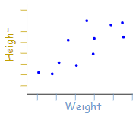**SCATTER PLOT**

A scatter plot has points that show the relationship between two sets of data.

In this example, each dot shows one person’s weight versus their height

**Example:** The local ice cream shop keeps track of how much ice cream they sell versus the noon temperature on that day. Here are their figures for the last 12 days.

|  |  |  |  |  |  |  |  |  |  |  |  |  |
| --- | --- | --- | --- | --- | --- | --- | --- | --- | --- | --- | --- | --- |
|  | **ICE CREAM SALES vs TEMPERATURE** | | | | | | | | | | | |
| Temperature oC | 14 | 16 | 12 | 15 | 19 | 22 | 20 | 25 | 19 | 26 | 23 | 18 |
| Ice Cream Sales ($) | 215 | 325 | 185 | 332 | 406 | 522 | 412 | 614 | 544 | 421 | 445 | 408 |

|  |  |  |  |  |  |  |  |  |  |  |  |
| --- | --- | --- | --- | --- | --- | --- | --- | --- | --- | --- | --- |
|  |  |  |  |  |  |  |  |  |  |  |  |
|  |  |  |  |  |  |  |  |  |  |  |  |
|  |  |  |  |  |  |  |  |  |  |  |  |
|  |  |  |  |  |  |  |  |  |  |  |  |
|  |  |  |  |  |  |  |  |  |  |  |  |
|  |  |  |  |  |  |  |  |  |  |  |  |
|  |  |  |  |  |  |  |  |  |  |  |  |
|  |  |  |  |  |  |  |  |  |  |  |  |
|  |  |  |  |  |  |  |  |  |  |  |  |
|  |  |  |  |  |  |  |  |  |  |  |  |
|  |  |  |  |  |  |  |  |  |  |  |  |
|  |  |  |  |  |  |  |  |  |  |  |  |
|  |  |  |  |  |  |  |  |  |  |  |  |
|  |  |  |  |  |  |  |  |  |  |  |  |
|  |  |  |  |  |  |  |  |  |  |  |  |

1. Make a scatter plot of the data.
2. Label the title
3. Identify the independent variable and label the “x” axis.
4. Identify the dependent variable and label the “y” axis.
5. Describe the relationship between the variables.

The _____________ the weather, the ________ sales.

**ANALYZING A SCATTER PLOT**

When the two sets of data are strongly linked together, we say they have a **high correlation.**



* Correlation is **positive** when the values **increase** together
* Correlation is **negative** when one value **decreases** as the other increases.

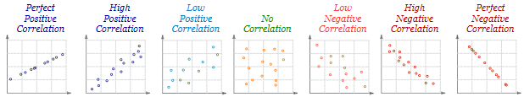

***EXAMPLE*** Classify each of the following scatter plots



***EXAMPLE***

Davis conducted an experiment comparing a person’s leg length and how long it takes to walk 100 m. His data is shown in the scatter plot.

1. 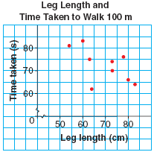What sort of relationship does the graph suggest between leg length and time taken to walk 100 m?
2. Use the scatter plot to estimate the time it would take a person with a leg length of 85 cm to walk 100 m
3. How might Davis make the results of his experiment more reliable?

***CONSIDERING CAUSE & EFFECT***

|  |
| --- |
| Observing a relationship between two variables does not mean that one variable causes a change in the other. Other factors could be involved, or the correlation could be a **coincidence.** Some relationships are natural and/or obvious, while others may have a **common cause** to both variables. |

**EXAMPLE:** State whether the claim in each situation is **reasonable**. If not, determine if there is a **common cause**, or if the relationship is **coincidental**.

1. A scientific study showed a negative correlation between aerobic exercise and blood pressure. It claimed that the increase in aerobic activity was the cause of the decrease in blood pressure.
2. Mila discovered a positive correlation between ice cream sales and the number of drowning incidents. She warned all of her friends not to eat ice cream if they intended on going swimming.
3. Since the 1950s the concentration of carbon dioxide (CO2) in the atmosphere has been increasing. Crime rates in most countries have also increased over this time period. A newspaper reports that the increase in CO2 level in the atmosphere cause people to commit crimes.