**Lesson: Slope**

The **slope** (also called gradient) of a straight line shows how _________ a straight line is.

**To Calculate the Slope**

Divide the **change in height (rise)** by the **change in horizontal distance (run)**

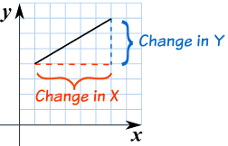

**Rise**

**Slope = $\frac{rise}{run}$**

**Run**

**LEVELS (AMOUNT) OF SLOPE**

|  |  |  |  |  |  |  |
| --- | --- | --- | --- | --- | --- | --- |
|  | **ZERO or**  **LEVEL** | **GENTLE** | **MODERATE** | **STRONG** | **EXTREME** | **STEEP** |
| **SLOPE**  **(%)** | 0% | 2 - 9% | 9 - 15% | 15 - 45% | 45 - 70% | 70% -100% |
| **DEGREE (O)** | 0o | 1.1 - 5o | 5 - 8.5o | 8.5 - 24o | 24 - 35O | 35 - 45o |

**Example**: For each staircase, count squares to determine the rise and the run and calculate the **slope**. Remember , 

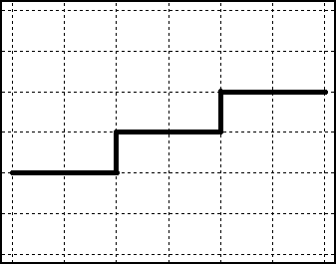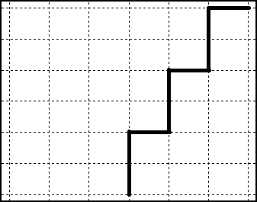

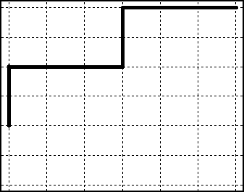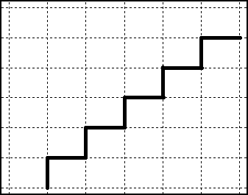   
Rise= Rise= Rise= Rise=

Run= Run= Run= Run=

Slope= Slope= Slope= Slope=

**Thinking**:

Each of the following diagrams represents a wheelchair ramp. Wheelchair ramps cannot have a slope steeper than ¼ or 0.25. Calculate the slope of the following to determine which, if any of these ramps are safe.

|  |  |  |  |
| --- | --- | --- | --- |
|  |  |  |  |
| Rise= | Rise= | Rise= | Rise= |
| Run= | Run= | Run= | Run= |
| Slope= | Slope= | Slope= | Slope= |

**TYPES OF SLOPES**

|  |  |  |  |
| --- | --- | --- | --- |
|  |  |  |  |
| http://www.mathsisfun.com/images/gradient2.gif | http://www.mathsisfun.com/images/gradient4.gif | http://www.mathsisfun.com/images/gradient5.gif | 11 |
| Positive Slope (uphill) | Negative Slope (downhill) | Zero Slope | Undefined Slope |
| ascending, increasing | descending, decreasing | horizontal | vertical |

**o**

**o**

**-**

**+**