CHECKING YOUR ANSWER
Steps:
- Write down the equation
- Draw a vertical line where the equal sign is to make a T-chart
- Sub the answer in for x
- Solve each side separately to see if they are equal
- If both sides are equal, the answer is RIGHT
- If both sides are not equal, the answer is WRONG

Example: Frodo solved the following equation and found out that $x=-2$
Check if his answer is right.
$$4x+25=17$$

Determine if each of the following answers is right by checking.
a) $x^{2}+9=16 Answer x=5$ | b) $\frac{x}{3}-1=13 Answer x=36$ |  | c) $5x-2=18+4x Answer x=20$
d) $4\left(2x+3\right)=10x+6 x=3$ |  | e) $\frac{2x-17}{5}=\frac{5x+7}{4} x=1$

SOLVING EQUATIONS WITH BRACKETS
Steps:
- Apply the distributive property
- Solve for x

1. Solve the following equations:
Teacher | Your Turn
$$3\left(x-2\right)=9$$ | a) $4\left(5+x\right)=-32$ | b) $40=10\left(3x^{2}-8\right)$

2. Solve and check the following equation.
$$2\left(5x+4\right)=68$$

SOLVING EQUATIONS WITH LIKE TERMS
Steps:
- Collect like terms
- Solve for x

1. Solve the following equations:
Teacher | Your Turn
$$3x+2+5x+7=49$$ | a) $-12=-22-x+2-3x$ | b) $6x^{2}+1-x^{2}+5+3x^{2}=206$

2. Solve and check the following equation.
$10x-12-3x=10-1$

PRACTICE
1. Solve the following equations:
a) $5\left(3x+1\right)=35$ | b) $3\left(4x-3\right)=-69$
c) $3\left(4x^{2}-5\right)=33$ | d) $2\left(8+2x^{2}\right)=212$

2. Solve each of the following equations:
a) $12x+4-5x+1=19$ | b) $x+9+4x=-31$
c) $7x^{2}+11-2x^{2}+x^{2}-4=61$ | d) $14=9x+15-7x-1$

3. Solve each of the following equations. Complete the maze by following your answers in order.
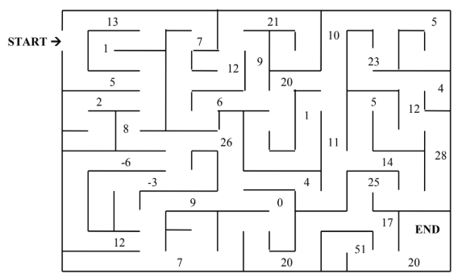

a) $x^{2}-40=129$ | b) $9x+25=34$ |  | c) $\frac{x}{2}+33=37$
d) $2\left(x-5\right)=-16$ | e) $4\left(3x-1\right)=80$ |  | f) $20=5\left(4+2x\right)$
g) $11\left(x-2\right)=22$ | h) $2\left(x+8\right)=38$ |  | i) $5x+3-x-2=41$
j) $3x-14-2x=9$ | k) $-7x+18+3x=-30$ |  | l) $–y+18+6y=43$
m) $5\left(x+1\right)+3\left(3-x\right)=42$ |  | n) $13\left(x+2\right)+2\left(7-6x\right)=65$
o) $5x+14-3x-10-x=21$ |  | p) $-9+7x^{2}+41-5x^{2}-10=822$

