**VOLUME and SURFACE AREA**

**Volume**: The amount of space occupied by an object **Possible Units**: cm3, m3, L, in3

**Surface Area**: The measure of the area of all the faces of an object. **Possible Units**: cm2, m2, in2

**Let’s review the shapes we will deal with:**

|  |  |
| --- | --- |
| **PRISM** | **PYRAMID** |
|  |  |
| **CONE** | **SPHERE** |
|  |  |

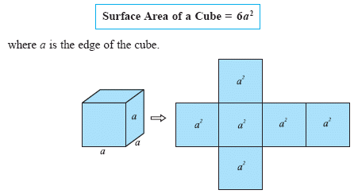**HOW TO FIND THE SURFACE AREA OF A PRISM or PYRAMID**

Follow these steps to find the surface area of most 3D shapes:

1) Draw each shape separately

2) Calculate the area of each shape

3) Add up all the areas

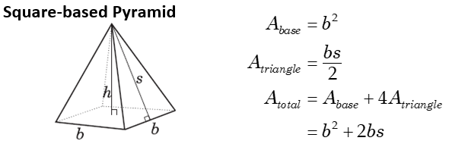

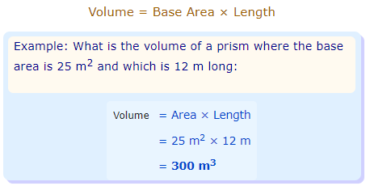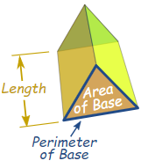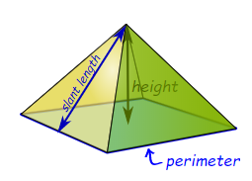**HOW TO FIND THE VOLUME OF A PRISM vs PYRAMID**

To calculate the volume of a prism, multiply the base area by its length (height).

To calculate the volume of a pyramid, multiply the base area by its height, then divide by three.

**VOLUME = 1/3 Base x Height**

**Example:** What is the volume of a pyramid where the base area is 25m2 and has a height of 12 m.

V = 1/3 Base Area x Height

V =

V = ______ m3

**2) HOW TO FIND THE SURFACE AREA OF A CYLINDER and CONE**

Follow these steps to find the surface area of most 3D shapes:

1) Draw each shape separately

2) Calculate the area of each shape

3) Add up all the areas

|  |  |
| --- | --- |
| **CYLINDER** | **CONE** |
| **Surface Area** = 2 × area of circle + area of rectangle  **Surface Area** = 2π*r*2 + 2π*rh*  where *r* is the radius and *h* is the height. | The surface Area has two parts:  **The Base Area** = π*r*2  **The Side Area** = π*rl*  **S.A = $πr^{2}+πrs$** |

**HOW TO FIND THE VOLUME OF A CYLINDER and CONE:**

|  |  |
| --- | --- |
| To calculate the volume we multiply the area of the base by the height of the cylinder:   * Area of the base: π × r2 * Height: h   And we get:  **Volume = π × r2× h** | To calculate the volume we multiply the area of the base by the height of the cone then divide by 3:   * Area of the base: π × r2 * Height: h   And we get:  **Volume = 1/3 × π × r2× h** |
| **Example:** What is the volume of a cylinder with a radius of 3 cm and height of 10 cm?  **Solution:** | **Example:** What is the volume of a cone with a radius of 3 cm and height of 10 cm?  **Solution:** |

**SPHERE:**

|  |  |
| --- | --- |
| **VOLUME** | **SURFACE AREA** |
|  | The surface area of a sphere is **four** times the surface area of one cross section through the centre of the sphere.  A= 4 πr2 |
| [http://t0.gstatic.com/images?q=tbn:KTL0quFtkoivfM:http://www.swgc.mun.ca/releases/PublishingImages/basketball.jpg](http://images.google.com/imgres?imgurl=http://www.swgc.mun.ca/releases/PublishingImages/basketball.jpg&imgrefurl=http://www.swgc.mun.ca/releases/Lists/Release%20List/DispForm.aspx?ID=557&usg=__e5OM8QKHSDNaXqkp0X-gvmaBAm0=&h=340&w=340&sz=30&hl=en&start=1&um=1&tbnid=KTL0quFtkoivfM:&tbnh=119&tbnw=119&prev=/images?q=basketball&hl=en&rls=com.microsoft:en-us:IE-SearchBox&rlz=1I7ADSA_en&sa=N&um=1)***Example:*** Determine the volume of this basketball if the radius is 15 cm. | [thumbnail](http://www.bing.com/images/search?q=basketball#focal=d3d95f2ae8ec5ebe1ad3ad0755c9652a&furl=http://www.aitkin.k12.mn.us/sports/RipplesideSports/images/basketball.gif)**Example:** Determine the surface area of the basketball if the radius is 15 cm. |

**PRACTICE:** Calculate the indicated:

|  |  |
| --- | --- |
| **VOLUME** | **SURFACE AREA** |
| **http://www.doe.mass.edu/mcas/images/db/05m06q27.gifVOLUME** | http://www.doe.mass.edu/mcas/images/db/05m06q27.gif**SURFACE AREA** |
| Determine the volume of this cylinder in yd3.  f-525-5a-1  6 yd | Determine the surface area of this drinking glass.  (Be careful…it is a glass. It has no top) |

**Volume and Surface Area of Prisms - Practice**

Find the volume & surface area of the following shapes (round to 1d.p. where needed):

|  |  |
| --- | --- |
| a. cube | b. |
| c. | d. A rectangular prism has a length of 6cm and a height of 12m. If the surface area of this prism is 664m2, determine the width. |
| e. A toy chest is in the shape of a rectangular prism. Determine the surface area of the toy chest. | f. A piece of cheese is in the shape of an isosceles triangular prism. The cheese needs to be wrapped with saran wrap. Determine the surface area of the cheese to find out how much wrap would cover this cheese. |
| ANSWERS: a. 42.9 in3 ,73.5in2; b. 80cm3 , 132cm2 ; c. 40.8 m3 , 82.2m2 ; d. 5m, e. 55.5ft2, f. 299.2cm2 | |

**Surface Area of Cylinders – Practice**

Find the surface area of the following shapes. Round answers to 1d.p. where necessary. Use 3.14 or the pi button for π.

|  |  |
| --- | --- |
| a. Find the surface area of a cylinder with a height of 3m and a diameter of 3m | b. |
| c. | d. If a cylinder has a surface area of 178.98cm2, and a radius of 3cm, determine the height of the cylinder. |
| ANSWERS: a. 42.4m2, b.99.5cm2, c. 439.8in2, d. h=6.5cm | |