OWNING | RENTING
Costs of Owning  - Purchase of a home includes a cash down payment and a mortgage loan which is paid, with interest  - Owners must pay property tax, a percentage of the estimated value of your home  - Most owners buy home insurance to protect their home and its contents  - Condo owners usually pay a monthly fee to cover operating, maintenance, administrative and improvement costs  - Owners pay for all utilities, maintenance, repairs and services they use | Costs of Renting  - A tenant uses a property owned by the landlord and pays rent for the use of the property  - Utilities and services such as heat, water, electricity, and parking may or may not be included in the rent, depending on the rental agreement  - The landlord will pay for repairs  - The tenant usually pays for phone, cable, and Internet service  - The tenant may wish to buy tenant insurance to protect his/her belongings

Example 1 Calculating Annual Expenses
Determine how much each expense will cost for one year.
- Monthly rent of $1400 | - Bi-weekly mortgage  payments of $856.21 | - Semi-annual home insurance payments of $546.75

Example 2 Total Monthly Housing Costs
Determine the total MONTHLY housing cost for the following expenses:
- Bi-weekly mortgage payment of $771 • Monthly house insurance of $85
- Annual property taxes of $3588 • Monthly gas/hydro bill of $177 (equal billing)
- Quarterly Water/Sewer bill of $75 (equal billing) • Monthly Internet/Cable bill of $110

Convert non-monthly to monthly  Mortgage:  Property Tax:  Water/Sewer: | Total Monthly  Mortgage:  Property Tax:  Water/Sewer:  Insurance:  Gas/Hydro:  Internet/Cable:  TOTAL:

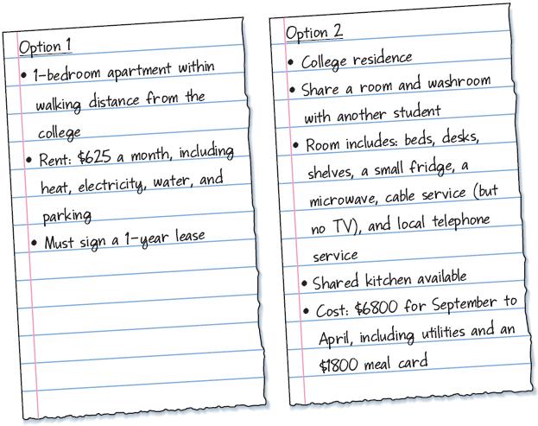
Example 3 Comparing Rental Properties
Sarah will be moving to Sarnia to attend
Lambton College.
- What is the annual rent for the apartment?
Is it more or less expensive than residence?

- What additional expenses might Sarah have
in setting up the apartment that she would
not have for the residence room?

- What, if any, benefits might there be to living in the apartment? To living in residence?

- Which option would you recommend? Justify your answer.

Example 3 Additional Renter's Costs
Renters will typically pay first and last month's rent before they can move in. Trevor is moving with his wife Sasha to a new home they are renting for $1950 per month. Before they can move in, they must pay first and last month's rent, a deposit of $200 for their electricity, and a deposit of $175 for the natural gas that heats their home. Before they can move into their home, how much will they have to pay?

