**DECIMALS**

|  |
| --- |
| https://www.varsitytutors.com/assets/vt-hotmath-legacy/hotmath_help/topics/rounding-numbers/numbers.gifDecimals are another form of numbers. Rounding means making a number simpler but keeping its value close to what it was.  How to round decimals:  Step 1: Circle the decimal place that will be rounded.  Step 2: If the number right to the circled one is 5 or more, round it up and erase the numbers after the circled one; if it is less than 5, leave the circled one as is and erase the numbers right of the circled one. |

|  |  |  |  |  |  |  |
| --- | --- | --- | --- | --- | --- | --- |
| |  |  | | --- | --- | | Ex1: Round 45.678 to one decimal place.  = 45.(6)78 7 is greater than 5. Round up  = 45.7 | Ex2: Round 35.648 to one decimal place | | Ex3: Round 5.326 to two decimal places | Ex4: Round 5.325 to two decimal places. | | Ex5: Round 67.1275 to the nearest tenth | Ex6: Round 67.1275 to the nearest hundredth |   **PRACTICAL PROBLEMS**  1. What is the total thickness of the following shims taken from a bearing: 0.065-inch, 0.150-inch, 0.130-inch, 0.185 inch and 0.005 inch? Round the final answer to two decimal places.  2. What is the total number of amperes in a parallel circuit if the following lamps are connected to the circuit: one 100-watt lamp, 0.834 ampere; one 60-watt lamp, 0.437 ampere; one 40-watt lamp, 0.375 ampere; one 25-watt lamp, 0.225 ampere; one 10-watt lamp, 0.175 ampere and one 7-watt lamp, 0.125 ampere?  3. The actual inside diameter of a 3-inch conduit is 3.375 inches and the actual outside diameter is 3.9375 inches. What is the wall thickness of this conduit?  4. If the cost of Romex cable is $108.75 per one hundred feet, determine the total cost for 37 feet. Round the final answer to a whole dollar.    5. Determine the circumference of a grinding wheel if the radius is 6 inches. Use the following formula: C = πd |

**CONVERTING BETWEEN FRACTIONS, DECIMALS AND PERCENTS**

There will be times when you need to convert numbers so that all of the numbers you are working with are in the same format. The most common conversions you will work with are from fractions to decimals and from decimals to fractions.

a) Percent to Decımal

To convert from percent to decimal: divide by 100, and remove the "%" sign. The easiest way to divide by 100 is to move the decimal point 2 places to the left:

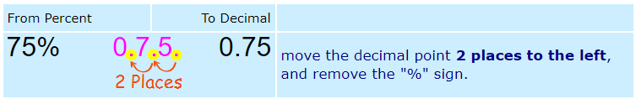

b) Decımal to Percent

To convert from decimal to percent: multiply by 100, and add a "%" sign. The easiest way to multiply by 100 is to move the decimal point 2 places to the right:

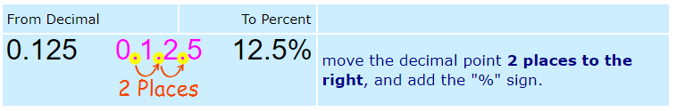

c) Fraction to Decimal

To convert a number from a fraction to a decimal, divide the numerator by the denominator.

Example: Convert 2/5 to a decimal: Divide 2 by 5 🡪 2 ÷ 5 = 0.4 🡪 Answer: 2/5 = 0.4

d) Decimal to Fraction  
There are three steps to convert a decimal to a fraction. The decimal .125 can be converted to a fraction as follows:

1. Place the number to the right of the decimal point in the numerator 🡪 125/1

2. Count the number of decimal places in the number. Place this number of zeros following a 1 in the denominator 🡪 125/1000

3. Reduce the fraction to its lowest terms 🡪 125/1000 = 1/8

e) Fraction to Percentage  
The easiest way to convert a fraction to a percentage to divide the top number by the bottom number. then multiply the result by 100, and add the "%" sign.

Example: Convert 3/8 to a percentage

First divide 3 by 8: 3 ÷ 8 = 0,375, then multiply by 100: 0,375 x 100 = 37,5 finally add the "%" sign: 37,5%  
Answer: 3/8 = 37,5%

f) Percentage to Fractıon  
To convert a percentage to a fractıon, fırst convert to a decimal (divide by 100), then use the steps for converting decimal to fractions.    
Ex: 80% = 80/100 = 4/5

g) What percent one number is of another

A percentage is a number expressed as a fraction of 100. You will usually see percentages with the percent sign, as in 35%.

You can calculate the percentage of a material that has been used in two steps.

1. Divide the used amount by the initial amount.

2. Multiply the result by 100.

If you had an initial supply of 300 sheets of plywood and you have used 80 of them, you calculate the percent used as follows:

80/300 = .27

.27 x 100 = 27%

|  |  |  |
| --- | --- | --- |
| **FRACTION** | **DECIMAL** | **PERCENTAGE** |
| $$\frac{23}{20}$$ |  |  |
| $$\frac{3}{8}$$ |  |  |
| $$\frac{40}{50}$$ |  |  |
|  | 0.914 |  |
|  | 0.23 |  |
|  | 0.229 |  |
|  |  | 92.1% |
|  |  | 149% |
|  |  | 26.5% |

**PERCENT PROBLEMS**

|  |
| --- |
| How to take a percent of a number:  Step 1: Multiply the number with the percentage  Step 2: Divide the answer by 100 |

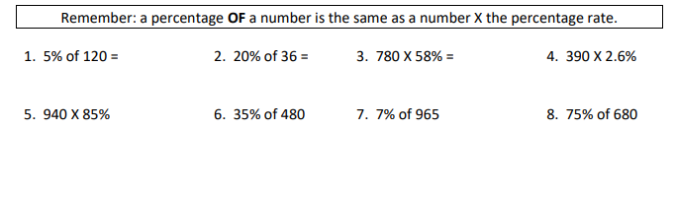

|  |  |
| --- | --- |
| **Example 1**: There were 25 apples. Molly took 20% of the apples home. How many apples did Molly take?  = 25 x 20 ÷ 100  = 5 | **Example 2**: Stephen spent 40% of his birthday money. He was given $145. How much does he have left? |
| **Example 3**: Nadiya achieved 45 out of 60 on her math test. What is this as a percent? | **Example 4**: An outfit is $34.95 and is on sale for 25% off. Taxes on this item are 13%. Calculate the total cost to purchase this item. *Calculate tax after discount.* |

**PRACTICAL PROBLEMS**

1. Below is a fictional table that could represent a publication from the CRA. The Income Tax column and the CPP, Canada Pension Plan column are both noted in %.

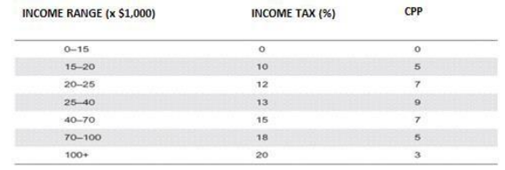

Complete the following table, using the chart from above.

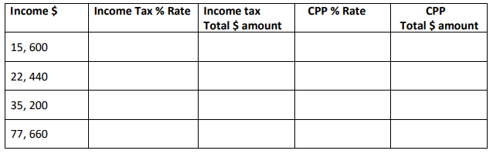

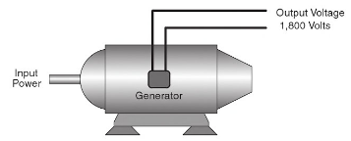2. The generator shown ordinarily generates 1500 volts. Find the percent of voltage increase that it is presently generating.

3. A motor rated at 90 horsepower is actually developing 105 horsepower. What is the percent of horsepower **overload**? *Round your final answer to whole percent.(Overload is the extra power generated more than its rate)*

4. Each worker receives $122.35 per day. The wages are reduced 8%. Find to the nearest cent the amount each worker receives per day after the cut in pay.

5. In replacing 55 test tubes, an apprentice broke 6. What percent of the tubes did the apprentice break?

6. A plumber charges $425 for a plumbing job. The cost of materials amounts to 62% of the total cost. Find the amount of money that the plumber receives for labor.

7. A 12-volt battery has had a capacity of 30 ampere-hours, but due to aging, has dropped to a capacity of 24 ampere-hours. Find the percent decrease in capacity.

8. An arborist charges 33% of the cost of a new motor for a job. If the motor costs $287 when new, what is the amount charged for the job?

**RATIO:** a comparison of two numbers or quantities with the same units.

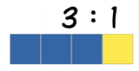

Figure 1: There are 3 black squares to 1 grey square

Ratios can be show in different ways:

|  |  |
| --- | --- |
| a. 2 cups of milk to 7 cups of water | b. $5 to $9 |

Example 2: Write each ratio in simplest form.

|  |  |  |
| --- | --- | --- |
| a. | b. 4:12 | c. 6 to 10 |

Example 3: Write the following ratios in simplest form.

|  |  |  |
| --- | --- | --- |
| a. 45 minutes to 60 min | b. 250 g to 1000 g | c. 100 cm to 175cm |

**RATE:** a comparison of two numbers having different units.

A rate is usually written as a ‘unit rate’, in which the second term is always 1.

|  |  |
| --- | --- |
| Example 4: John earns $60 for working 4 hours. What is his rate of pay? | Example 5: A car runs at a speed of 30m/s. How far can it run in 1 minute? |
| Example 6: A 200g bag of mixed nuts costs $3.40. Calculate the unit rate. (Unit rate = cost/amount) | Example 7: A Comparison  A 200g bag of popcorn costs $6.00. A 500g bag costs $10.00. Find the unit rate of each bag to compare which size is the better value. |

**PROPORTION:** is an equation which states that two ratios are equal. 

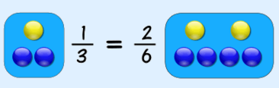

Some proportions can be solved with simple multiplication or division between equivalent ratios; others are more complicated and can be solved using ‘cross multiplication’.

|  |  |  |
| --- | --- | --- |
| Example 8: | Example 9: | Example 10:  *\*see below* |

**CROSS MULTIPLICATION**

**Example 1: Find the missing value ‘m’**

*You should be able to answer this by solving the ‘simple’ equivalent fraction but I will use this simple example to show you how cross multiplication works.

|  |  |  |  |  |
| --- | --- | --- | --- | --- |
| **Question** | **Draw the cross** | **STEP 1:  Set up the equation** | **STEP 2: Simplify** | **STEP 3: Get the unknown value alone by dividing both sides by the number on the same side as the unknown value.** |
|  |  |  |  |  |

**Example 2:**

|  |  |  |  |  |
| --- | --- | --- | --- | --- |
| **Question** | **Draw the cross** | **STEP 1:  Set up the equation** | **STEP 2: Simplify** | **STEP 3: Get the unknown value alone by dividing both sides by the number on the same side as the unknown value.** |
|  |  |  |  |  |

**PROPORTION PROBLEMS**

|  |  |
| --- | --- |
| Example 11: A pendulum completes 7 swings every three seconds. How many swings does it complete in a minute? | Example 12: Apples are $2.00 per dozen (12), how many apples can you get for $5.50? |

**PRACTICAL PROBLEMS**

1. Express each ratio in its lowest terms.

|  |  |  |  |
| --- | --- | --- | --- |
| a. 5:15 = | b. 10:25 | c. 4:12 | c. ¾ : ¼ |

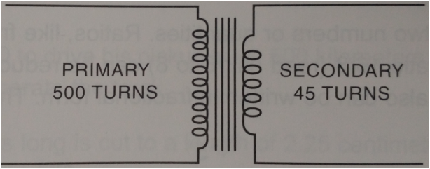2. What is the ratio of the number of the number of primary turns to the number of secondary turns in the following diagram?

3. What is the ratio of the speed of one generator with an output of 3500 watts to a second generator with an output of 24500 watts?

4. If it takes one electrician 18 hours to wire a house and a second electrician 45 hours to wire a similar house, what is the ratio of the second electrician’s time to the first electrician’s time?

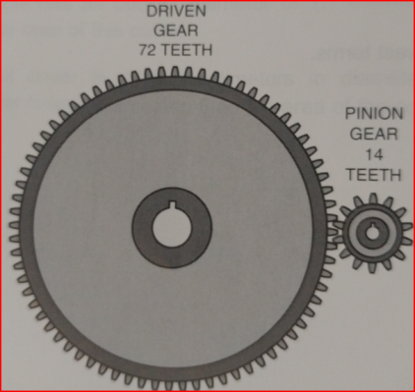

5. What is the ratio of a pinion gear with 14 teeth to a driven gear with 72 teeth?

6. A motor-driven pump discharges 306 gallons of water in 3.6 minutes. How long will it take to discharge 5200 gallons? Express the answer to the nearest tenth (1 decimal place).

7. A wire whose resistance is 5.075 ohms has a diameter of 31.961 circular mils. What is the resistance of a wire of the same material and length if the diameter is 40.404 circular mils? Use the following formula and round your answer to the nearest thousandth (3 decimal places). .

8. A wire 2725 feet long and 85 mils in diameter has a resistance of 0.372 ohm. Find to the nearest thousandth the resistance of 3600 feet of the same wire.

9. If a wire 1325 feet long has a resistance of 0.65 ohm, what is the resistance to the nearest hundredth of one mile of the same wire? [1 mile = 5280 feet]

10. If 120 feet of 2-inch conduit cost $154.50, what will 325 feet of 2-inch conduit cost?