**REVIEW**

Ben and Jen have 24 m of fencing to enclose a vegetable garden at the back of their house. Find the dimensions of the rectangular garden that would maximize the area using algebra.

**B. Using the factored form to find the coordinates of the vertex of a quadratic function** 

|  |  |
| --- | --- |
| **Step 1:**  **a) Find the x-intercepts by either GCFing, factoring or using the quadratic formula.**  **b) PLOT these points and draw the axis of symmetry.** | |
| **Step 2:**  **If you notice, the “x” coordinate of the vertex is halfway between the x-intercepts. The equation of axis of symmetry is also the “x” coordinate of the vertex. In a nutshell, just AVERAGE the ZEROS.**  **Step 3:**  **Vertex is a point on the plane with “x” and “y” coordinates. You know the “x” coordinate; all you need to do is plug this value ___ for x to determine “y” coordinate.** |  |
| **CONCLUSION:** | |

**FALLING OBJECT**

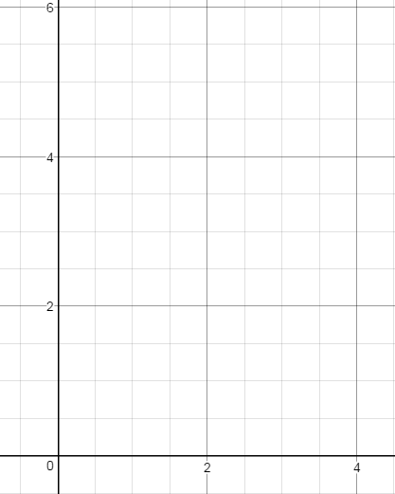A ball is kicked and follows the path modeled by , where the height above ground, *h*, is in metres, and the time, *t*, is in seconds.

a) Determine the maximum height reached by the ball by **averaging the zeros**.

b) Sketch the graph of the path of the ball.

c) How long does it take before the ball hits the ground?

d) State the domain and the range of the function.

Determine the *x*-intercepts, the equation of the axis of symmetry, the coordinates of the vertex, and the *y*-intercept then sketch the graph of the quadratic function.

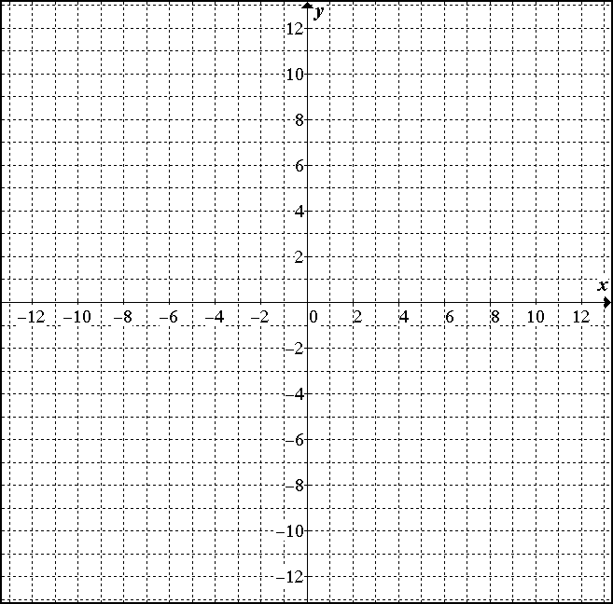

**PRACTICE**

1) Determine the vertex by averaging the zeros.

a) 

b) 

d) 

2. The path of a golf ball can be modelled by the function , where *h* is the height of the golf ball, in metres, and *d* is the horizontal distance travelled, in metres. What is the maximum height of the golf ball? At what horizontal distance does the golf ball reach its maximum height?

3. A ball is thrown vertically upward off the roof of a 34 m tall building. The height of the ball *h* in metres, can be approximated by the function where *t* is the time in seconds, after the ball is thrown.

a) Sketch the graph.

b) How high is the ball after 2 s?

c) Find the maximum height of the ball.

4. A tennis ball is thrown up into the air. Its height *h* in metres after *t* seconds, is given by the function 

a) Sketch the graph.

b) Determine the maximum height of the ball and the time it takes to reach it.

c) How high is the ball after 3 s?

5. A rectangular lot is bordered on one side by a stream and on the other three sides by 600 metres of fencing. Determine the dimensions of the lot if its area is a maximum.

6. A lifeguard marks off a rectangular swimming area at a beach with 200 m of rope. What is the greatest area of water she can enclose if the rope only makes 3 sides of the rectangle? (No rope is needed along the shore side of the swimming area.)

7. Determine the maximum possible area for a rectangle with perimeter 20