Discovering the Slope Formula #2

1. Plot the following points and draw the segment created by joining the points.
(a) A(-2, 4) B(6, -4) (b) C(3, -3) D(1, 5)
(c) E(-3, -2) F(1, 1) (d) G(2, 4) H(5, -1)

2. Determine the slope of each segment by counting rise and run.

We don’t want to plot points EVERY time we want to know slope. We can create a formula that uses two points to calculate the slope.
The points given here are: (-1, 4) and (1, 1).
Pretend there is a point where the two arrows meet.
This point is (-1, 1).
How can you use these 3 points to find the vertical distance (rise) and the horizontal distance (run)?

3. Try to create a formula that you can use to calculate the slope of each of the segments you drew above!

Practice with the Slope Formula #2
Find the slope of a line passing through each of the following pairs of points.
State the answer in simplest form.
1. (-9, 8) and (0, 9) | 2. (0, 6) and (5, -2)
3. (6, 0) and (0, -6) | 4. (-4, 1) and (-8, -3)
5. (-9, 3) and (-8, -3) | 6. (-4, 4) and (2, -3)
7. (5, -4) and (6, 9) | 8. (-8, -5) and (0, 3)
9. (-1, -9) and (-6, -2) | 10. (-3, 1) and (-1, -6)
11. (11, 17) and (-8, -18) | 12. (-14, 18) and (8, 0)
13. (14, -19) and (-2, -13) | 14. (-2, 14) and (-9, -17)
15. (-16, 5) and (-5, -5) | 16. (-17, 7) and (9, -4)
17. (-49, -86) and (25, 93) | 18. (-91, -20) and (-43, 3)

a) The following graph shows the cost of renting a banquet hall. Initially the cost is $300 just for the hall. There is a per person cost in addition to the initial fee to cover the meal cost.

How much does it cost for each additional person who attends the event? This value is called the rate of change, and is a unit rate – in this case cost per person.

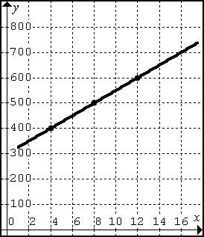
Calculate the slope of this line.

b) The following graph shows the balance in Jenny’s bank account over 7 weeks. She started with $300 in her account but has been spending her money at a constant rate.

How much did her account decrease by each week? This value is called the rate of change, and in this case is spending per week.

Calculate the slope of this line.

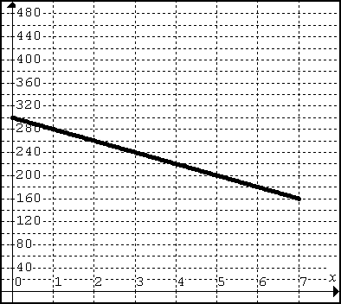
c) Molly is an antique hunter. Her father had found a unique gem years ago on the ground (it was free!!). Over time this item became more and more rare. The value for this item increased at a constant rate over the years and now, 30 years later, it is worth $6000. Each year the value increased by around $600. Calculate the slope of the line.

How much did this gem increase in value each year? This value is called the rate of change, and in this case is $ value per year.

Calculate the slope of this line.
