Definition: Learning styles are simply different approaches or ways of learning.
Learning Styles
VISUAL LEARNERS | AUDITORY LEARNERS | KINESTHETIC LEARNERS
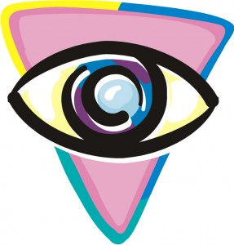 | 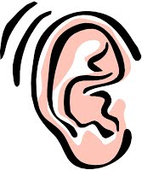 | 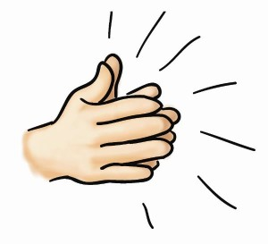
Visual learners learn best when the things to see. Do you like to keep an eye on the teacher by sitting toward the front of the class and observing the near lesson? Do you love when lessons include diagrams or pictures?  Visual learners can benefit from:  - Draw a map of events in history or science experience  - Create a survey or plan everything!  - Copy what is at the table  - Take notes, make lists  - Watch Videos  - Organize your notes key concepts or color  - Use reflection cards  - Use highlighters, circle words, Deputy, Line words | Auditory Learners learn best by listening and hearing things. Do you have difficulty understanding through reading, but you understand the lessons and listening to what the teacher said?  - Auditory Learners can benefit from:  - Use word association to remember words, facts, words  - Save lessons  - Watch Videos  - Repeat the facts with their eyes closed  - Participate in group discussions  - Using hearing recordings to practice the language  - Save notes after writing | Kinesthetic learners learn best if they do things or activities. Do you have difficulty sitting in class and you often find yourself playing with your style or an object?  Kinesthetic learners can benefit from:  - Study in blocks  - Taking courses with labs  - Role Play  - Take experiential excursions  - Studying with others.

TASK: DISCOVER YOUR LEARNING STYLE
Complete the online learning style test, when finished click , snip the screen using Snipping Tool. Paste it below.

