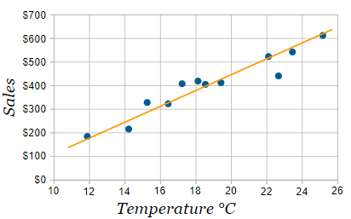**LINE OF BEST FIT**

***What is a Line of Best Fit (LOBF)?***

* A _______________-________ drawn through data points to **BEST** represent  
  a _____________ relationship between _____ variables. AKA trend line or regression line
* The _________ the correlation the more difficult it is to draw an LOBF
* Draw LOBF _________ possible to all points, and ______ points above the line as below.

**KEY WORDS**

Straight line

Linear

Two

Weaker

As close as

As many

Far away

Inaccurate

Anomalies

reflect

one or more

affect

**SEA LEVEL RISE**

|  |  |
| --- | --- |
| **A scatter plot of sea level rise** | **Here is the drawn “Line of Best Fit”** |
|  |  |

**THE EFFECT OF OUTLIERS ON THE LOBF**

* An outlier is a point that lies ________ _______ from the main cluster of data
* May be caused by _______________ measurements or _____________ in the data set (an unusually tall person)
* The LOBF should ____________ all points in the data set, including outliers
* ______________________ outliers will ________ the path of the LOBF

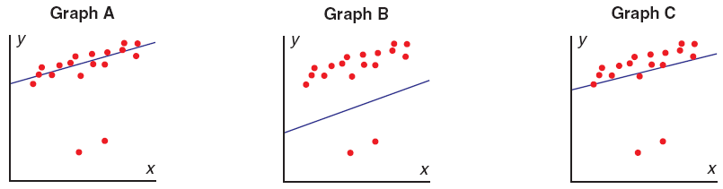

LOBF drawn in graph c fits the scatter plot the best because of the outliers.

**YOUR TURN**

Draw a line through the maximum number of points, balancing about an equal number of points above and below the line

**Example 1:**

1. Use a straightedge (clear, if possible) to draw the line of best fit (this assumes the pattern is linear).

|  |  |
| --- | --- |
|  |  |

**RECALL**

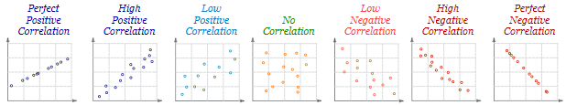

2) State the type of correlation for graph A and B.

**Example 2: Draw** a line of best fit for each of the following scatter plots, if possible. State the type of correlation

|  |  |  |  |
| --- | --- | --- | --- |
|  |  |  |  |

**INTERPOLATING AND EXTRAPOLATING**

We don’t just draw the line of best fit ‘just’ for the fun of it. This line describes the general relationship of the data and can be used to determine unknown values.

**Interpolate** – to estimate a value between (within) two known values.

**Extrapolate** – to predict a value by following a pattern beyond known values.

Several students were recording the temperature of boiling water that sat in a cup. Their results were combined and used to create this scatter plot graph. Use the graph to answer the following questions:

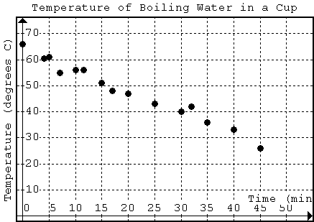

1. What type of correlation is this relationship?
2. Draw a line of best fit.
3. What was the temperature at 27 minutes? Use your line of best fit to find this missing data.
4. At what time did the temperature reach 30 degrees C? Use your line of best fit to ***interpolate*** this data.
5. At what time did the water reach a temperature of 10 degrees C? Extend your line of best fit to ***extrapolate*** this data.
6. What was the temperature at 50 minutes? Extend your line of best fit to ***extrapolate*** this data.

**[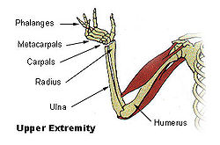](http://en.wikipedia.org/wiki/File:Illu_upper_extremity.jpg)Application of the Line of Best Fit**

Anthropologists and forensic scientists use data to help them determine information about people. Often only a few bones are available or the evidence is inconclusive. In spite of these difficulties, by accessing the information in large databases and investigating relationships between data scientists can determine information about the height, age, and sex of the person they are examining. In this problem we are going to look at the relationship between the humerus bone “the funny bone” which is the bone of the upper arm and the radius bone.

1. Construct a graph that compares the radius of the humerus bone to the length of the bone.

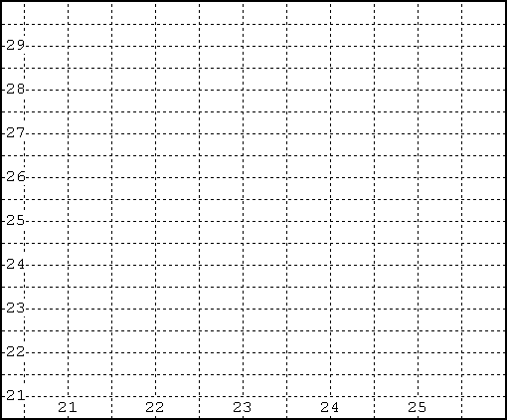

|  |  |
| --- | --- |
| **Radius (cm)** | **Humerus (cm)** |
| 25 | 29.7 |
| 22 | 26.5 |
| 23.5 | 27.1 |
| 22.5 | 26 |
| 23. | 28 |
| 22.6 | 25.2 |
| 21.4 | 24 |
| 21.9 | 23.8 |
| 23.5 | 26.7 |
| 24.3 | 29 |
| 24 | 27 |

1. Draw a LOBF then describe the type of correlation is this relationship?
2. Circle the point on the graph that represents the data for a humerus that is 27.1cm long. How long is the radius? _____
3. Underline the statement that describes the direction of the plotted points in the graph?
   * The plotted points rise upward from left to right.
   * The plotted points fall downward from left to right.
   * The plotted points are scattered across the graph.
   * The plotted points lie flat along the horizontal.
4. As the length of the radius gets longer, what happens to the length of the humerus?
5. Do you think that you can use the length of the radius to predict the length of the humerus? Explain.
6. Extrapolate the length of humerus if the length of radius is 21 cm.