MODELLING PERIODIC BEHAVIOUR
The largest Ferris Wheel opened in Chaoyang Park, Beijing just in time for the 2008 Olympics. The 682-foot-high wheel, which has its centre 346 feet above the ground, will give up to 3,840 passengers per hour a fantastic view of the city, and surrounding area. Each of the wheel’s 48 capsules holds 40 people.  Suppose that you and a group of friends are riding the Ferris wheel. The ride then begins with you at point A. The Ferris wheel turns counter clockwise at a constant speed. The wheel takes 60 seconds to complete one revolution. | 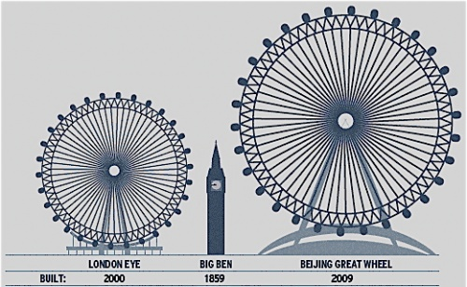
1. Point A is when you get on the wheel. Determine the time and height at point A. ______________________
2. Point C is the maximum height you will reach. Determine the time and height at point C. ______________________
3. Point B is half way between A and C. Determine the time and height at point B. ____________________________
4. Point D is half way between C and E. Determine the time and height at point D. ____________________________
5. Point E is when you complete one revolution. Determine the time and height at point E. _______________________
B  C  D  A (0, )  E | Rotation of Wheel in Seconds Height Relative to the ground in Feet  0  15  30  45  60
6. Plot the points on a grid. Sketch a curve of best fit to show the relationship between your height, h, and the time, t.

KEY IDEAS
Max
- A function is PERIODIC if it has a pattern of y-values that repeats at regular intervals.
- One complete pattern of a periodic function is called a CYCLE. A cycle may begin at any point on the graph.
- The horizontal distance from the beginning of one cycle to the beginning of the next cycle is called the period.
- The horizontal line that is halfway between the maximum (peak) and minimum (trough) values of a periodic curve is called the AXIS OF THE CURVE.
The equation of the AXIS OF THE CURVE is $y=\frac{\max{ + min}}{2}$
- The magnitude of the vertical distance from the AXIS OF THE CURVE to either the max (peak) or min (trough) value is called the amplitude of the function. The amplitude is always positive.
The amplitude, a, is calculated as $a=\frac{\max{- min}}{2}$

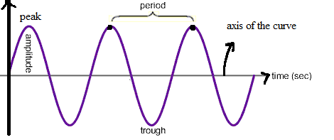
$$a=\frac{\max{- min}}{2}$$
$$y=\frac{\max{ + min}}{2}$$

Example 1: Determine if the function is periodic.
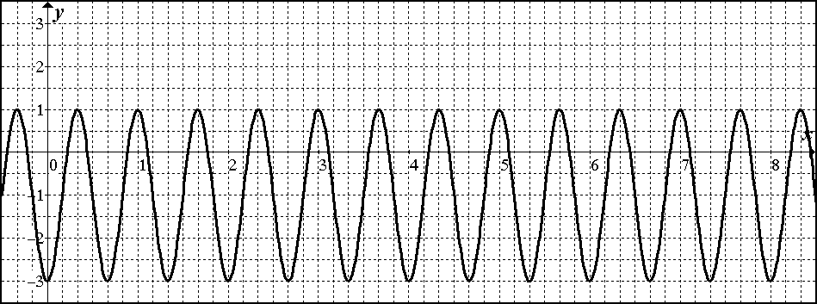
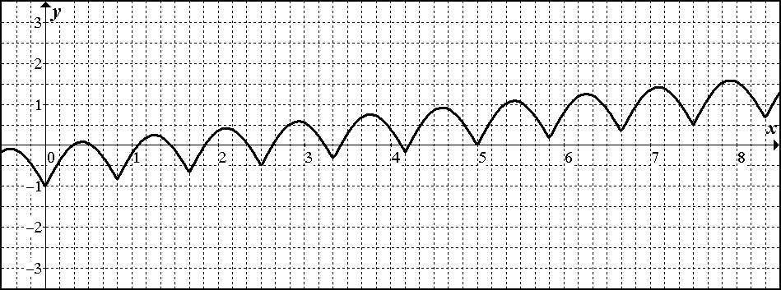

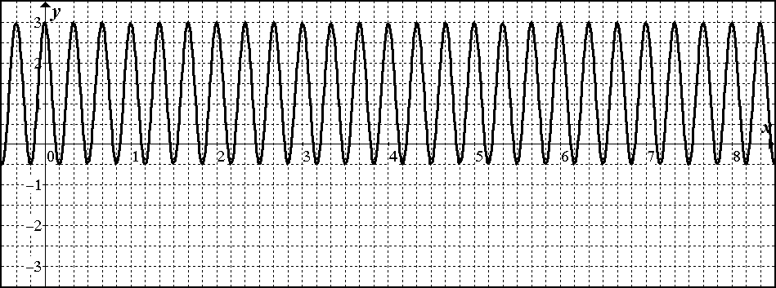
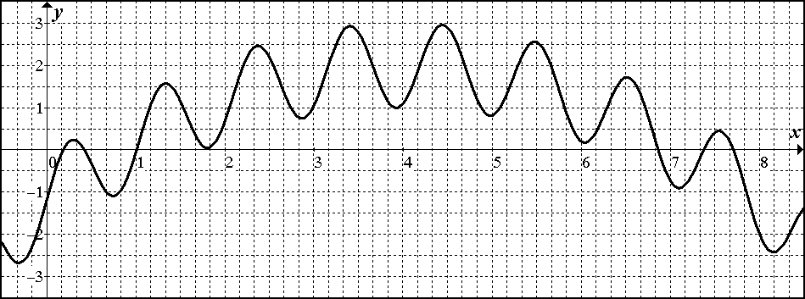

Example 2: Determine whether the term periodic can be used to describe the graph for each situation. If so, state the period, max, min, equation of the axis, and amplitude.
