Angle of elevation (inclination) is the angle made between the ______________________ and the line of sight _____________________ to an object.



Angle of depression is the angle made between the ______________________ and the line of sight _____________________ to an object.



**Example 1:** A wheelchair ramp is needed at the entrance of a restaurant. The ramp is to be 6.10 m long and have a rise of 0.45 m. Calculate the angle of inclination of the ramp.

**Example 2:** From the top of a bridge, Maria looks down at a sailboat at an angle of depression of 15o. The bridge is 18 m above the water. Calculate the horizontal distance from the bridge to the sailboat.

Primary Trigonometry Ratio Application Problems

Steps to solving problems using trigonometric ratios

1. Identify ______________________________________________________________________
2. Model _______________________________________________________________________
3. Label ________________________________________________________________________
4. Write ________________________________________________________________________
5. Substitute _____________________________________________________________________
6. Solve ________________________________________________________________________

**Example 1:** While walking to school you pass a barn with a silo. Looking up to the top of the silo you estimate the angle of elevation to be about . You continue walking and find that you were 40 m from the silo. Using this information and our knowledge of trigonometric ratios, calculate the height of the silo.

j0297185

**Example 2:** A helicopter sights a campfire at an angle of from the horizontal. The helicopter is hovering 400 m above the ground. What is the horizontal distance between the helicopter and the campfire?

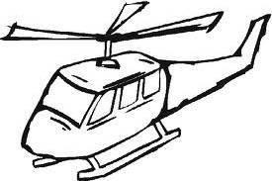

smokesignalscampfire

**Example 3:** A sailboat that is 2 km due East of a lighthouse sends a signal to the lighthouse that   
it is in distress. The lighthouse quickly signals the coast guard that is due South of the lighthouse and   
7 km Southwest of the sailboat. What heading from due north should the coast guard take in order to intercept the troubled sailboat?

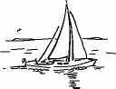

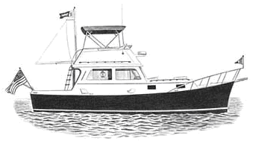

**Example 4:** Safety by-laws state that for a ladder to be stable, the angle the base of the ladder makes with the ground should be between and . A safety inspector at a construction site notices a painter on a 10 m ladder that is leaning against a wall. The base of the ladder is 1.5 m away from the wall. Does the inspector have cause to be concerned? Explain.

**Primary Trigonometry Ratio Application Practice**

1. A 5-m ladder is resting against a wall. The base of the ladder is 2 m along the ground from the base of the wall. What angle does the base of the ladder make with the ground? Express your answer to the nearest tenth of a degree.
2. An 80-m tower is supported by a guy wire attached to the top of the tower. If the wire forms an angle of elevation of , how long is it? Express your answer to the nearest tenth of a metre.
3. The highest point along a cliff is 80 m above the lakeshore. A surveyor stands on the top of the cliff, looking through a 1.5 m tall transit instrument. He spots a boat out on the lake, at an angle of depression of . How far, to the nearest tenth of a metre, is it from the boat to the base of the cliff?
4. Michael stands 10.0 m from the base of a building. He measures the angle of elevation to the top of the building to be . Michael’s measurement was made from 1.5 m above the ground. Determine the height of the building to the nearest metre.
5. Two buildings are 60 m apart. The angle of depression from the top of the taller building to the top of the shorter building is . The height of the shorter building is 30.4 m. What is the height of taller building? Express your answer to the nearest tenth of a metre.
6. From the top of a 150 m high cliff, the angles of depression of two boats on the water are  and . How far apart are the boats?
7. Two buildings are 20 m apart. The angle from the top of the shorter building to the top of the taller building is . The angle from the top of the shorter building to the base of the taller building is . What is the height of the taller building?
8. The CN Tower is 553.33 m high. Lina looks up at the top of the tower at a  angle of elevation. She calculates the distance, *d*, from the base of the tower as follows:

|  |  |
| --- | --- |
| d **≅**149 | Explain why Lina’s solution is incorrect.  Write a correct solution |