Trigonometric Ratios for Obtuse Triangles
53.1°
Q1
Q2

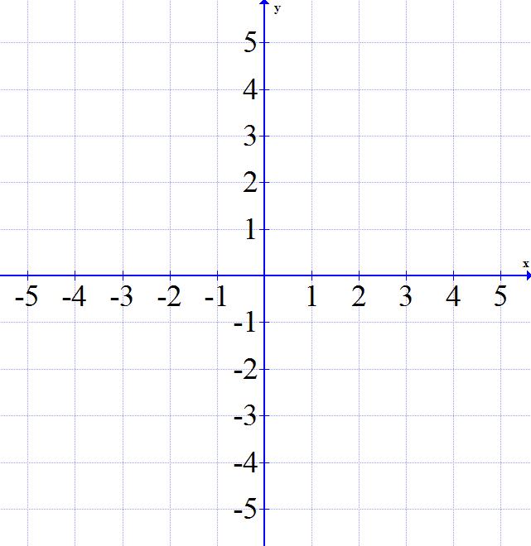
Cartesian coordinate system is divided into 4 quadrants.
P
- Label the quadrants on the grid
- Identify the opposite, adjacent and hypotenuse of reference angle 53.1^{O}
- What is the x-coordinate of point P? _____
What is the y-coordinate of point P? _____
- Write the 3 trigonometric ratios using the triangle
Sin 53.1 = Cos 53.1 = Tan 53.1 =

Notice that the length of the adjacent side is the x-coordinate and the length of the opposite side is the y-coordinate.
We can use this idea to find the trigonometric ratios of obtuse angles.
α
126.9°
Sin 126.9 = O/H Cos 126.9 = A/H Tan 126.9 = O/A
5
4
= 4/5
-3

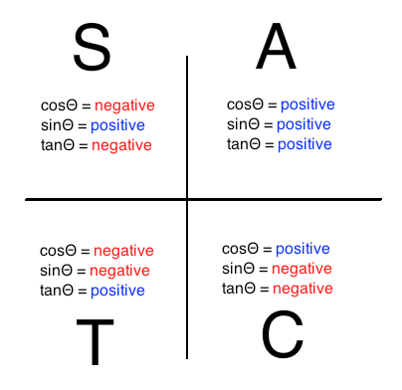
Where are sin, cos and tan positive? This is called the CAST rule:
Notice: For an angle between 0° and 180°,
- If cos or tan are positive the angle is in quadrant ___
- If cos or tan are negative the angle is in quadrant ___
- If sin is positive the angle could be in either quadrant ___ or ___.

There are always two angles that could give us the same sin ratio.

1) SINE RATIO (if positive one acute one obtuse, if negative one obtuse)
Example: Angle A is between 0ᴼ and 180ᴼ. Determine all measures of angle A in the following case: sin A = 0.2079
Solution: According to CAST rule, sin A is positive in two quadrants: 1 and 2.
ANGLE 1: ACUTE ANGLE in Q1 | ANGLE 2: OBTUSE ANGLE in Q2
Sin⁻¹ 0.2079 = A  12º  A = 12º | Once, we find the acute angle, the obtuse one is rather easy.  12º  168º  180 – 12 = 168  Check: sin 168º = _____
CONCLUSION: A is 12 or 168 degrees.

Your turn:
a) sin A = 0.4045  Since sin ratio is +ve in two quadrants. You need to find two angles: acute and obtuse.  Acute: ______ Obtuse: ________ | b) sin A = 0.8345

2) COSINE RATIO (if positive only one acute, if negative one obtuse)
Example: Angle A is between 0ᴼ and 180ᴼ. Determine all measures of angle A in the following case: cos A = - 0.8191
Note: We will be dealing with only Q1 and Q2 since angle A is between 0 and 180 degrees.

STEP 1: FIND REFERENCE ANGLE  ACUTE ANGLE in Q1 | STEP 2: REFLECT THE REFERENCE ANGLE  INTO Q2 TO FIND THE OBTUSE ANGLE in Q2
Disregard the sign because it only tells us where the angle is. Since the given cos ratio is -ve. We will seek the angle in Q2.  35º  cos⁻¹(0.8191) = A  A = 35 (reference angle)  cos 35 is positive. We are interested in the obtuse angle. | 180 – 35 = 145^{O}  35º  35º
CONCLUSION: The obtuse angle A is 145º

TRY
a) cos A = - 0.6345 | b) cos A = - 0.3876

TANGENT RATIO (if positive only one acute, if negative one obtuse)
Example: Angle A is between 0ᴼ and 180ᴼ. Determine all measures of angle A in the following case: tan A = - 2.145
Note: We will be dealing with only Q1 and Q2 since angle A is between 0 and 180 degrees.

STEP 1: FIND REFERENCE ANGLE  ACUTE ANGLE in Q1 | STEP 2: REFLECT THE REFERENCE ANGLE  INTO Q2 TO FIND THE OBTUSE ANGLE in Q2
Disregard the sign because it only tells us where the angle is. Since the given tan ratio is -ve. We will seek the angle in Q2.  .  tan⁻¹(2.145) = A  65º  A = 65 (reference angle)  tan 65 is positive. We are interested in the obtuse angle. | 180 – 65 = 115^{O}  65º  65º

CONCLUSION: The obtuse angle A is 115º.

YOUR TURN: Angle A is between 0ᴼ and 180ᴼ. Determine all measures of angle A in the following cases:
a) tan A = 1.428 | b) tan A = -1.428

PRACTICE
Angle A is between 0ᴼ and 180ᴼ. Determine all measures of angle A in the following cases:
a) sin A = 0.1358  Angle is in the quadrant(s) _________ | b) cos A = - 0.7856  Angle is in the quadrant(s) _________ | c) tan A = -2.1945  Angle is in the quadrant(s) _________
d) sin A = 0.8135  Angle is in the quadrant(s) _________ | e) cos A = -0.2487  Angle is in the quadrant(s) _________ | f) tan A = - 5.3854  Angle is in the quadrant(s) _________

