Steps | Example #1  y = -2x² – 4x + 3 | Example #2  y = - 5x² + 20x + 1
Common factor the coefficient of the x² term from the first two terms. Do not factor out the x.

Divide the coefficient of x by 2, and then square it.

Add and subtract that value inside the bracket of the equation two steps above.

Move the last term in the bracket to the outside of the bracket and multiply it with the number in front of the bracket. Add the two constants together.

Factor the perfect square trinomial inside the bracket.

 | 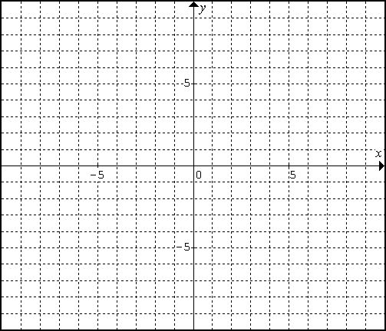
Now, determine the zeros:
Set y = 0
Remove the k
Remove the a
Square root – Don’t forget the ±
Remove the h

Steps | Example #3  y = x² – 6x + 5 | Example #4  y = x² – 2x + 1
Common factor the coefficient of the x² term from the first two terms. Do not factor out the x.

Divide the coefficient of x by 2, then square it.

Add and subtract that value inside the bracket of the equation two steps above.

Move the last term in the bracket to the outside of the bracket and multiply it with the number in front of the bracket. Add the two constants together.

Factor the perfect square trinomial inside the bracket.

Now, determine the zeros:
Set y = 0
Remove the k
Remove the a
Square root – Don’t forget the ±
Remove the h

Steps | Example #5  y = -3x² – 6x | Example #6  y = -2x² + 8x
Common factor the coefficient of the x² term from the first two terms. Do not factor out the x.

Divide the coefficient of x by 2, then square it.

Add and subtract that value inside the bracket of the equation two steps above.

Move the last term in the bracket to the outside of the bracket and multiply it with the number in front of the bracket. Add the two constants together.

Factor the perfect square trinomial inside the bracket.

Now, determine the zeros:
Set y = 0
Remove the k
Remove the a
Square root – Don’t forget the ±
Remove the h

