- __________ is the money you earn. __________________ are the money you spend.
KEY WORDS
- income
- expenses
- tracks
- spend
- earn
- going
- important
- goal
- per month
- 12
- savings
- balance
- more
- balancing
- A BUDGET is an organized list that _____________________ income and expenses.
- Budgets are used as a tool in financial planning:
  - To make sure you don’t _______________ more than you _____________
  - To help you understand exactly where your money is _________________
  - To help you focus your spending on the things that are most ______________ to you
  - To help you save to meet a financial _________________
- Personal budgets are usually planned ______________. Monthly amounts can then be multiplied by _______ to determine annual amounts.
- Income and expenses are recorded by type of income or expense. Money set aside for the future is called ______________ and is shown as an expense.
- The _____________ of a budget is the difference between total expenses and total income.
- If the balance is negative you are spending _____________ than you earn. You need to adjust some expenses so that the balance is zero. This is called _________________ the budget.

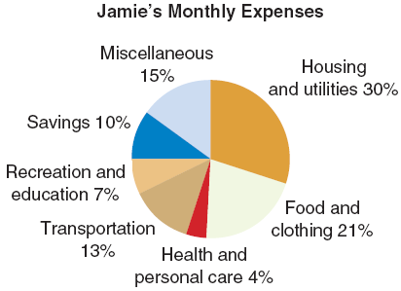
Example 1 Interpreting a Budget
This pie chart shows Jamie’s expenses for one month. The total dollar value of Jamie’s monthly expenses was $3 000.
- How much did she spend on transportation?

- How much did she spend on her top two expenses combined?

Example 2 Designing a Budget
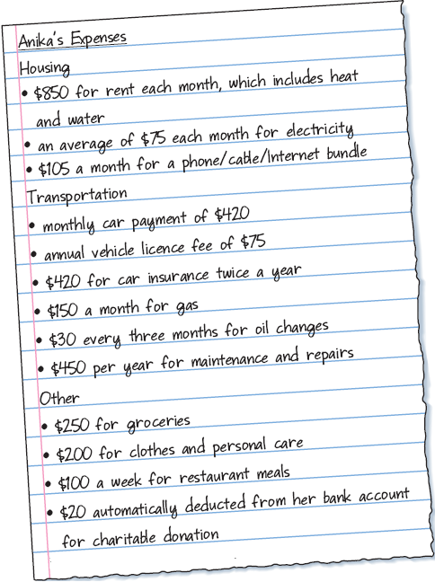
Anika is 28 year old professional who needs to save $7 500 over the next 12 months to start her own small business. Her monthly income after payroll deductions is $3 000. She earns an average of $50 a month from investments. She prepares the following list of her expenses.

- Which costs are fixed? Which costs are variable? Label them on the list.
- Anika needs to save $7500 in 12 months. Calculate her monthly savings to reach this goal.

- Convert all amounts to monthly amounts.
ROUND all values to the nearest DOLLAR.

- Are there expenses that you think Anika has forgotten to include? Explain. Estimate the monthly amount for any missing expenses.

 | Monthly Amount ($)
INCOME | Fixed | Variable | Total
Salary | $
Investments
Total Income
EXPENSES
Housing
Rent
Utilities
Phone/Cable/Internet
Subtotal
Transportation
Car Payment
Licence Fee
Insurance
Gas
Oil Change
Maintenance & Repairs
Subtotal
Food
Groceries
Eating Out
Subtotal
Other
Clothing/Personal
Entertainment
Charitable Donations
Subtotal
Savings
Total Expenses
BALANCE = Total Income – Total Expenses
- Create a monthly budget
that shows fixed and variable expenses in each budget category. Group items where appropriate. Include any estimates from
part c.

- What percent of Anika’s costs are fixed? Why is this important?

- Can Anika meet her savings goal with her current income and expenses? If not, in which categories might she be able to cut back on costs?

- How did the budget help you answer parts e and f? Explain.

