EVOLUTION OF NUMBERS & NUMBER SETS
The Counting Numbers
We can use numbers to count: 1, 2, 3, 4, etc. We humans have been using numbers to count with for thousands of years. It is a very natural thing to do.
- You can have “3 friends”
- a field can have “6 cows”
Counting Numbers: {1, 2, 3…}
So we have:

Zero
The idea of zero, though natural to us now, was not natural to early humans…if there is nothing to count, how can you count it?

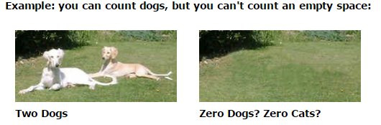

An empty patch of grass is just an empty patch of grass!

But about 3,000 years ago people needed to tell the difference between numbers like 4 and 40. Without the zero they look the same! So they used a “placeholder”, a space or special symbol, to show “there are no digits here”

5 2 So, “5 2” meant “502”

The idea of zero had begun, but it wasn’t for another thousand years or so that people started thinking of it as an acutal number.
But now we can think, “I had 3 oranges, then I ate the 3 oranges, now I have zero oranges.”
The Whole Numbers
So, let us add zero to the counting numbers to make a new set of numbers.
We need a new name, and that name is “Whole Numbers”:
Whole Numbers: {0, 1, 2, 3…}

The Natural Numbers (N)
Natural numbers can mean:
- the “counting numbers”: {1, 2, 3…}
- or the “whole numbers”: {0, 1, 3…}
depending on the subject. The controversy is caused by whether zero is “natural” or not.
Negative Numbers
We can count forward: 1, 2, 3, 4…
When we can backwards we have negative numbers -1, -2, -3, -4…
When a number is less than zero it is simply negative.
Integers Numbers (Z)
If we include the negative numbers with the whole numbers, we have a new set of numbers that are called integers.
Integers: {…-3, -2, -1, 0, 1, 2, 3…}

The integers include zero, the counting numbers, and the negative of the counting numbers,
Rational Numbers (Q)
Any number that can be written as a fraction is called a Rational Number.
So, if “p” and “q” are integers, then $p/q=3/2$ is a rational number.

The only time this does not work is when q is zero.

Rational numbers include:
- all the integers
- and all fractions
IRRATIONAL NUMBERS
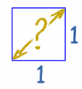
If you draw a square (of size “1”), what is the distance across the diagonal?
You know that the is the square root of 2, which is 1.4142135623730950…(etc)
But it is not a number like 3, or five-thirds. So it is not a rational number. We call them Irrational Numbers. Some examples are $\sqrt{2, }$ π (Pi)

You need irrational numbers to:
- find the diagonal distance across some squares,
- to work out lots of calculations with circles (using π)

We really should include irrational numbers. Thus, we need to introduce a new set of numbers…
REAL NUMBERS (R)
Real numbers include:
- the rational numbers, and
- the irrational numbers

A Real Number can be thought of as any number.

SUMMARY
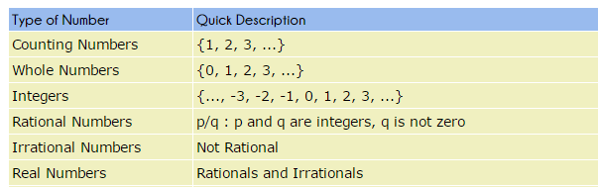

This lesson was inspired by www.mathisfun.com
SYMBOLS
> greater than  e.g. x > 0, x is greater than 0 | o open circle, does not include point.  e.g. x > 2
< less than  e.g. x < 0, x is less than 0 | ● closed circle, includes point  e.g. a ≤ 4
≥ greater than or equal to  e.g. x ≥ 0 x is greater than or equal to 0 | { } set
≤ less than or equal to  e.g. x ≤ 0, x is less than or equal to 0 | | such that  is an element of, or is in the set of
Notation Format
Good form: 0 ≤ x ≤ 8 (x is between 0 and 8)
Bad form: anything else Ex. x ≥ 0 and x ≤ 8

How to state Domain - D: {x∈R}  x is any Real number.  "∈" is the symbol meaning "in the set of" | How to state Range - R: { y∈R | y ≥5}  y is a Real number such that y is greater than or equal to 5.

1. State the domain and range of each relation from its graph.
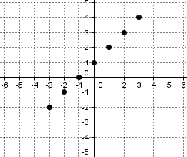a) | 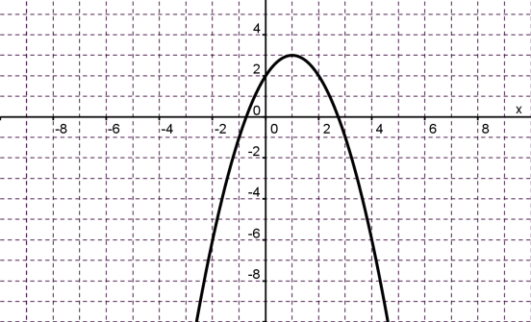  b)
c)  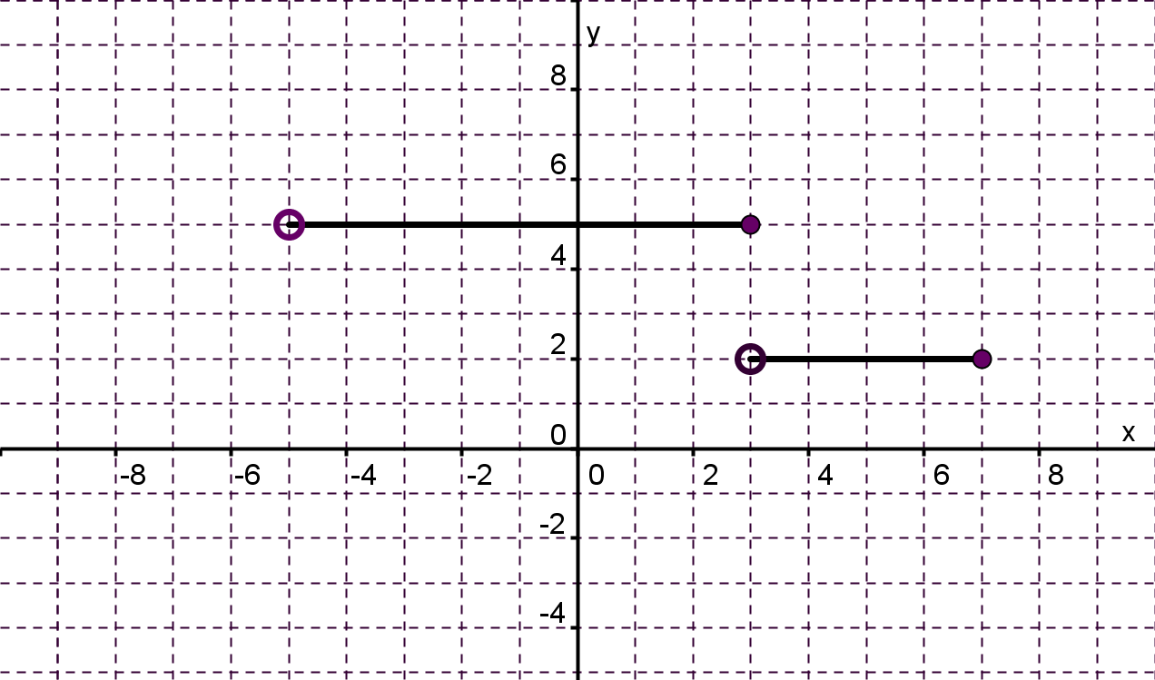 | 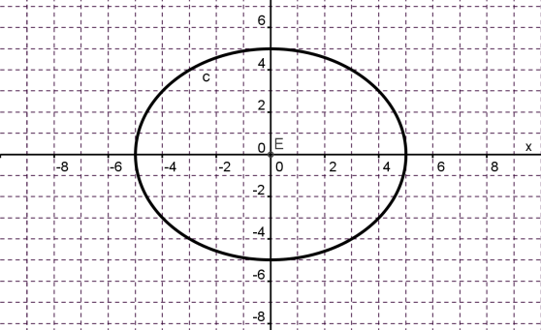  d)

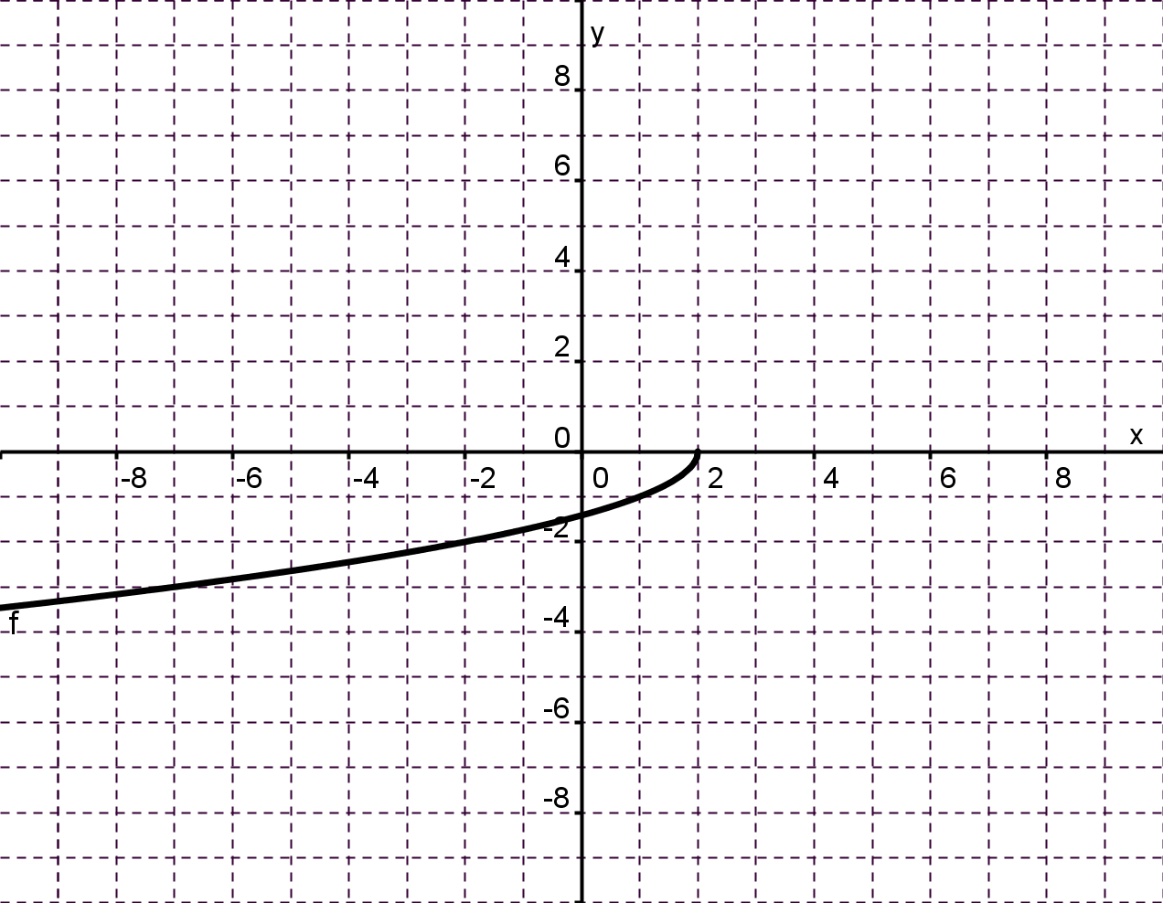  e) | 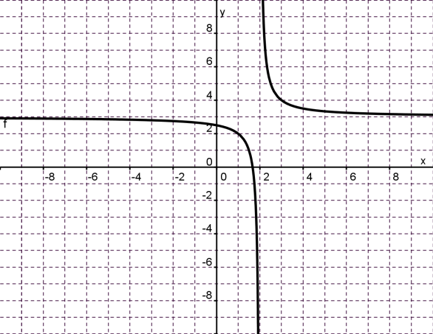  f)

2) Determining Domain And Range From The Function Equation
a) $f\left(x\right)=2x-3$

b) $g\left(x\right)=-3{(x+1)}^{2}+6$

c) $h\left(x\right)= \sqrt{2-x}$

