DEFINITION: The y-intercept is the point on the y-axis where your line crosses or meets the y-axis. It is also the coordinate that has an x-value of ZERO. (0, y)
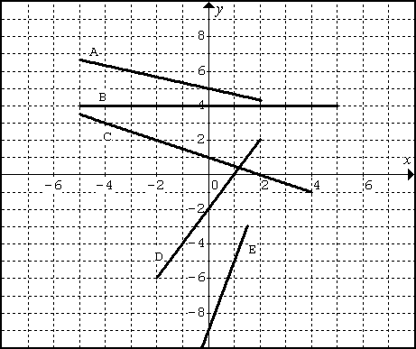
For each line on the grid to the right, state the COORDINATE of the y-intercept. Line A is done for you.

- ( 0 , 5 )
- ( , )
- ( , )
- ( , )
- ( , )

What do all these points have in common?

DEFINITION: The x-intercept is the point on the x-axis where your line crosses or meets the x-axis. It is also the coordinate that has a y-value of ZERO. (x, 0)
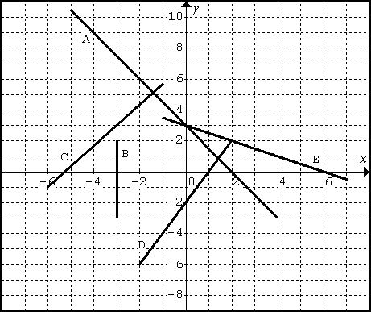
For each line on the grid to the right, state the COORDINATE of the x-intercept. Line A is done for you. *

- ( 2 , 0 )
- ( , )
- ( , )
- ( , )
- ( , )

What do all these points have in common?
Lesson: Graphing with x-Intercepts and y-Intercepts
- Note problems where you are asked to find both the intercepts, the line is usually not in y=mx+b form, rather a different form (possibly standard form Ax + By + C = 0).

QUESTION 1: PART A  Given the equation 3x + 4y = 12 what are the intercepts of this line.  SOLUTION  To find the y-intercept, the x-value must be 0.  - Substitute x=0  - Solve the equation for y  The y-intercept is ( 0 , )  To find the x-intercept, the y-value must be 0.  - Substitute y=0  - Solve the equation for y  The x-intercept is ( , 0 )  QUESTION 1: PART B  Graph the line 3x + 4y = 12 using the intercepts.  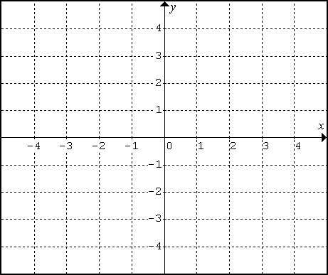  Plot the coordinates of each intercept and connect the two points to create your line. | QUESTION 2 : PART A  Given the equation -6x + 10y – 24 = 0 what are the intercepts of this line.  SOLUTION  To find the y-intercept, the x-value must be 0.  - Substitute x=0  - Solve the equation for y  The y-intercept is ( 0 , )  To find the x-intercept, the y-value must be 0.  - Substitute y=0  - Solve the equation for y  The x-intercept is ( , 0 )  QUESTION 2 : PART B  Graph the line -6x + 10y – 24 = 0 using the intercepts.  Plot the coordinates of each intercept and connect the two points to create your line.

Practice: Graphing with x-Intercepts and y-Intercepts

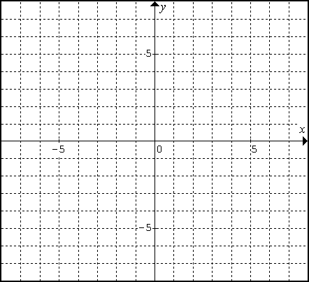  a. 4x – y = 8  x-intercept:  (_____, _____)  y-intercept:  (_____, _____) | b. 7x – 9y = 63  x-intercept:  (_____, _____)  y-intercept:  (_____, _____)
c. x + 2y = 5  x-intercept:  (_____, _____)  y-intercept:  (_____, _____) | d. 2x – 5y = – 4  x-intercept:  (_____, _____)  y-intercept:  (_____, _____)
e. 3x + 4y – 8 = 0  x-intercept:  (_____, _____)  y-intercept:  (_____, _____) | f. 4x – y = 9  x-intercept:  (_____, _____)  y-intercept:  (_____, _____)
ANSWERS: a. (2, 0) (0, -8) b. (9, 0), (0, -7) c. (5, 0), (0, 2.5) d. (-2, 0), (0, 0.8), e. (, 0) (0, 2) f. (, 0) (0, -9)

