Factoring – Greatest Common Factor

***REVIEW TYPES OF FACTORING***

|  |  |  |
| --- | --- | --- |
| 1. Trinomial Factoring | i.e. x2 + 8x + 12 |  |
| 1. Perfect Square Trinomial | i.e. x2 – 10x + 25 |  |
| 1. Difference of Squares | i.e. x2 – 121 |  |

***GREATEST COMMON FACTOR* (x2 + bx)**

|  |  |
| --- | --- |
| **Method 1**  Rewrite the Polynomial in the form x2 + bx + c   * Find two numbers that multiply to ______ and add to _______   i.e. x2 + 5x = | **Method 2**  Find the Greatest Common Factor   * The largest ___________ by which you can ______________ **ALL** terms in a polynomial   i.e. x2 + 5x GCF = _______ |

***EXAMPLES***

|  |  |  |
| --- | --- | --- |
| 1. x2 + 15x | 1. 4x2 – 8 | 1. 3x2 + 18x |

***FULLY FACTORING TRINOMIALS of the FORM ax2 +bx + c***

|  |  |
| --- | --- |
| 4x2 – 8x – 60 | **Steps to Fully Factoring** (in this order)   1. Always look for a **common factor first** 2. **CHECK**: Can it be factored further?    1. Is it a difference of squares?    2. Is it a perfect square trinomial?    3. Are there two numbers which multiply to **c** and add to **b**? |

Greatest Common Factor – Practice

1. **Complete the following table. The first one is done for you.**

|  |  |  |
| --- | --- | --- |
| **Trinomial** | **Common Factored Form** | **Fully Factored Form** |
| 3x2 + 21x + 36 | 3(x2 + 7x + 12) | 3(x+ 3)(x + 4) |
| 2x2 + 2x – 12 |  |  |
| 5x2 – 30x + 40 |  |  |
| -7x2 – 21x -14 |  |  |

1. **FULLY FACTOR each of the following.**

|  |  |  |
| --- | --- | --- |
|  |  |  |
|  |  |  |
|  |  |  |
|  |  |  |
|  |  |  |
|  |  |  |
|  |  |  |

1. **Application Questions**
2. The surface area (SA) for a cone is given by the formula 

|  |  |
| --- | --- |
|  | * 1. Factor the expression for the surface area   2. If 3 cones all have a radius of 20 cm, find the surface area if the side length is:      1. 40 cm      2. 45 cm      3. 50 cm |

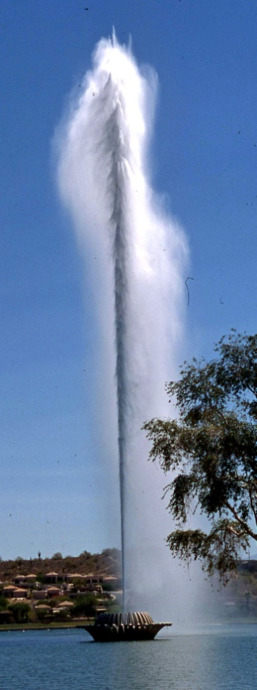

1. The makers of the Gateway Geyser in St. Louis, Missouri claim that the water is shot out of the fountain at 76 m/s and reaches a height of over 183 m.

Ignoring air resistance, the height, *h*, in metres, of the water can be modelled by the relation: , where ***t*** is the time, in seconds.

* 1. Factor the expression for the height of the water.
  2. Make a table of values for the times from 0 s to 10 s. Graph your results. What is the approximate maximum height of the water?

|  |  |  |  |  |  |
| --- | --- | --- | --- | --- | --- |
| |  |  | | --- | --- | | Time | Height | | 0  1  2  3  4  5  6  7  8  9  10 |  | | tmp3 |

* 1. Due to air resistance, the water only reaches about 65% of the predicted height. Is the manufacturer’s claim regarding a maximum height of 183 m reasonable? Explain.