Optimize: Determine the best solution while adhering to given constraints
Concept 1: Maximum Deck Size – MAXIMIZING THE AREA
Complete the table below:
OBSERVATION:
The rectangles above have the same ______________.
Rectangle ___ has the greatest area.

CONCLUSION:
When enclosing FOUR SIDES, the maximum rectangular area for a fixed perimeter is obtained by forming a ____________.
Rectangle | Length (m) | Width (m) | Perimeter (m) | Area (m²)
A | 15 | 5 | 2(15+5) = 40 | 15 x 5 = 75
B | 12 | 8
C | 10 | 10
D | 18 | 2
E | 9 | 11

Solved Example: Find the maximum area for a rectangular four-sided area you can enclose with a 60 m rope at a beach. [Hint: Recall that the four-sided shape will be a SQUARE.]
Solution: The square will provide the maximum area. We need to form a square that has a 60m perimeter.
1 side of the square = 60 / 4 = 15
The enclosed area will by 15 by 15; thus, its area is 15 x 15 = 225 m².

Try these: Find the dimensions (integer values) of the largest rectangular area that can be made given the following perimeters. Calculate the area for each shapes.
a) 48 m | b) 100 m
c) 36 m | d) 144 m

Concept 2: Minimum Perimeter for a Fixed Area – MINIMIZING THE PERIMETER
Complete the table below:
OBSERVATION:
The rectangles above have the same ______________.
Rectangle ___ has the least perimeter area.

CONCLUSION:
When enclosing FOUR SIDES, the minimum perimeter for a given rectangular area is obtained by forming a ____________.
Rectangle | Length (m) | Width (m) | Area (m²) | Perimeter (m)
A | 2 | 18 | 2 x 18 = 36 | 2(2 + 18) = 40
B | 3 | 12
C | 4 | 9
D | 6 | 6
E | 9 | 4
Solved example: Find the dimensions of the rectangle that will provide the least perimeter if the area is 81 m².
Solution: The square will provide the least perimeter. We know the area of this square which is 81.
One side of the square is = $\sqrt{81}=9$
Therefore, it is a 9 by 9 square that will give the least perimeter.

Try these: Find the dimensions (integer values) of the smallest rectangular perimeter that can be made given the following areas:
a) 36m² | b) 100 m²
c) 144 m² | d) 256 m²

Concept 3: MAXIMUM 3-SIDED AREA
CONCLUSION:
When enclosing THREE SIDES, the maximum area for a given rectangular area is obtained by forming a rectangle whose length is twice its width.
Let “w” represent the width “2w” represent the length.
w
w
2w

Solved example: Your manager asked you to create a three-sided rectangular area at the beach with a 100 m rope that will have the greatest area. What are the dimensions?
Solution: Since this is a three-sided enclosing, we will use the following figure:
w + 2w + w = 4w
w
w
2w
4w is the perimeter because that is how much rope we have
4w = 100 divide both sides by 4
4w / 4 = 100 / 4
w = 25
width = 25 length = 50
Therefore; it is 25 by 50 rectangle with its three sides enclosed.

Your turn:
Organizers of an outdoor music festival want to enclose a rectangular dining area against a large barn. They have 80 m of rope to use as a fence. Determine the length and width of a fence that will provide the maximum dining area. Use words and diagrams in your answer.

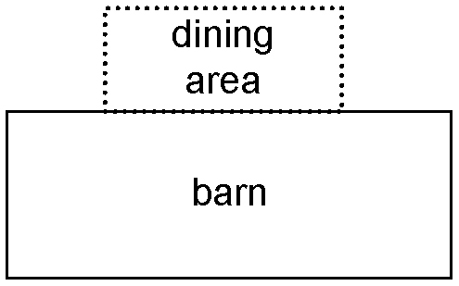

PRACTICE
1. An inbox tray has 3 walls and an open side on one of the longer sides. Determine the maximum area of the tray if all three walls total to a length of 812 mm.

2. The perimeter of a rectangular piece of cardboard is 46 centimetres. Determine the dimensions that maximize the area.

3. The maximum area of a fenced in pool deck is 1024 m². Determine the length of fencing that is required.

4. Three sides of a lookout deck have a railing, while the fourth side is open. Determine the maximum area if there is 648 cm of railing.

5. The area of a rectangular box is 722 500 mm². Determine the dimensions that minimize the perimeter.

