|  |
| --- |
| Congratulations! You have made it to the math cheerleading team. Just imagine a group of dedicated mathletes spreading the cheer of math throughout the school! The best part about being on the math cheerleading team is that you get paid… per cheer! Of course, since the team is a MATH team, it takes a bit of calculating to figure out how much you get paid.  Here’s what the coach told you:  *If you do 10 cheers, you get paid $2 per cheer (NOT BAD!)*  *You will get 10¢ less per cheer for every cheer over 10 cheers,*  *but you will get 10¢ more per cheer for every cheer under 10 cheers.*  The question going around the team is “How many cheers do we need to do in order to get the most money?” |

**Fill** in the table below to find out (start at 10 cheers and work up and down). **Plot** the points on the grid below. **Draw** a line of best fit.

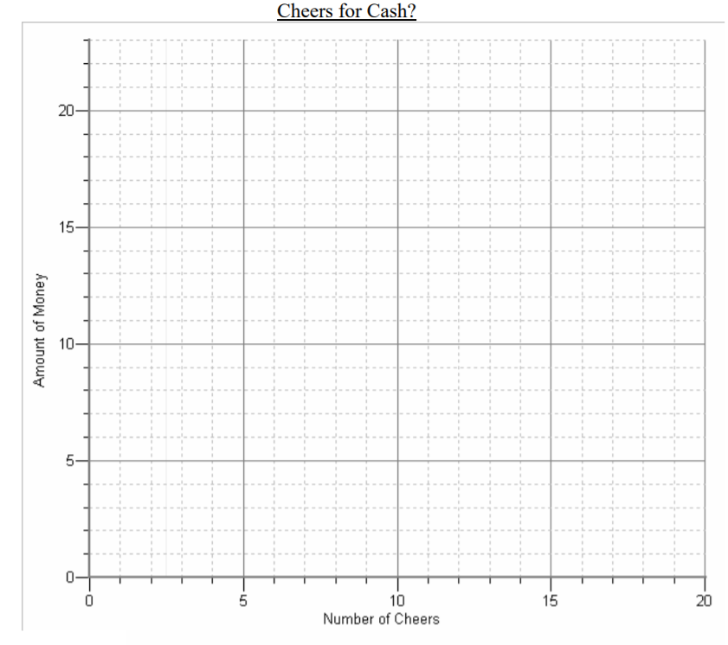

|  |  |  |  |  |
| --- | --- | --- | --- | --- |
| **Number of Cheers** | **Price per**  **Cheer** | **Total Money Paid**  **(1st x 2nd columns)** | **1st**  **differences** | **2nd**  **differences** |
| 7 | $2.30 |  |  |  |
| 8 | $2.10 + 10¢ = $2.20 |  |  |  |
| 9 | $2.00 + 10¢ = $2.10 |  |  |  |
| 10 | $2.00 | 10 x $2.00 = $20.00 |  |  |
| 11 | $2.00 - 10¢ = $1.90 |  |  |  |
| 12 | $1.90 - 10¢ = $1.80 |  |  |  |
| 13 |  |  |  |  |
| 14 |  |  |  |  |
| 15 |  |  |  |  |
| 16 |  |  |  |  |
| 17 |  |  |  |  |
| 18 |  |  |  |  |
| 19 |  |  |  |  |
| 20 |  |  |  |  |

**Conclusion:**

* The maximum money of ______ is paid when you do _____ math cheers. This point on the graph is called ____________ .
* In the table of values, the 1st differences are _____________, 2nd differences are _________.

**Thinking:** Describe the trends in the graph and state when would you stop cheering?

|  |
| --- |
| **QUADRATIC MODELS**  **KEY WORDS**  Non-linear  Constant  Second  Parabola  Two  y = ax2+bx+c  a is not 0.  Represent quantities that are ___________ which do not have a _________ rate of change   * In a table of values, the ____________ differences are equal * The graph is a curve called a ___________________________ * The equation has a degree of ______ and is written in the form _______________ where _______________________ |

**EXAMPLE 1:** Which models represent quadratic relations?

* *Find 2nd differences*

|  |  |
| --- | --- |
|  |  |
|  |  |
| e) | f) |

**THINKING**

Determine if the graph shown represents a quadratic relation or not. Show/explain how you got your answer.