THINK ABOUT IT: Determine the value of x if the given shape below is a square.
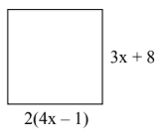

SOLVING EQUATIONS WITH FRACTIONS
Steps:
- Determine the Lowest Common Denominator for all the fractions
- Multiply every term by LCD
- solve for x
Evaluate $6×\frac{2}{3}$

Teacher | Your Turn
$$\frac{x}{2} - \frac{1}{3} = \frac{13}{6}$$ | $$a) \frac{x}{3} - 3 = \frac{7}{2}$$ | $$b) \frac{x}{4} + \frac{x}{2}= 6$$
$$\frac{x-4}{2} = \frac{x-3}{3}$$ | $$a) \frac{5x+4}{5} = \frac{5x+13}{10}$$ | $$b) \frac{1}{3}\left(x+4\right) = \frac{1}{5}(x+2)$$

PRACTICE
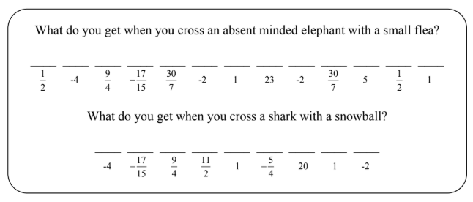
1. Solve each equation below on a separate sheet of paper and find the solution in the code. Each time the solution appears, write the letter of that exercise above it.

G] | $$\frac{x}{2} + \frac{2x}{3} = 5$$ | M] | $$\frac{2}{5}x - \frac{4}{3} = \frac{1}{3}x + \frac{1}{5}$$
I] | $$\frac{9x}{5} - \frac{3x}{2} = 6$$ | B] | $$\frac{3}{14}k + \frac{5}{7} = \frac{4}{7} + \frac{1}{2}k + \frac{1}{2}$$
O] | $$\frac{n}{4} - \frac{3}{2} = \frac{-15}{16}$$ | R] | $$\frac{x}{4} - 2 + \frac{3}{4} = x - \frac{2}{5}$$
S] | $$\frac{a}{3} + \frac{5}{3} = \frac{7}{2}$$ | N] | $$\frac{4x}{3} - \frac{x}{3} - \frac{1}{2} = \frac{9}{2}$$
A] | $$\frac{3x}{4} - \frac{1}{4} + \frac{x}{2} = \frac{3}{8}$$ | F] | $$\frac{1}{10}m + \frac{4}{5} - \frac{1}{15}m + \frac{1}{3}= 1$$
E] | $$\frac{2t}{3} - \frac{5t}{4} + \frac{2}{3} = \frac{11}{6}$$ | T] | $$\frac{5x}{6} - \frac{3}{8} + \frac{x}{8} = \frac{x}{3} + \frac{1}{4}$$

2. Solve each equation below:
$$a) \frac{x}{2} + \frac{4}{5} = \frac{23}{10} - x$$ | $$b) -\frac{1}{2}x - \frac{1}{8} = x + \frac{5}{8}$$
$$c) 6=-\frac{3}{5}(a-7)$$ | $$d) \frac{1}{3}\left(p+2\right) = -5$$
$$e) \frac{3x+5}{5} = 12$$ | $$f) \frac{3(s-4)}{4} = \frac{2(s-3)}{3}$$

