Complete the table of values below and graph.
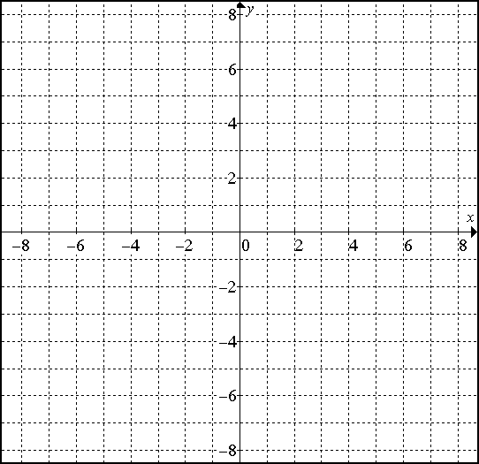
1.
$$x$$ | $$y=-x+4$$ | $$( x ,y )$$
-2
-1
0
1
2

2.
$$x$$ | $$y=\frac{1}{2}x-3$$ | $$( x ,y )$$
-4
-2
0
2
4

