**THE SINE LAW**

**KEY WORDS**

Sine rule

Side

Opposite

Length

|  |
| --- |
| So far, we have used trigonometric ratios to solve right angle triangles. The ____ _____ can be used in any triangle (not just right-angled triangles) where a ____ and its ______ angle are known. |

|  |
| --- |
| **CASE 1) FINDING SIDE: ANGLE – ANGLE – SIDE** |
| If you need to find the **_______** of a side, you need to use the version of the Sine Rule where the lengths are on the top:   |  |  |  |  | | --- | --- | --- | --- | |  | *a* | = | *b* | | sin(*A*) | sin(*B*) |   You will only ever need two parts of the Sine Rule formula, not all three. You will need to know at least one pair of a side with its opposite angle to use the Sine Rule. |

**Example 1:** Determine the length of x:

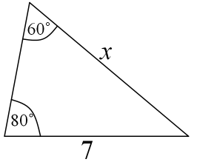

|  |  |
| --- | --- |
|  |  |
|  |  | |
|  |  | |

|  |
| --- |
| **CASE 2) FINDING ANGLE: SIDE – SIDE – OPPOSITE ANGLE** |
| If you need to find the size of an angle, you need to use the version of the Sine Rule where the angles are on the top:   |  |  |  |  | | --- | --- | --- | --- | |  | sin(*A*) | = | sin(*B*) | | *a* | *b* |   As before, you will only need two parts of the Sine Rule , and you still need at least a side and its opposite angle. |

**Example 2:**

Determine the angle to the nearest degree:

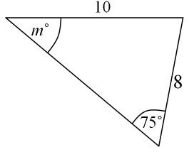

***PRACTICE:***

1. Find the measure of  to the nearest tenth of a degree.

**SOLVE**

To determine all unknown angles and sides.

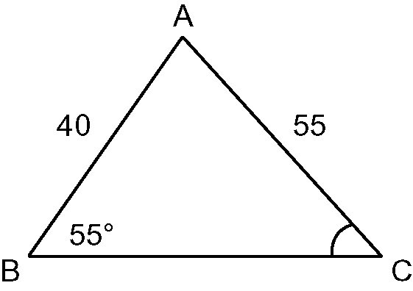

1. Find the measure of side *e* to the nearest tenth.

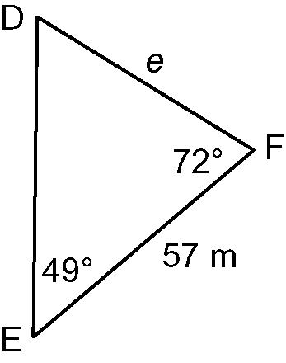

1. Solve the triangle *ABC* given , cm, cm
2. Solve for the unknown value to the nearest tenth

|  |  |
| --- | --- |
|  |  |

1. Find the measure of to the nearest degree

|  |  |
| --- | --- |
| taBLM1-8-1s3-2 |  |

6) Find the measure of the indicated side to the nearest tenth.

|  |  |
| --- | --- |
| 1. taBLM1-8-1s3-4 | 1. taBLM1-8-1s3-6 |

1. Solve each triangle *ABC*.

|  |  |
| --- | --- |
|  | 1. Given , , |

1. Two guy wires 27 m and 15 m in length are to be fastened to the top of a TV tower from two points B and C as shown. The angle of elevation to the top of the tower of the longer wire is . How far apart are points B and C and how tall is the tower?

