**The Sine Law in Acute Triangles**

So far we’ve used trigonometry to solve right angle triangles. For **non-right angle** triangles we use the **SINE LAW**. It allows us to find the length of sides and measurement of angles in _________________ triangles (no right angle).



What information must be given in a triangle in order to use sine law to solve it?

**To SOLVE a triangle means to find ___________________________________________________**

***EXAMPLES***:

1. Find the measure of  to the nearest tenth of a degree.

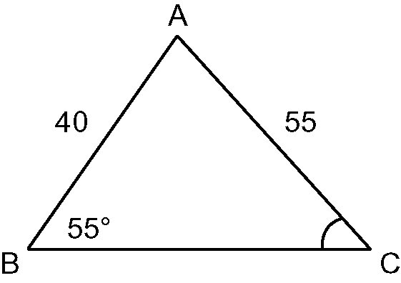

1. Find the measure of side *e* to the nearest tenth.

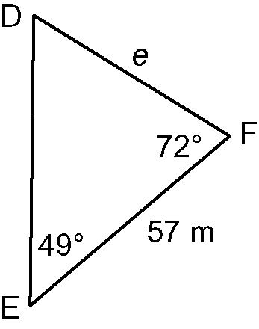

1. Solve the triangle △*ABC* given , cm, cm

**Sine Law Practice**

1. Solve for the unknown value to the nearest tenth

|  |  |
| --- | --- |
|  |  |

1. Find the measure of to the nearest degree

|  |  |
| --- | --- |
| 1. taBLM1-8-1s3-2 |  |

1. Find the measure of the indicated side to the nearest tenth.

|  |  |
| --- | --- |
| 1. taBLM1-8-1s3-4 | 1. taBLM1-8-1s3-6 |

1. Explain why this triangle cannot be solved

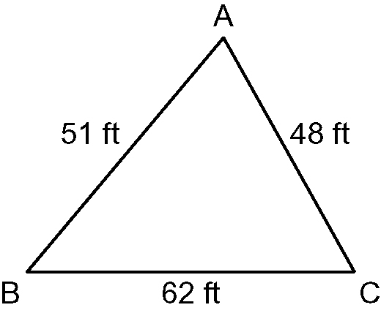

1. Solve each triangle △*ABC*.

|  |  |
| --- | --- |
|  | 1. Given , , |

1. 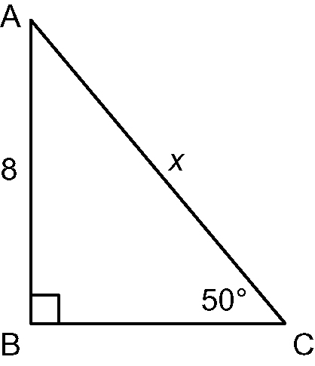a) Use the **sine ratio** to find the value of *x*, to the nearest tenth

b) Use the **sine law** to find the value of *x*, to the nearest tenth

c) Explain why the two methods are equivalent for a **right** triangle.

1. Two guy wires 27 m and 15 m in length are to be fastened to the top of a TV tower from two points B and C as shown. The angle of elevation to the top of the tower of the longer wire is . How far apart are points B and C and how tall is the tower?

