*- Things that Make You Go Hmmmm…*

|  |  |
| --- | --- |
| ***Warm-up:*** Ted and Ned are going to race their dirt bikes.  Since Ted is younger, Ned is going to  give him a 10 mile head start.  Ted travels at 10 mph and Ned travels at 20 mph.  At what time will Ned catch up with Ted? How far will they have traveled when they meet?  **Ted’s** equation:  *y* = 10*x* + 10 *x* = time in hours  **Ned’s** equation: *y* = 20*x* + 0 *y* = distance in miles   |  | | --- | | Turn on your **DESMOS**  [http://t1.gstatic.com/images?q=tbn:ANd9GcScy7LsBXdnU0ZXuyZawDGiuEWyk6-YmHd5yWV15gkzkDqVa77DyQ](http://www.google.ca/imgres?q=laptop+clip+art&hl=en&biw=1107&bih=617&gbv=2&tbm=isch&tbnid=NCV1SFw5DngSLM:&imgrefurl=http://www.computerclipart.com/computer_clipart_images/laptop_computer_coloring_page_0521-1004-3015-4009.html&docid=8PRvVSxIIGKSiM&w=300&h=270&ei=yjpDTorsDpDegQfRx-HGCQ&zoom=1) |  1. Use the Online Graphing Calculator to graph the two lines. **Sketch** them on the grid to the right. Be sure the point of intersection is showing.      1. Determine the point of intersection of the two lines.   ____________________     1. What does this point represent in the context of this word problem? |

Do 2 lines always intersect in one point? Check it!

***Task 1: One Solution***

* 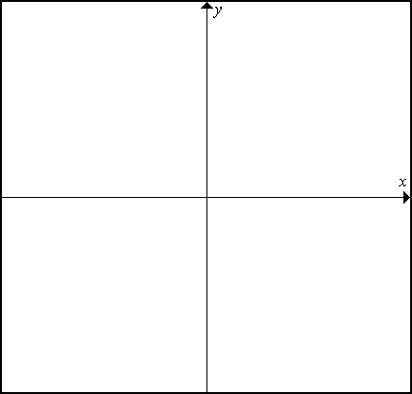Click/ touch on the **“x”** to delete the equations**.**
* Change the equation to, and then change the colour of the line to black.
* Change the equation to y = 4x -5, then change the colour of the line to orange.

1. Sketch the two graphs on the grid provided.
2. Why is there one solution to the linear system?
3. How can you tell by looking at the equations that there will be one solution to the linear system?
4. Predict the equation of another line which would have one solution with .

________________________ Verify your answer by graphing it on the Desmos.



* Using the **green** line, change the equation to:



* Using the **blue** line, change the equation to:



1. Sketch the two graphs on the grid provided.
2. Why is there one solution to the linear system?
3. How can you tell by looking at the equations that there will be one solution to the linear system?
4. Predict the equation of another line which would have one solution with .

________________________ Verify your answer by graphing it on the Desmos.

***Task 2: No Solution***



* Using the **green** line, change the equation to: 
* Using the **blue** line, change the equation to: 

1. Sketch the two graphs on the grid provided.
2. Why is there no solution to the linear system ?
3. How can you tell by looking at the equations that there will not be a solution to the linear system?
4. Predict the equation of another line which would have no solution with .

________________________ Verify your answer by graphing it on the Desmos.



* Using the **green** line, change the equation to:



* Using the **blue** line, change the equation to:



1. Sketch the two graphs on the grid provided.
2. Why is there no solution to the linear system ?
3. How can you tell by looking at the equations that there will not be a solution to the linear system?
4. Predict the equation of another line which would have no solution with .

________________________ Verify your answer by graphing it on the Desmos.

***Task 3: Many Solutions***



* Using the **green** line, change the equation to:



* Using the **blue** line, change the equation to:



1. Sketch the two graphs on the grid provided.
2. Why are there multiple solutions to the linear system ?
3. How can you tell by looking at the equations that there will be multiple solutions to the linear system?
4. Predict the equation of another line which would have multiple solutions with .

________________________ Verify your answer by graphing it on the Desmos.

**SUMMARY**

|  |
| --- |
| linear-types    same _______ different ________ same _________  different _______ same _________ |

***Task 4: Practice***

1. Determine the number of solutions each linear system has. Justify your decision.
2.  b.  c.  d. 

e.  f.  g.  h. 

1. Sarah and Shannon mow lawns during the summer to earn money. They both calculated their start-up expenses, operating expenses, and income per hour of mowing. They wrote these equations for their income, *I*, after *h* hours of mowing.



1. What are Shannon’s start-up costs?
2. What does Sarah charge per hour?
3. Will Sarah ever earn as much money as Shannon? Justify your decision.
4. Sketch what these two graphs would look like.
5. An air traffic controller is plotting the course of two jets scheduled to land in about 15 minutes. One aircraft is following a path defined by the equation  and the other by the equation . Should the controller alter the paths of either aircraft? Justify your decision.