**Use Similar Triangles to Solve Problems**

|  |
| --- |
| The geometry of similar figures is a powerful area of mathematics. Similar triangles can be used to measure the heights of objects that are difficult to get to, such as trees, tall buildings, and cliffs. |

**Scale Factor (k)**

The scale factor, k, is a useful quantity when working with similar triangles such as the ones shown.

The value of k relating corresponding sides in these two triangles is 3, because if you multiply each side length in by 3, you obtain the corresponding side length in.

You can apply the scale factor to find an unknown side length in one triangle if you know the corresponding side length in a similar triangle.

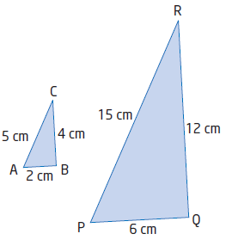

**A) Solve for an Unknown Side and Angle**

**Ex1.** Given ∆ABC ~ ∆DEF, find the **measure** of ∠C and the **length** of DE to the nearest tenth of a unit.

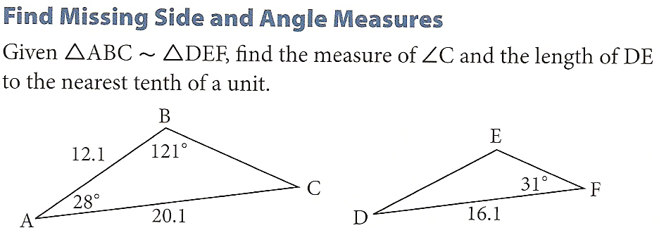

**B) Areas of Similar Figures**

**Ex1.** What is the relationship between the areas in each pair of similar figures? Find the scale factor, k, for each pair of figures.

|  |  |
| --- | --- |
|  |  |

|  |  |
| --- | --- |
| k = | k = |
| |  |  | | --- | --- | |  |  | | |  |  | | --- | --- | |  |  | |  |  | |
| Relationship between two areas? | Relationship between two areas? |

|  |
| --- |
| Another way to write this is .Meaning, the ratio of the area of the larger figure to the area of the smaller figure is equal to the square of the scale factor, k. |

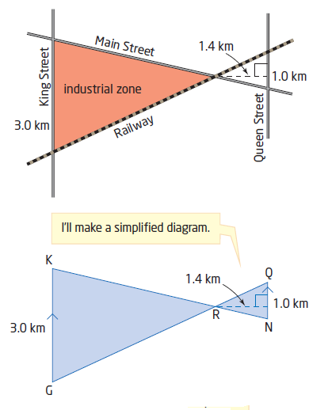

**Ex.** The shaded area is to be an industrial zone.

Find the area of the industrial zone. Assume that King and Queen are parallel and that all streets and the track are straight.

**Ex.** Find the length of FG to the nearest tenth of a unit.

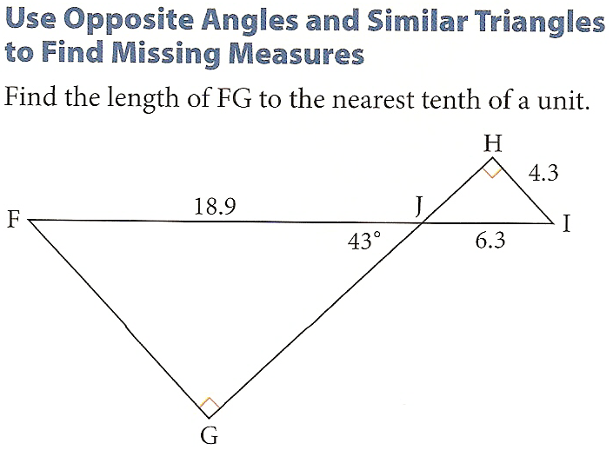

**Ex.** To determine the width of a river, Naomi finds a willow tree and a maple tree that are directly across from each other on opposite shores. Using a third tree on the shoreline, Naomi plants two stakes, A and B, and measures the distance shown.

Find the width of the river using the information that Naomi found.

