**Volume of Pyramids**

To find the volume of any pyramid:

find the volume for the prism with the same base and height and then divide by 3.

|  |  |
| --- | --- |
| **Pyramid (Square, Rectangular, Triangular Based)**  http://www.ajdesigner.com/phpgeometricformulas/pyramid.png  In this case, the Base of the pyramid is a rectangle.        In this case, the Base of the pyramid is a triangle. | *B is the area of the base* |

|  |  |
| --- | --- |
| **Example 1:** Determine the volume of this pyramid is cm3.  M5Q9 | **Example 2:** Determine the volume of this pyramid in m3. |

**Volume of a Cone**

|  |  |
| --- | --- |
| ***Cone*** *– Basically, a circle-based pyramid* |  |

***Example 3:*** Determine the volume of this cone in cm3.



***Example 4:*** Determine the volume of this cone in cm3.



**Surface Area of Pyramids**

|  |  |
| --- | --- |
| ***Pyramid (Square, Rectangular, Triangular, or any Polygonal Based)***    [http://images.google.com/images?q=tbn:XyOT6cwl4fTiGM:http://mathworld.wolfram.com/images/eps-gif/J02Net_600.gif](http://mathworld.wolfram.com/images/eps-gif/J02Net_600.gif)If the Base Area is not given, use the appropriate formula to determine the area.  http://mathworld.wolfram.com/images/eps-gif/J01Net_500.gif | Add the area of the base and all the sides  Each side will be a triangle    The shape of the base will vary |

***Example 1:*** Determine the surface area of this square based prism in in2.

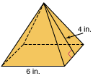

***Example 2:*** Determine the surface area of this rectangular based prism in ft2.



***Example 3:*** Determine the surface area of this pentagonal based prism in cm2.



**Surface Area of Cones**

[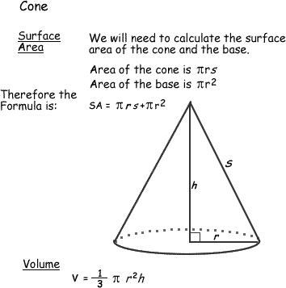](http://z.about.com/d/math/1/0/t/L/conerr.jpg)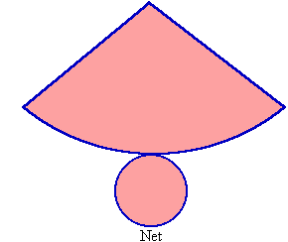

r

s

***Example 3:*** Determine the surface area of this cone if the diameter of the base is 3cm and the slant height is 9cm.

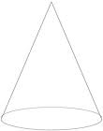

***Example 4:*** Determine the surface area of cone if the cone height is 4m, and the radius is 3m.

[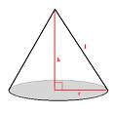](http://www.google.ca/imgres?imgurl=http://library.thinkquest.org/20991/media/geo_cone2.gif&imgrefurl=http://library.thinkquest.org/20991/geo/solids.html&usg=__hADWS9KMgktOXSHMUTO777NrSN0=&h=300&w=300&sz=4&hl=en&start=40&um=1&itbs=1&tbnid=4YN9zLhgWTN8HM:&tbnh=116&tbnw=116&prev=/images?q=cone&start=20&um=1&hl=en&sa=N&ndsp=20&tbs=isch:1)

**Volume and Surface Area of Pyramids - Practice**

Round to 1d.p. where necessary

|  |  |
| --- | --- |
| a. Find the **volume** and **surface** **area** of a pyramid with a square base of 4cmx4cm and triangle height of 12cm and the pyramid height of 11.83cm. | b. Find the **volume** and **surface area** of this square based pyramid if pyramid’s height is 2.73 in. |
| c. Find the **surface** **area** of this prism that is created using all equilateral triangles.  **3.5** | d. **SA** |
| ANSWERS: a. 112cm2 63.1cm3, b. 21.3in2, c. 28m2, d.52.5ft2 | |

**Volume and Surface Area of Cones - Practice**

|  |  |
| --- | --- |
| a. | b. |
| c. | 1. If a cone has a volume of 175.84cm3, and a base radius of 5cm, determine the slant height of the cone and calculate the surface area. |
| ANSWERS: a. 885.9 m2, b. 2029.5 cm2, c 1095.9 in2, d. 8.4cm 210.5cm2 | |